[Date] NHS Number:
Address Line 1
Address Line 2
Address Line 3
Address Line 4

Dear Parent /Guardian of [Full name]

Your child is now due for their COVID-19 vaccination
[Add appointment information here]
If you cannot attend or have any questions about the appointment, you can:
- Phone us on (XXXX) between (insert working hours)
- Email us at (XXXX@wales.nhs.uk)
Rydym yn croesawu e-byst a galwadau ffôn yn Gymraeg. Byddwn yn ymateb yn Gymraeg yn ddi-oed. We welcome emails and phone calls in Welsh. We will respond in Welsh without delay.

Why is the vaccine important?
The COVID-19 vaccine is being offered to children and young people aged six months and over who have a weakened immune system.

The vaccine can help lower your child’s risk of getting seriously ill from COVID-19 and needing hospital care.

Even if your child has been vaccinated before, their protection fades and virus strains change over time. This is why they’re being invited for another dose.

Does the vaccine work?
The vaccine is safe, effective and can help make COVID-19 a milder illness if you do catch it. Millions of doses have been safely given in the UK.

Please make every effort to attend your appointment to stay protected.
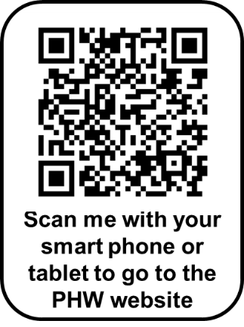
If you or your child would like more information, you can:
- visit the Public Health Wales (PHW) website at:
phw.nhs.wales/covidvaccine
- scan the QR code
- speak to the healthcare staff at your appointment, or
- visit the [Health Board] website at [insert web link]

Yours sincerely
The Booking Team

[Date] NHS Number:
Address Line 1
Address Line 2
Address Line 3
Address Line 4

Annwyl Riant/Gwarcheidwad [Full name]

Mae’n amser i'ch plentyn gael ei frechiad COVID-19
[Add appointment information here]
Os na allwch fynd i’r apwyntiad neu os oes gennych gwestiynau am yr apwyntiad, gallwch:
- Ffonio ni ar (XXXX) rhwng (insert working hours)
- Anfon e-bost atom (XXXX@wales.nhs.uk)
Rydym yn croesawu e-byst a galwadau ffôn yn Gymraeg. Byddwn yn ymateb yn Gymraeg yn ddi-oed.

Pam mae’r brechlyn yn bwysig?
Mae brechlyn COVID-19 yn cael ei gynnig i blant a phobl ifanc chwe mis oed a hŷn sydd â system imiwnedd wan.

Gall y brechlyn helpu i leihau risg eich plentyn o fynd yn ddifrifol wael o ganlyniad i COVID-19 ac angen gofal ysbyty.

Hyd yn oed os yw eich plentyn wedi cael ei frechu o'r blaen, mae eu hamddiffyniad yn pylu ac mae straeniau’r feirws yn newid dros amser. Dyma pam eu bod yn cael eu gwahodd am ddos arall.

Ydy'r brechlyn yn gweithio?
Mae'r brechlyn yn ddiogel, yn effeithiol a gall helpu i wneud COVID-19 yn salwch ysgafnach os ydych chi'n ei ddal. Mae miliynau o ddosau wedi cael eu rhoi yn ddiogel yn y DU.

Gwnewch bob ymdrech i fynychu'ch apwyntiad i gynnal eich amddiffyniad.

Os hoffech chi neu’ch plentyn gael rhagor o wybodaeth, gallwch:
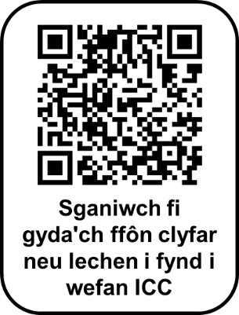
- fynd i wefan Iechyd Cyhoeddus Cymru (ICC) yn:
icc.gig.cymru/brechlyncovid
- sganio’r cod QR
- siaradwch â'r staff gofal iechyd yn eich apwyntiad, neu
- ewch i wefan [Health Board] yn [insert web link]

Yn gywir
Y Tîm Trefnu Apwyntiadau

