
Welsh Cancer Intelligence and Surveillance Unit
Official Statistics: Cancer Survival in Wales, 2002-2022
Note:
- ‘All cancers’ refers to ‘All cancers excluding non-melanoma skin cancer (NMSC).’
- ‘All stageable cancers’ refers to a combined grouping of all cancers that can be staged at diagnosis or have staging data available.
- Survival rates are age-standardised estimates of net survival (%) unless stated otherwise, considering the different age-structure in that population compared to other areas and previous years.
- Percentage point differences are absolute and not relative differences.
- ‘Early stage’ is defined as Stage 1 and 2 diagnoses combined, and ‘Late stage’ is Stage 3 and 4 diagnoses combined.
Headlines
For people diagnosed with cancer in Wales during 2018 to 2022, 75% survived one year from diagnosis and 60% survived five years from diagnosis, after accounting for other causes of death.
Cancer survival improved steadily from the early 2000s to the mid 2010s. Between the 2002-2006 and 2014-2018 diagnosis periods, one year survival rose by 8 percentage points and five year survival by 9 percentage points (Figure 1).
However, improvements have since stalled, with trends remaining broadly flat up to 2018-2022. This levelling off began before the pandemic, from the 2015-2019 period.

One-year cancer survival has recovered significantly following the COVID-19 pandemic.
Looking at single years of diagnosis, one-year cancer survival fell by 4 percentage points between 2019 and 2020, around the onset of the COVID-19 pandemic. By 2022, it had recovered to pre-pandemic levels (Figure 2).
Cancers typically diagnosed at a later stage - such as colorectal and lung - experienced the largest temporary declines in one-year survival but have since recovered well. In contrast, cancers more often diagnosed earlier - including prostate and breast - were less affected.

Cancer survival worsens with increasing area deprivation. In 2018-2022, five-year survival was significantly higher in the least deprived areas than in the most deprived areas.
Despite broad improvements in cancer survival, the area deprivation gap has remained stable, with estimates around 10-13 percentage points higher in the least deprived areas (Figure 3).
Colorectal cancer has consistently had the widest deprivation gap amongst the most common cancers. This difference narrowed up to the 2017–2021 diagnosis period but has since widened again, driven by improving five-year survival in the least deprived areas alongside little change in the most deprived (Figure 4).

The area deprivation gap in five-year unstandardised net survival is almost twice as large for late-stage diagnosis than for early-stage.
For all stageable cancers, deprivation inequalities are significant for both stage groupings, though markedly wider for late-stage diagnosis (Figure 5).
Site-specific relationships are less consistent. For colorectal five-year survival and lung cancer one-year survival, deprivation gaps are significant for late-stage, but not early-stage diagnosis. In contrast, prostate and female breast cancers show smaller differences overall, with no clear or consistent relationship with deprivation across stage groupings.
Interpretation should consider that COVID-19 disrupted access to screening, GP referral and diagnostics, and this may have affected stage at diagnosis differently across deprivation groups.

Useful links
Please find our cancer survival statistics on our Cancer Reporting Tool here.
For more information on the methodology used in cancer survival official statistics and the new stage at diagnosis by area deprivation analysis, please see the technical guide here.
This document is also available in Welsh here.

Appendix

Figure 1: Trends in one- and five-year survival of cancer in Wales.
One- and five-year age-standardised net survival (%), all cancers excluding NMSC, persons aged 15-99, Wales, 2002-2006 to 2018-2022
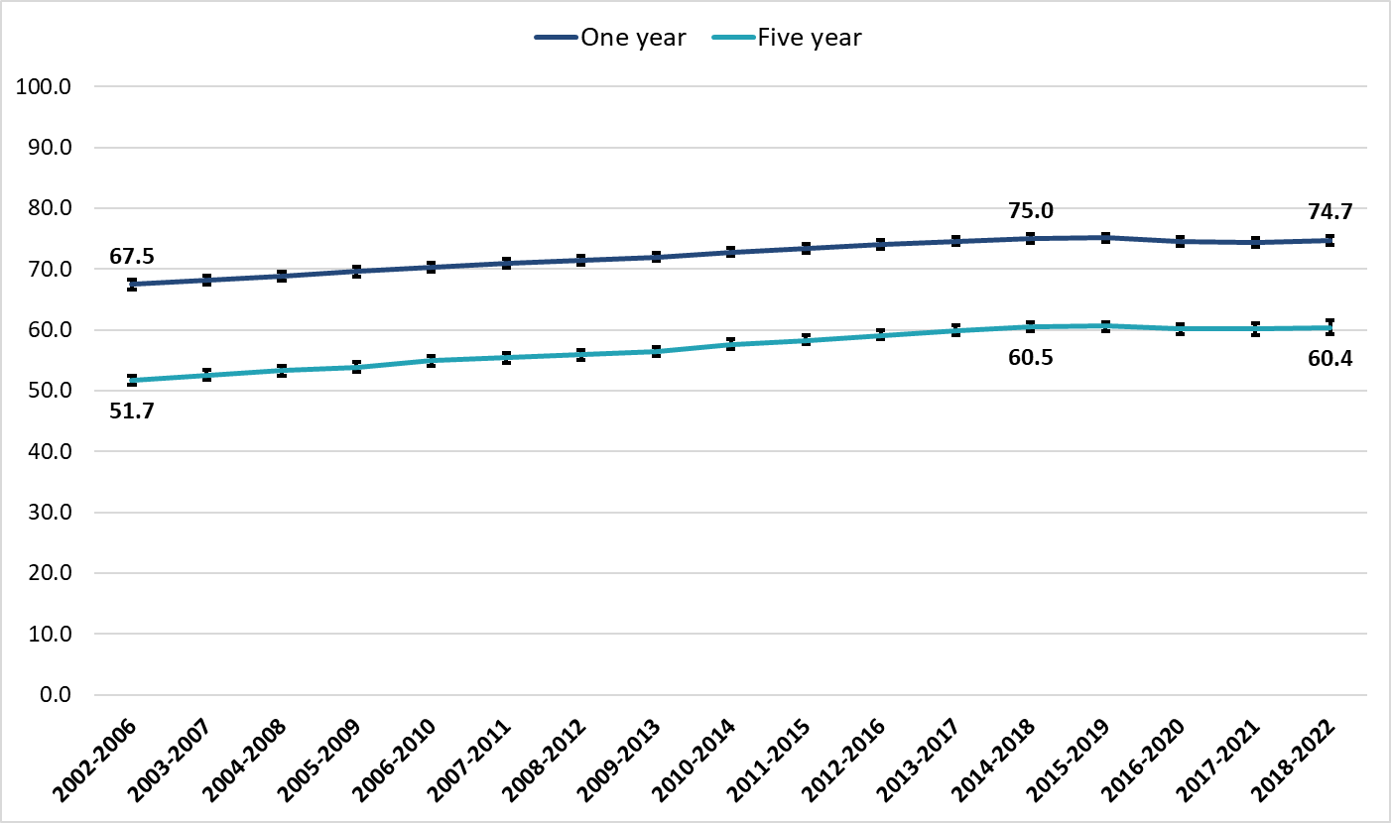
Produced by Public Health Wales, using cancer registration data (WCISU), public health mortality (PHM) & mid-year population estimates (MYE) (ONS) and Welsh Index of Multiple Deprivation (WIMD) (WG)

Figure 2: Trends in one-year survival of cancer in Wales.
One-year age-standardised net survival (%), all cancers excluding NMSC, persons aged 15-99, Wales, 2002-2022
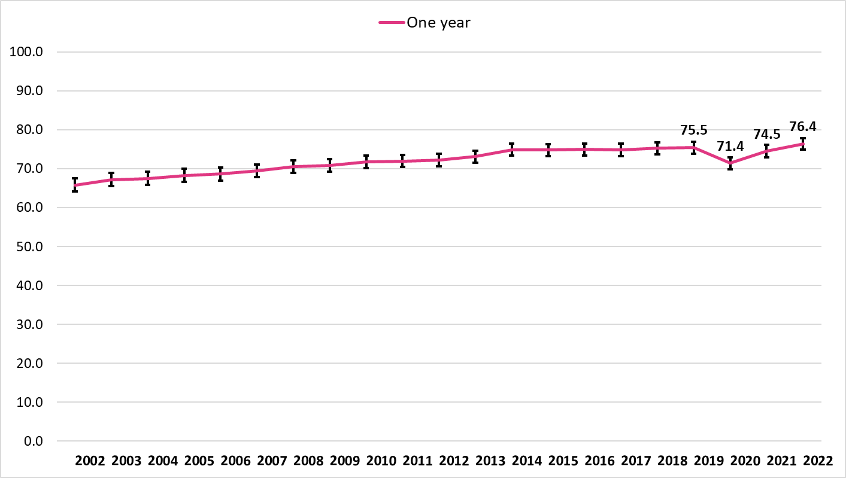
Produced by Public Health Wales, using cancer registration data (WCISU), PHM & MYE) (ONS) and WIMD (WG)

Figure 3: Trends in five-year survival of cancer in Wales by area deprivation fifth.
Five-year unstandardised net survival (%) by deprivation fifth, all cancers excluding NMSC, persons aged 15-99, Wales, 2002-2006 to 2018-2022
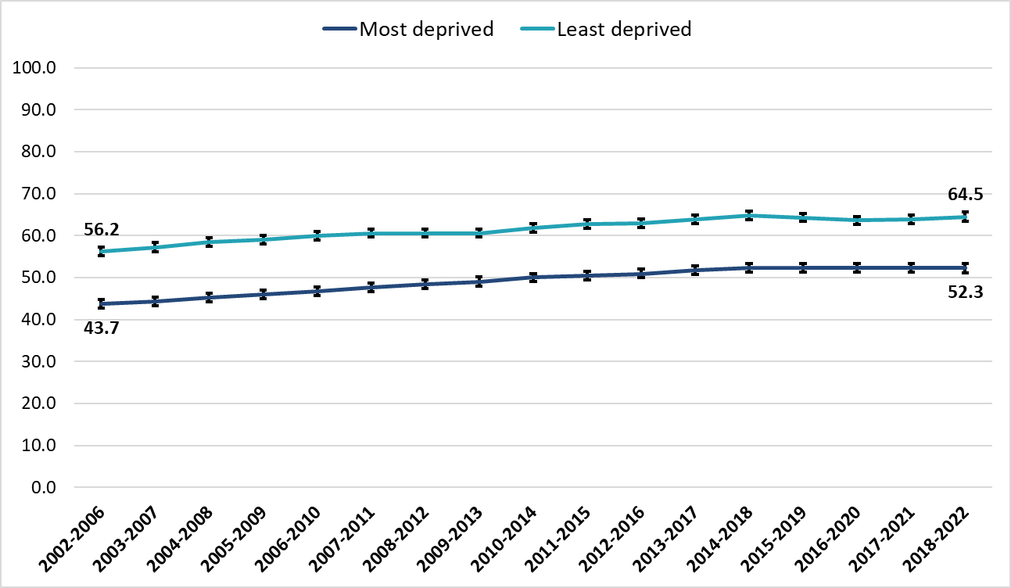
Produced by Public Health Wales, using cancer registration data (WCISU), PHM & MYE) (ONS) and WIMD (WG)

Figure 4: Trends in five-year survival of colorectal (bowel) cancer in Wales by area deprivation fifth.
Five-year unstandardised net survival (%) by deprivation fifth, colorectal cancer, persons aged 15-99, Wales, 2002-2006 to 2018-2022
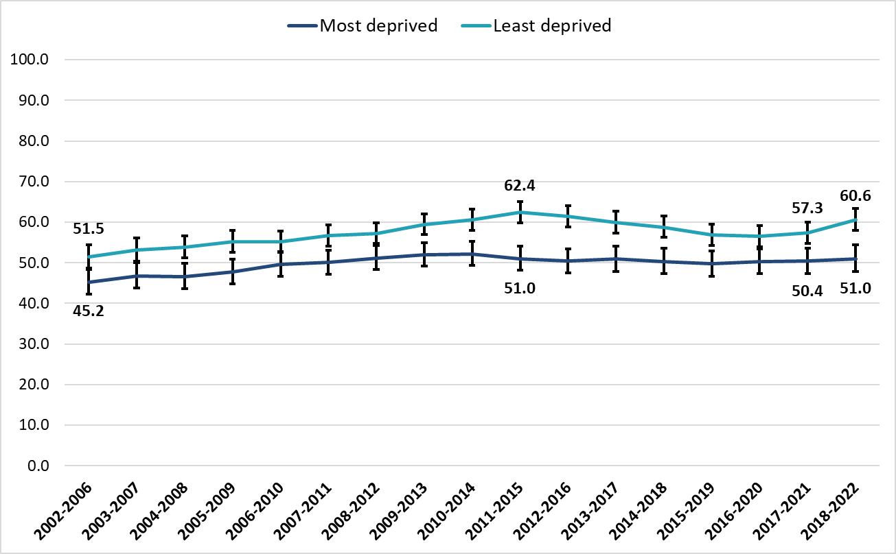
Produced by Public Health Wales, using cancer registration data (WCISU), PHM & MYE) (ONS) and WIMD (WG)

Figure 5: Five-year survival of early- and late-stage diagnoses of stageable cancers in Wales by area deprivation fifth during the diagnosis period 2018-2022.
Five-year unstandardised net survival (%) by stage at diagnosis and deprivation fifth, all stageable cancers, persons aged 15-99, Wales, 2018-2022
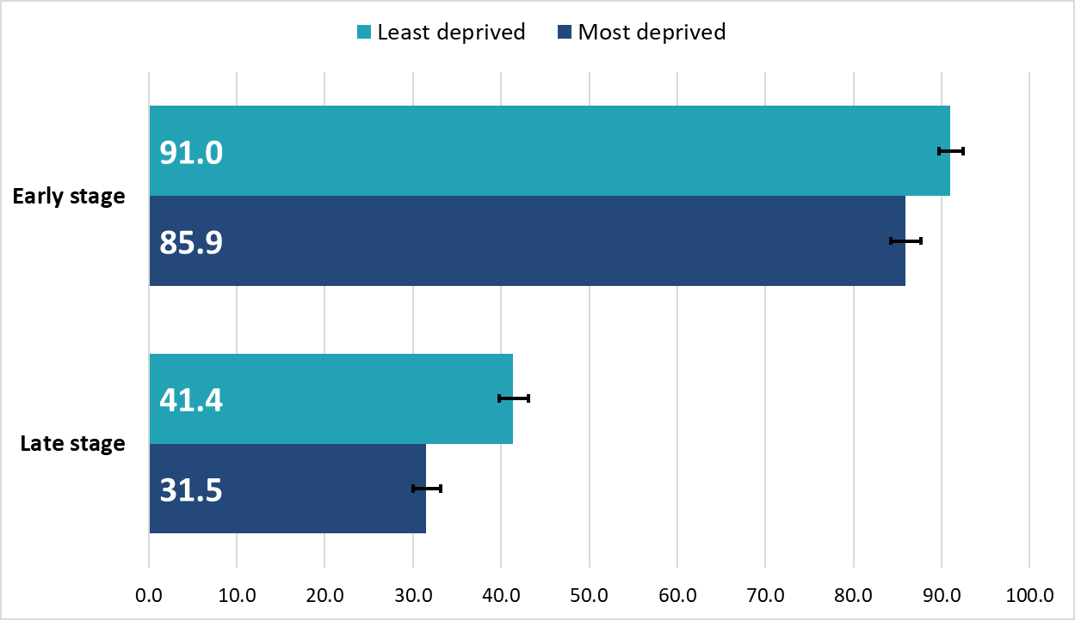
Produced by Public Health Wales, using cancer registration data (WCISU), PHM & MYE) (ONS) and WIMD (WG)

