
Welsh Cancer Intelligence and Surveillance Unit
Official Statistics: Cancer Incidence in Wales, 2002-2022
Note:
- ‘Cancer cases’ refers to ‘All cancers excluding non-melanoma skin cancer (NMSC).’
- ‘Incidence rate’ refers to ‘Age-adjusted incidence rate.’ That is, the annual number of new cases of cancer per 100,000 people, considering the different age-structure in that population compared to other areas and previous years.
- ‘Pandemic’ refers to the year 2020.
- ‘Pre-pandemic’ refers to years 2018-2019.
- ‘Early stage’ is defined as Stage 1 and Stage 2 diagnoses combined.
- ‘Late stage’ is defined as Stage 3 and Stage 4 diagnoses combined.
Headlines
For the first time, we are reporting on stage at cancer diagnosis by area deprivation. We are also reporting on neuroendocrine cancers (NENs) and small cell lung cancers (SCLC).
New cases of cancer increased by 18% in 2022 (21,006 cases) compared to the pandemic’s first year (17,858 cases in 2020). By 2022, the number of new cases was higher than before the pandemic (annual average 20,472 cases for 2018-2019). This could suggest the beginning of a return to pre-pandemic trends (Figure 1), along with a rebound of some of the delayed cases that were not detected during the pandemic.
The number of new cases of cancer increased by almost a third (31%) in just over two decades (from 2002 to 2022). This was an average annual increase of 1.5% (Figure 1).
The incidence rate was 20% higher in the most deprived areas compared to the least deprived areas in 2022 (Figure 2). This 20% gap has remained since 2006.
Over half of all cancer cases in 2022 were in people aged 70 and over. This pattern has remained throughout the years we report on (2002-2022). The aging profile of the Welsh population explains our findings; getting older is the main risk factor for developing most cancers.
The lasting effects of the pandemic may continue to influence incidence trends in the coming years. We will continue to monitor and report on these developments as they evolve.

Stage at diagnosis by area deprivation
As deprivation increased from the least to the most deprived fifth (20%) of areas in Wales, the proportion of later-stage diagnoses also increased, with a higher proportion of late-stage diagnoses compared to early-stage in the most deprived areas between 2011 and 2022 (Figure 3).
The incidence rate of early-stage cancer diagnoses decreased during the pandemic in 2020 across all area deprivation fifths, whilst the rate of late-stage diagnoses remained slightly more stable. This appears to start recovering in the years following (2021-2022), with the rate of both early and late-stage diagnoses increasing across nearly all deprivation fifths, with a stronger recovery in early-stage rates.
Lung and colorectal (bowel) cancer
The overall incidence rate for lung cancer was 2.3 times higher in the most deprived fifth of areas, compared to the least deprived in 2022. The rate of late-stage lung cancer diagnoses is considerably higher than early-stage across all areas of deprivation (Figure 4).
In the most deprived areas, the late-stage lung cancer incidence rate was 2.3 times higher than for early-stage in 2022. In comparison, in the least deprived areas, the late-stage incidence rate was 2 times higher than early-stage. When we compare the late-stage incidence rate in the most deprived areas to the late-stage rate in the least deprived areas in 2022, it is 2.6 times higher in the most deprived areas. (Figure 4).
Similarly to lung cancer, colorectal cancer had a higher rate of late-stage diagnoses compared to early-stage across all area deprivation fifths in Wales throughout 2011-2022 (Figure 5). The gap in rates between early and late-stage diagnoses widened as the level of area deprivation increased in 2022.
Female breast and prostate cancer
In contrast to the later-stage profile of lung and colorectal cancer diagnoses, female breast cancers and prostate cancers tend to be diagnosed at an earlier stage.
In 2022, 72% of women who were diagnosed with breast cancer were diagnosed at an early stage. This was similar across all deprivation fifths throughout the reporting period (2011-2022) (Figure 6).
The number of prostate cancers diagnosed dropped by 23% during the pandemic before starting to increase from 2021 onwards across all stages and area deprivation fifths. However, the rate of men diagnosed at later stages overtook earlier-stage in the most deprived fifth in 2021 and 2022, whilst men in lesser deprived fifths had higher rates of early-stage diagnoses (Figure 7).

Neuro-endocrine cancers (NENs) and small cell lung cancer (SCLC)
In 2022, there were 359 cases of epithelial NENs (excluding SCLC) and 231 cases of small cell lung cancer in Wales. This equates to incidence rates of 11 cases and 7 cases per 100,000 persons, respectively.
Between 2016 and 2022, small cell lung cancer made up on average 9.5% of all lung cancer cases in Wales annually.
The rate of epithelial NENs followed a similar trend to other cancer types during the pandemic, with the rate dropping before starting to recover in the following years (Figure 8).
Similar to some other cancer types, the incidence rate of epithelial NENs was higher in the most deprived fifth compared to the least deprived between 2016 and 2022 (Figure 9).

Useful links
Please find our cancer incidence statistics on our Cancer Reporting Tool here.
Non-melanoma skin cancer (NMSC) incidence is reported separately and can be found here.
For more information on the methodology used in cancer incidence official statistics and the new stage at diagnosis by area deprivation analysis, please see the technical guide here.
For more information on neuro-endocrine cancers, visit the Cancer Research UK website here: Neuroendocrine cancers | Cancer Research UK
This document is also available in Welsh here (LINK).

Appendix

Figure 1: Trends in the annual number of new cases of cancer.
All cancers excluding NMSC, count, persons, all ages, Wales, 2002-2022
Produced by Public Health Wales, using cancer registration data (WCISU)
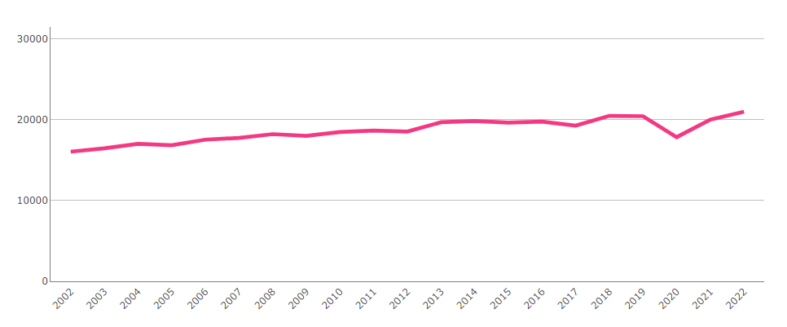

Figure 2: Trends in cancer incidence rates by area deprivation fifth.
All cancers excluding NMSC, European age-standardised rate, persons, all ages, Wales, 2002-2022
Produced by Public Health Wales, using cancer registration data (WCISU), mid-year estimates (MYE) (ONS) and Welsh Index of Multiple Deprivation (WIMD) (WG)
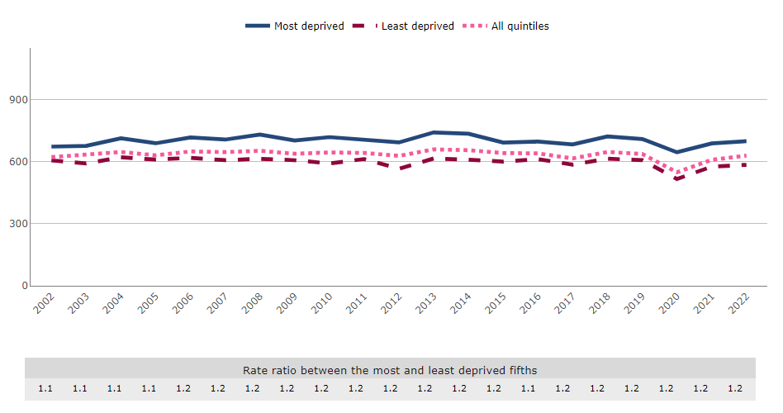

Figure 3: Trends in the proportion of early and late-stage diagnoses by area deprivation fifth.
All stageable cancers, proportion (%), persons, all ages, Wales, 2011-2022
Produced by Public Health Wales, using cancer registration data (WCISU), MYE (ONS) and WIMD (WG)
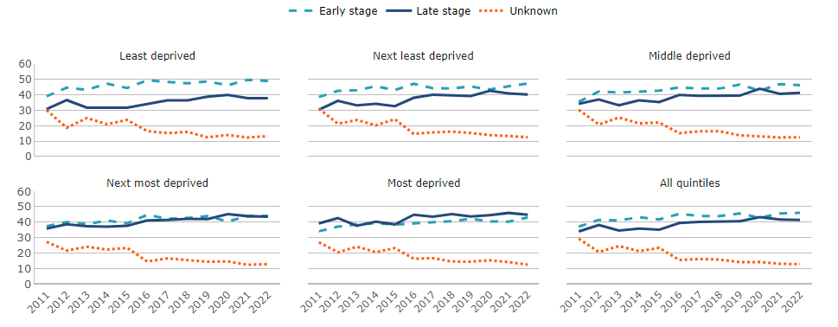

Figure 4: Trends in lung cancer incidence rates by stage at cancer diagnosis and area deprivation fifths.
Lung cancer, European age-standardised rate, persons, all ages, Wales, 2011-2022
Produced by Public Health Wales, using cancer registration data (WCISU), MYE (ONS) and WIMD (WG)
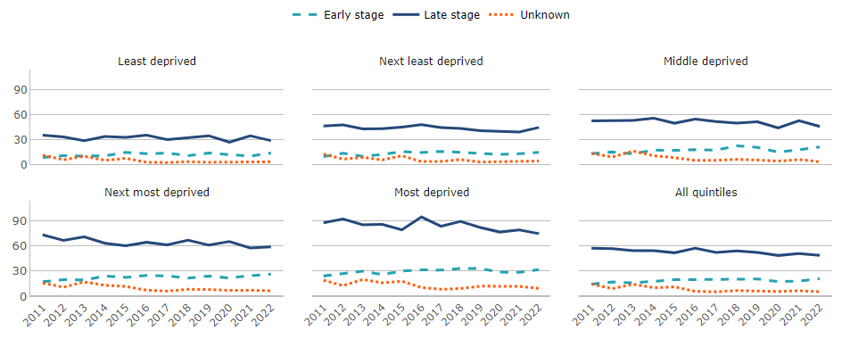

Figure 5: Trends in colorectal cancer incidence rates by stage at cancer diagnosis and area deprivation fifths.
Colorectal cancer, European age-standardised rate, persons, all ages, Wales, 2011-2022
Produced by Public Health Wales, using cancer registration data (WCISU), MYE (ONS) and WIMD (WG)
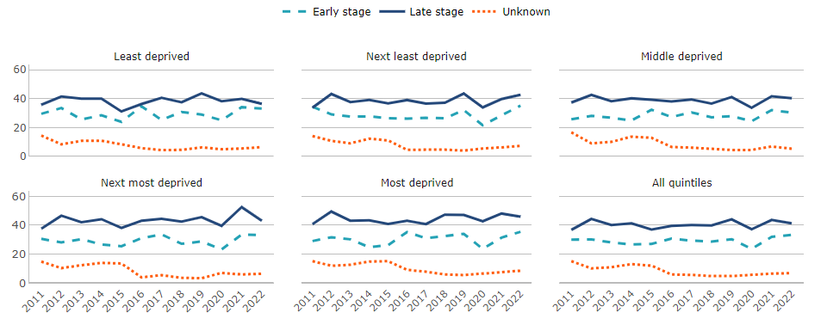

Figure 6: The proportion of early and late-stage diagnoses of female breast cancer by area deprivation fifth in 2022.
Breast cancer, proportion (%), women, all ages, Wales, 2022
Produced by Public Health Wales, using cancer registration data (WCISU), MYE (ONS) and WIMD (WG)

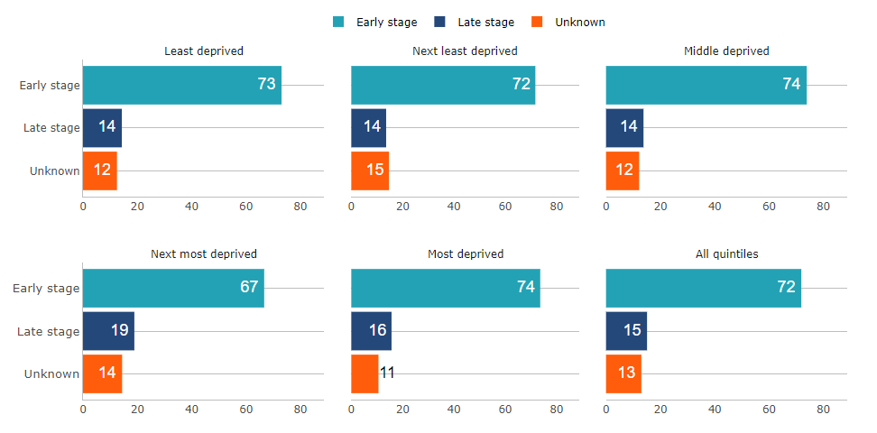

Figure 7: Trends in prostate cancer incidence rates by stage at cancer diagnosis and area deprivation fifths.
Prostate cancer, European age-standardised rate, men, all ages, Wales, 2011-2022
Produced by Public Health Wales, using cancer registration data (WCISU), MYE (ONS) and WIMD (WG)
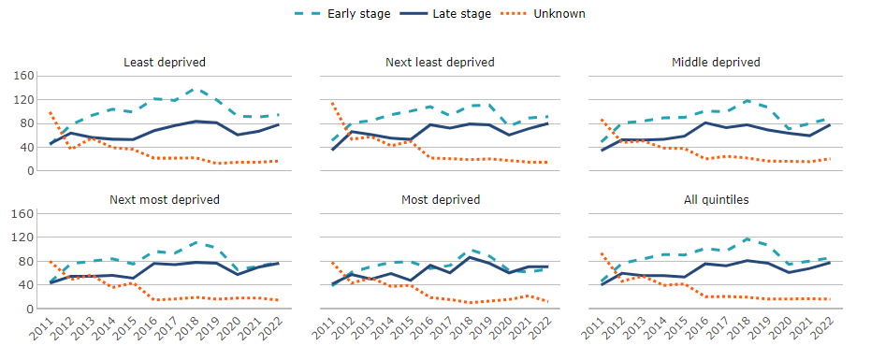

Figure 8: Trends in the epithelial neuro-endocrine cancer (excluding small cell lung cancer) incidence rate.
Epithelial NEN excluding SCLC, European age-standardised rate, persons, all ages, Wales, 2016-2022
Produced by Public Health Wales, using cancer registration data (WCISU), MYE (ONS) and WIMD (WG)
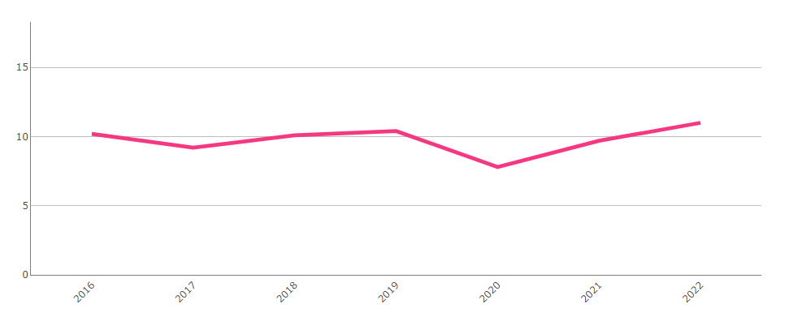

Figure 9: Trends in the epithelial neuro-endocrine (excluding small cell lung cancer) incidence rate by area deprivation fifth.
Epithelial NEN excluding SCLC, European age-standardised rate, persons, all ages, Wales, 2016-2022
Produced by Public Health Wales, using cancer registration data (WCISU), MYE (ONS) and WIMD (WG)
