








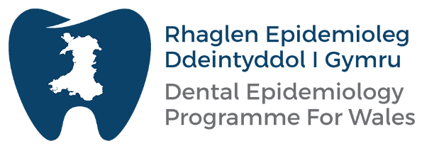
Add Partner Logos
(White versions preferred)
Main Title
Subtitle
Version 1.0
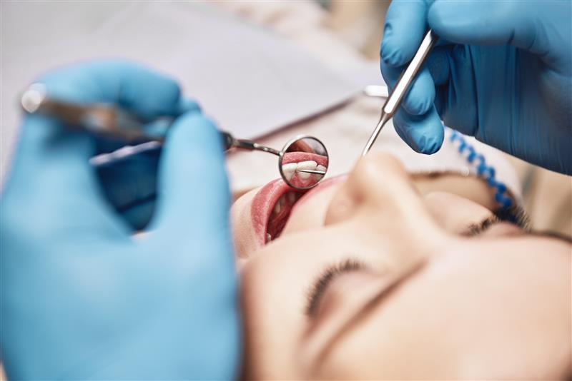
Oral health of 5-year-old children in Wales 2022-23: Summary
Oral Health Intelligence, Public Health Wales
Welsh Oral Health Information Unit, Cardiff University
January 2024
Version 0.3

This is a summary of the NHS Wales Dental Epidemiological Programme’s inspection of school year one (five-year-old) children undertaken across Wales in 2022-23. Data was collected by the NHS Community Dental Service teams within each Local Health Board and analysed by the Welsh Oral Health Information Unit at Cardiff University in conjunction with Oral Health Intelligence at Public Health Wales. Further information can be found in the Technical Report ‘Picture of Oral Health 2023’, published by the Welsh Oral Health Information Unit, Cardiff University.

Acknowledgements

Public Health Wales would like to extend our gratitude to all the schools that agreed to participate and facilitate the survey. Equally, we would also like to thank all the Community Dental Service teams in each Health Board for all their hard work in contacting the schools and collecting the data.

Contents:

1-Summary…………………………………………………………….. 3

2-Background………………………………………………………… 4

3-Wales
a-Prevalence of dental caries…………………………………. 5
b-Severity of dental caries…………………………………….. 5
c-Deprivation and oral health inequality……………………. 6

4-Health Board data
a-Prevalence of dental caries…………………………………. 7
b-Severity of dental caries…………………………………….. 7

5-Unitary Authority data…………………………………………….. 8

6-Impact of Dental Disease…………………………………………. 8

1-Summary
The prevalence and severity of dental caries in school year one children (aged 5-6 years) continues to fall across Wales. In 2007/08, 14 out of a class of 30 children would have decay experience and these 14 children would have an average of 4.2 teeth affected. In 2022/23, this had fallen to 10 children out of a class of 30, with an average of 3.38 teeth affected. However, the extent of the reduction in prevalence appears to be levelling off, with no statistically significant difference between the surveys in 2015/16 and 2022/23 at a national level. In terms of severity, there has been a statistically significant fall in the number of teeth affected by the disease across Wales between 2015/16 and 2022/23.

Prevalence of dental caries experience ranges from 19.6% in Powys THB to 44.0% in Cwm Taf Morgannwg UHB. Since 2015/16 there has been a reduction in prevalence in Aneurin Bevan UHB and Powys THB, no change in Betsi Cadwaladr UHB and Hywel Dda UHB and an increase in Cardiff and Vale UHB. Due to the Bridgend County Borough Council area change, it is not possible to interpret changes in disease prevalence in Cwm Taf Morgannwg and Swansea Bay UHB.

The severity of dental caries ranges from 0.64 in Powys THB to 1.54 in Cwm Taf Morgannwg UHB. Since 2015/16 there has been a reduction in Aneurin Bevan UHB and no change in Powys THB, Betsi Cadwaladr UHB, Hywel Dda UHB and Cardiff and Vale UHB. Again, due to the Bridgend County Borough Council area change, it is not possible to interpret changes in disease severity in CTMUHB and SBUHB

The prevalence and severity of dental caries continue to follow a social gradient, with those from the most deprived areas more likely to experience the disease and have more teeth affected.
The 2022/23 survey was the first since the COVID pandemic. As such, the data collected would be from children who were born in 2016/17 and so would have been approximately three years of age at the time of the pandemic. Given this, it is difficult to infer whether COVID had an impact on the prevalence and severity of dental caries collected in 2022/23 and a repeat of the survey is recommended in 2024/25.

Dental caries has at least one or more impacts in 18.4% of children across Wales (approaching 1 in 5 children), when measured by the Early Childhood Oral Health Impact Scale. The prevalence of one or more child or family impacts varied between 14.6% in Hywel Dda UHB to 19.6% in Betsi Cadwaladr UHB.

2-Background
Surveys of 5-year-old (school year one) children provide detailed data on oral health need for surveillance, service planning and evaluation. They also provide valuable information in relation to the Well-being of Future Generations (Wales) Act. This is the fifth survey since positive ‘opt-in’ consent was implemented.

The NHS Dental Epidemiological Programme for Wales is the responsibility of Public Health Wales, Oral Health Information Unit at Cardiff University and Local Health Boards. The Welsh Government mandates Public Health Wales to conduct the programme under Welsh Health Circular WHC (2021) 32: Role and Provision of Dental Public Health in Wales. Community Dental Services based in Health Boards in Wales are mandated by the Welsh Government to conduct the data collection for the programme under Welsh Health Circular WHC (2022) 22: Role of the Community Dental Service. All-Wales co-ordination is undertaken by the Dental Epidemiology Co-ordinator for Public Health Wales. The sampling frame, data cleaning, analysis and reporting undertaken by the Welsh Oral Health Information Unit at Cardiff University.

The objectives of the NHS Dental Epidemiology Programme for Wales inspection of school year one (5-year-old) children were to:

- Record data, from a sample of school year one children in Wales in the school terms, Winter 2022/2023 and Spring 2023;

- Obtain valid estimates of caries prevalence and severity in school year one children which will be comparable with recent previous surveys
The survey followed the guidance from the British Association for the Study of Community Dentistry (Pitts et al., 1997; Pine et al., 1997a; Pine et al.,1997b). The results are presented to highlight changes in the prevalence and severity of dental caries across Wales, Health Boards and Unitary Authorities. The summary uses the term d3mft to describe dental caries in deciduous teeth that were either decayed (into dentine), extracted or filled due to caries. More detailed information is provided by the Technical Report produced by the Welsh Oral Health Information Unit. Please note that no data was available for Ceredigion for either the prevalence or severity of the disease.

3-Wales
a-Prevalence of dental caries
There has been a reduction in the prevalence of dental caries experience in school year one children from 47.6% in 2007/08 to 32.4% in 2022/23 (this inspection). Although there appears to be reduction between 2015/16 and 2022/23, this was not statistically significant. Figure 1 provides an overview, with the bars spaced to provide a sense of the trend over time.

Figure 1: Prevalence of dental caries experience (%d3mft>0) in school year one children 2007/08 to 2022/23

b-Severity of dental caries
Figure 2 provides the details of the observed severity of dental caries across Wales. This records the mean number of teeth that either have active disease, a filling or have been extracted (d3mft). There has been a reduction in the average number of teeth affected by dental caries from 1.98 in 2007/08 to 1.11 in 2022/23. There has also been a decrease between 2015/16 and 2022/23.

Figure 2: Severity of dental caries (d3mft) in school year one children 2007/08 to 2022/23

c-Deprivation
The prevalence of dental caries experience (%d3mft>0) follows a social gradient, with more disease being experienced by those from the deprived backgrounds (Figure 3). Across most quintiles of the Welsh Index of Multiple Deprivation the data shows an overall reduction when compared to earlier surveys, but the pattern of distribution in 2022/23 remains similar. Equally, the severity of dental caries follows a social gradient (Figure 4).

Figure 3: Prevalence of dental caries experience (%d3mft>0) by the Welsh Index of Multiple Deprivation (2019) Quintile 2007/08 to 2022/23

Figure 4: Severity of dental caries by the Welsh Index of Multiple Deprivation (2019) quintile 2007/08 to 2022/23

4-Health Board
a-Prevalence of dental caries
The prevalence of dental caries experience ranges from 19.6% in Powys THB to 44.0% in Cwm Taf Morgannwg UHB. Since 2015/16 there has been: 1) a reduction in the prevalence of disease in Aneurin Bevan UHB and Powys THB; 2) no change in Betsi Cadwaladr UHB and Hywel Dda UHB; and 3) an increase in Cardiff and Vale UHB. Due to the Bridgend County Borough Council area change, it is not possible to interpret changes in disease prevalence in Cwm Taf Morgannwg UHB (formerly Cwm Taf UHB) and Swansea Bay UHB (formerly Abertawe Bro Morgannwg UHB).

Figure 5: Prevalence of dental caries experience (% d3mt>0) by Local Health Board 2007/08 to 2022/23

b-Severity of dental caries
Figure 6 highlights the severity of dental caries across the Health Boards. The average number of teeth with dental caries experience (d3mft) ranges from 0.64 in Powys THB to 1.54 in Cwm Taf Morgannwg UHB. Since 2015/16 there has been a reduction in the severity of disease in Aneurin Bevan UHB and no change in Betsi Cadwaladr UHB, Cardiff and Vale UHB, Hywel Dda UHB and Powys THB. Due to the Bridgend County Borough Council area change, it is not possible to interpret changes in disease severity in Cwm Taf Morgannwg UHB (formerly Cwm Taf UHB) and Swansea Bay UHB (formerly Abertawe Bro Morgannwg UHB). Further detail is available in the Technical Report.

Figure 6: Severity of dental caries by Health Board (mean number of d3mft)

5-Unitary Authority
Figures 7 and 8 show the distribution of the prevalence of dental caries (% d3mft>0) and the severity of the disease across the Unitary Authorities in Wales. Dental caries prevalence ranges from 17.8% in the Vale of Glamorgan to 50.2% in Merthyr Tydfil. Severity ranges from 0.42 in the Vale of Glamorgan to 1.90 in Merthyr Tydfil.

6-Impact of Dental Disease
Table 1 highlights the reported impact that dental disease had on the participating children using the Early Childhood Oral Health Impact Scale (Pahel et al., 2007). The prevalence of one or more child or family impacts varied between 14.6% in Hywel Dda UHB to 19.6% in Betsi Cadwaladr UHB. Across Wales, 18.4% of those surveyed had one or more impacts due to the disease (approaching 1 in 5 children).

Figure 7: Choropleth of the prevalence of dental caries (%d3mft>0) across Wales 2022/23
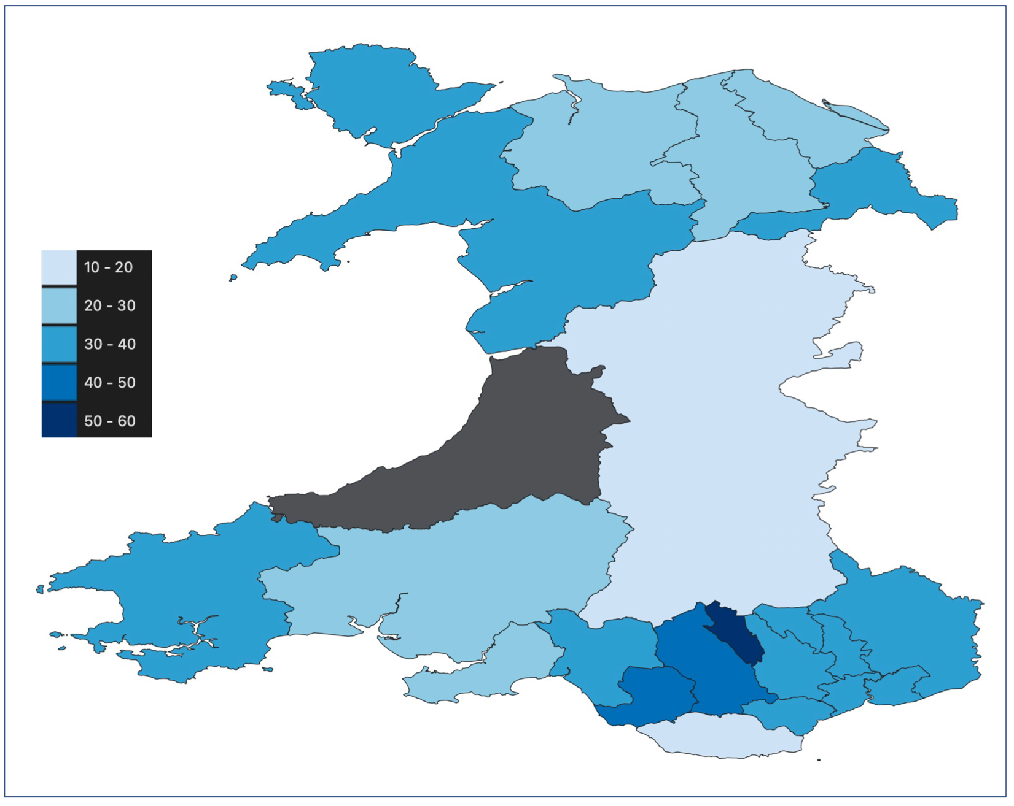

Figure 8: Choropleth of the severity of dental caries across Wales 2022/23
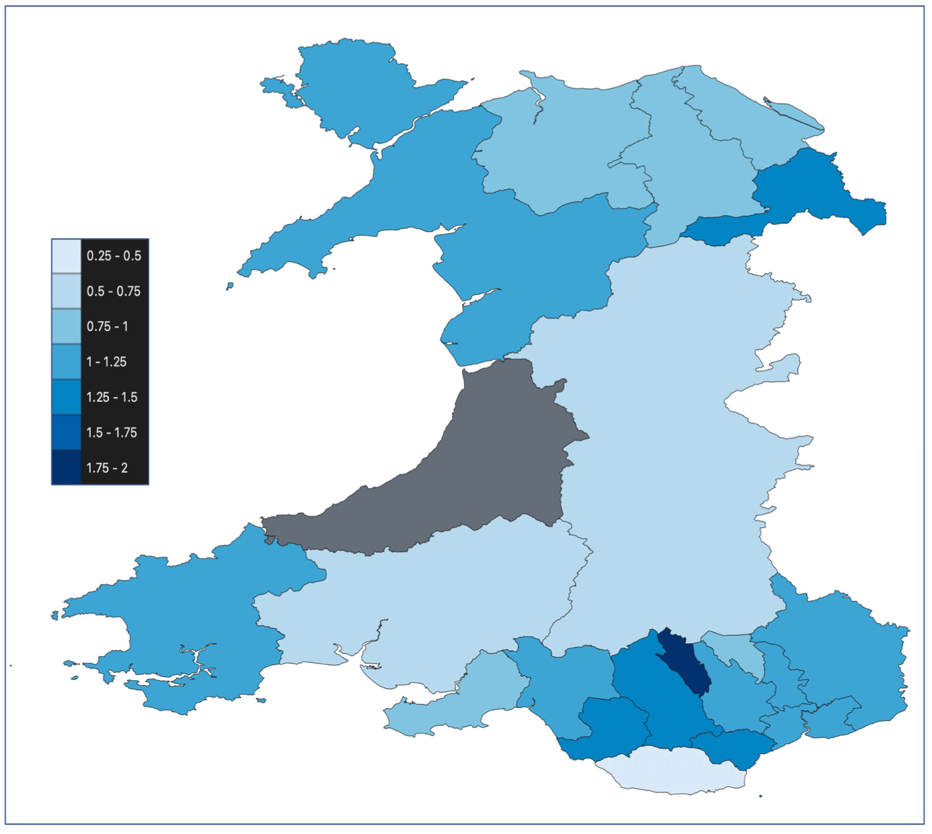

Table 1: Impact of dental caries on participating children

 | Prevalence (%)
 | One or more child impacts | One or more family impacts | One or more child or family impacts
Aneurin Bevan UHB | 15.7% | 9.8% | 19.2%
Betsi Cadwaladr UHB | 16.4% | 10.0% | 19.6%
Cardiff and Vale UHB | 16.7% | 8.5% | 19.5%
Cwm Taf Morgannwg UHB | 14.4% | 7.9% | 17.0%
Hywel Dda UHB | 11.9% | 7.9% | 14.6%
Powys THB | 12.4% | 8.8% | 17.0%
Swansea Bay UHB | 16.5% | 7.9% | 18.6%
WALES | 15.4% | 8.9% | 18.4%

References
Pahel BT, Rozier RG, Slade GD. Parental perceptions of children's oral health: the Early Childhood Oral Health Impact Scale (ECOHIS). Health and quality of life outcomes. 2007 Dec;5:1-0.

Pine CM, Pitts NB, Nugent ZJ. British Association for the Study of Community Dentistry (BASCD) guidance on sampling for surveys of child dental health. A BASCD coordinated dental epidemiology programme quality standard. Community Dent Health. 1997 Mar;14 Suppl 1:10-7. PMID: 9114554.

Pine CM, Pitts NB, Nugent ZJ. British Association for the Study of Community Dentistry (BASCD) guidance on the statistical aspects of training and calibration of examiners for surveys of child dental health. A BASCD coordinated dental epidemiology programme quality standard. Community Dent Health. 1997 Mar;14 Suppl 1:18-29. PMID: 911455

Pitts NB, Evans DJ, Pine CM. British Association for the Study of Community Dentistry (BASCD) diagnostic criteria for caries prevalence surveys-1996/97. Community Dent Health. 1997 Mar;14 Suppl 1:6-9. PMID: 9114553.
Gweithio gyda'n gilydd
i greu Cymru iachach
Working together
for a healthier Wales

