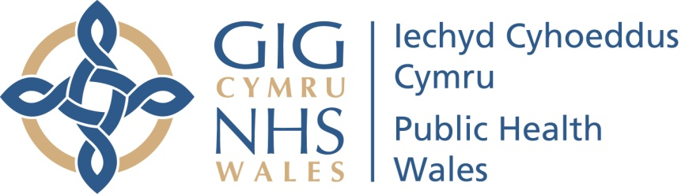

The Pre-release Access to Official Statistics (Wales) Order 2009
Declaration as to persons granted pre-release access to official statistics
Child Measurement Programme for Wales, 2016/17 school year
Published 19th April 2018, 9.30 a.m.
Pre-release access to this release of official statistics was granted for a period of five working days prior to the date of publication, to those people in the positions / organisations listed below:
Public Health Wales
- Director of Health and Wellbeing
- Natalie Field – Consultant in Public Health – ‘Every Child’ lead
- Chris Jones – Communications Officer
- James Field – Communications manager
- Stacey Oliver – Cowshed Communications
NHS Wales Health Boards
- Alison Merry, Consultant in Public Health – Powys Teaching Health Board
- Siobhan Adams, Consultant in Public Health – Betsy Cadwaladr University Health Board
- Suzanne Wood, Consultant in Public Health Medicine – Cardiff and Vale University Health Board
- Judith Tomlinson – Consultant in Public Health – Abertawe Bro Morgannwg University Health Board
Welsh Government
- Cabinet Secretary for Health and Social Service
- Chief Medical Officer
- Nathan Cook, Head of Healthy and Active branch, Public Health Division
- Irfon Rees, Deputy Director for Public Health
- Chris Roberts, Health lead – Knowledge and Analytical Services
- Rebekah Tune – Communications

