Appendix B

RISK ASSESSMENT - REGISTERED HEALTHCARE PRACTITIONER CONCERNS

NAME:
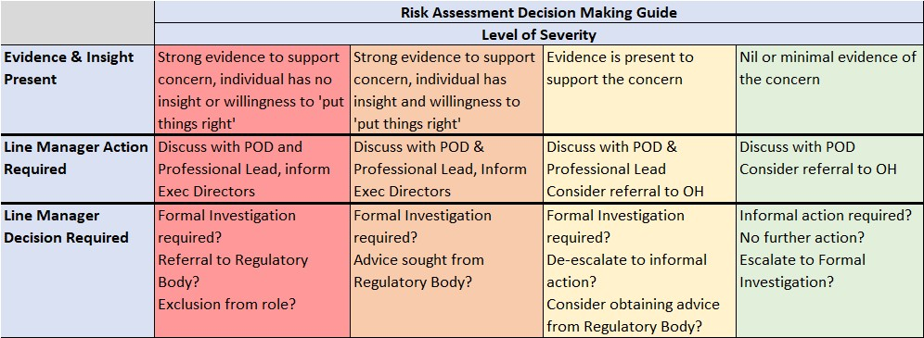
Risk Assessment Decision Making Guidance

For each of the five categories listed in the risk assessment score sheet, you should carefully consider the evidence/concern and determine the level of severity using the detailed guidance in the ‘Evidence and Insight present’ detail. Each category should include a robust commentary of the level selected.

Note: Action and Decision should be based on the highest level of severity recorded across any of the categories. Eg, only one of the categories needs to score in the ‘red level of severity’ for the line manager to consider formal investigation, referral to regulatory body, exclusion from role.

Conduct – Conduct refers to the registrant’s attitude or behaviour at work, where the person generally has control over their actions and conduct. Consider if there is a wilfulness from the registrant surrounding the concern. Conduct can include issues with probity, allegations of bullying/harassment, wilful failure to follow recognised practice and organisational policies, authorised absence as well as harm to patients and clients.

Capability – Capability refers to an employee’s skills, ability, aptitude and knowledge in relation to the role they are employed to do. Concern over capability is when an employee is unable to achieve the expected standards of performance due to lack of skill, ability or training. Examples could include poor clinical practice, language difficulties, working below the level expected.

Health – Registered healthcare practitioners should ensure they look after both their physical and mental health and should not undertake activities which they knowingly are unwell enough to perform. They must not put their patients or members of the public at risk because of their own health issues. Example would be non-disclosure of a condition therefore putting patients/public at risk.

Professionalism – Registered healthcare practitioners not only represent their employer but also their Professional Regulatory Body and should practice their profession in line with the requisite standards. Examples could include, inappropriate behaviour, complaints from colleagues/patients, abusing their power and or position, deliberately withholding information, misleading actions.

History – Consider whether this concern is a ‘first time’ occurrence. Is it a repeated occurrence and what was the timespan between. Consider if there is a pattern of behaviour and whether there has been any previous informal/formal action taken.

Risk Assessment Score Sheet

Conduct
Severity Level
Comment
Capability/Competence
Severity Level
Comment
Health
Severity Level
Comment
Professionalism
Severity Level
Comment
History
Severity Level
Comment

Other Concerns/Considerations

Is there a safeguarding issue? Yes/No
If yes, please give details:

Is there Police Involvement? Yes/No
If yes, please give details on the following:
Has a common law notification of police involvement been received for the individual?
Has a professional strategy meeting been convened under section 5 of the Wales Safeguarding Procedures?
What was the outcome?
Was there a recommendation for a referral to a regulatory body?

Should NHS Counter Fraud be contacted? Yes/No
If yes, please give details:

Should the practitioner be excluded from the workplace? Yes/No
If yes, include robust reasons for the decision to exclude:

Could the employee be given support/supervision during the period of any FtP process allowing them to remain in the workplace? Yes/No
Comment required for Yes (describe arrangements) & No answer:

Support services discussed/referred to?
All staff Employee Assistance Programme – Vivup (0800 023 9387) vivup.co.uk (Employee Access Code: 108611)
All healthcare staff – Canopi (0800 058 2738) canopi.nhs.wales
Occupational Health Service - 0300 123 9850
GP

Action Recommended:

Signed: Date:
(Line Manager)

Send a copy of this Risk Assessment to POD and maintain a copy on the employee’s electronic file (held by the Line Manager)

