 |  |  |  | Name of Meeting  Board
Date of Meeting
27/07/2023
Agenda item:
5.2
Well-being Statement 2023
Executive lead: |  | Dr Sumina Azam, National Director of Policy and International Health, World Health Organisation Collaborating Centre.
Author: |  | Ann Jones, Principal in Sustainable Development and Health, in partnership with the Strategy and Planning Team.
Approval/Scrutiny route: |  | Business Executive Team
Purpose
The purpose of the paper is to present our refreshed Well-being statement as a legal response to the Well-being of Future Generation Act (2015):
“Public bodies must publish a statement when setting their well-being objectives explaining why they feel the objective will help them achieve the goals and how it has applied the sustainable development principle. They must also make sure that they involve people interested in achieving the goals and that those people reflect the diversity of their area”.
The Business Executive Team has recommended the Statement to the Board for approval.
The Board are asked to approve the Well-being statement.
Recommendation:
APPROVE | CONSIDER |  | RECOMMEND |  | ADOPT | ASSURANCE
The Board is asked to:
- Approve the Well-being statement.
- Receive assurance that the Long-Term Strategy has been developed through the lens of the Act as demonstrated in the Well-being statement.

Link to Public Health Wales Strategic Plan

Public Health Wales has an agreed strategic plan, which has identified seven strategic priorities and well-being objectives.

This report contributes to the following:
Strategic Priority/Well-being Objective | All Strategic Priorities/Well-being Objectives
Strategic Priority/Well-being Objective | All Strategic Priorities/Well-being Objectives
Strategic Priority/Well-being Objective | All Strategic Priorities/Well-being Objectives
Summary impact analysis

Equality and Health Impact Assessment | An Equality and Health Impact Assessment is not required.
Risk and Assurance | Our Strategic Risks are detailed within Our Strategic Plan.
Health and Care Standards | This report supports and/or takes into account the Health and Care Standards for NHS Wales Quality Themes
Health and Care Standards | Choose an item.
Health and Care Standards | Choose an item.
Health and Care Standards | Choose an item.
Financial implications | Within existing financial resources
People implications | Within existing financial resources

Purpose / situation

The review of our long-term strategy has allowed us to formally assess our existing priorities and refresh our Well-being objectives. The purpose of the well-being objectives is to maximise the organisation’s contribution to achieving each of the seven well-being goals.

The objectives were developed by taking a Well-being of Future Generations ‘lens’ to the organisation’s Long-Term Strategy. The Well-being of Future Generation (WFG) Act is our framework for how we work and what we do, and as such our strategic priorities are also our well-being objectives, shaping our organisation’s work going forward.

The purpose of the paper is to present our refreshed Well-being statement as a legal response to the WFG Act (2015):
“Public bodies must publish a statement when setting their well-being objectives explaining why they feel the objective will help them achieve the goals and how it has applied the sustainable development principle. They must also make sure that they involve people interested in achieving the goals and that those people reflect the diversity of their area”.

The Business Executive Team has recommended the Statement to the Board for approval. The Board are asked to approve the Well-being statement and receive assurance that the Long-Term Strategy has been developed through the lens of the Act as demonstrated in the Well-being statement.

Background

The foundation of the legislative framework around sustainability in Wales is the Well-being of Future Generations Act (2016). The Act requires public bodies in Wales to think about the long-term impact of their decisions, to work better with people, communities and each other, and to prevent persistent problems such as poverty, health inequalities and climate change.
Considering the challenges that Wales is facing now and in the long-term, the review of our long-term strategy in 2023 allowed us to formally assess our existing priorities, including engaging with our key partners and stakeholders. This ensures that our future focus and action is having the biggest impact and delivering maximum value for the people of Wales. The Five Ways of Working, collectively known as the Sustainable Development Principle, have been an instrumental part of reviewing our Long-term Strategy.

- Description/Assessment
The refreshed Well-being Statement 2023, explains how the organisation meets the Well-being goals and how it has applied the Sustainable Development Principle in developing the Long-term strategy. This is to show how the organisation is adopting the approach from the beginning and demonstrates clearly how the organisation is responding to the legal requirements of the WFG Act.

Well-being of Future Generations (Wales) Act 2015

The Well-being Statement clearly demonstrates how the Well-being objectives and the Sustainable Development Principle have been addressed in developing the Long-term strategy. It also highlights some case studies as good practice across the organisation.

The Health and Sustainability Hub was set up in 2016 to support Public Health Wales deliver its organisational response to the WFG Act. The Health and Sustainability Hub continues to champion the WFG Act helping Public Health Wales to embed the Act across the organisation, maximising opportunities to improve health and well-being and reduce inequalities whilst reducing our impact on the planet. The Organisation as a whole meets the legal requirements as below.

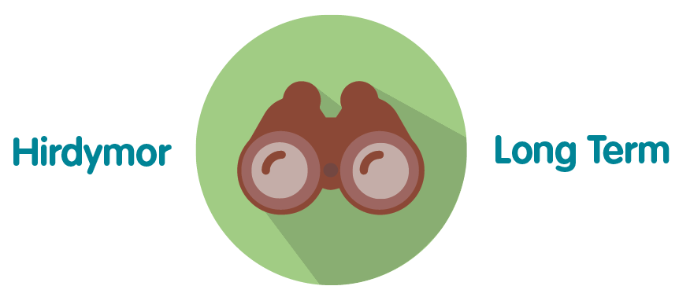 | The organisation’s response to the WFG Act is supporting the delivery of Public Health Wales’  Long Term Strategy and Integrated Medium Term Plan.
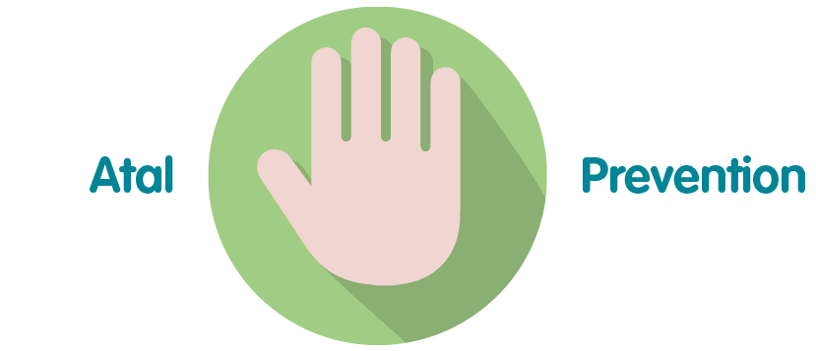 | This response to the WFG Act is paramount to the successful performance of the organisation in order for it to achieve its purpose.
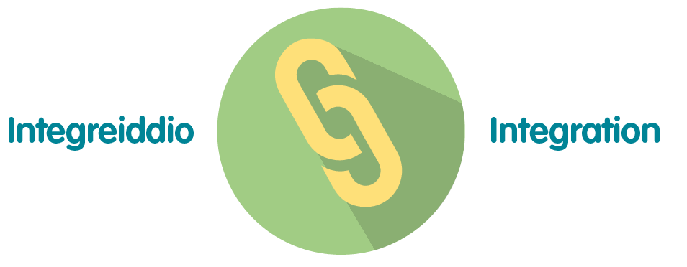 | Public Health Wales’ response to the WFG Act is integrated across the organisation’s Strategic Priorities/Well-being Objectives and Directorates
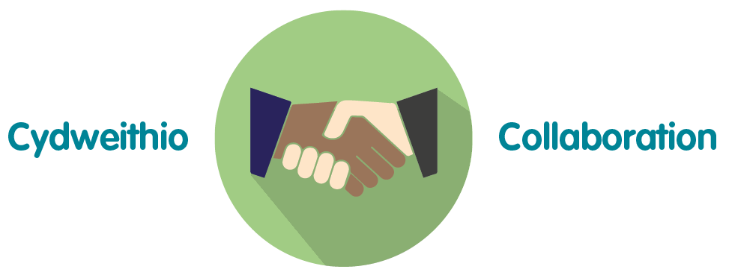 | As described in the report, the organisation is working with a range of collaborations to deliver its response to the WFG Act.
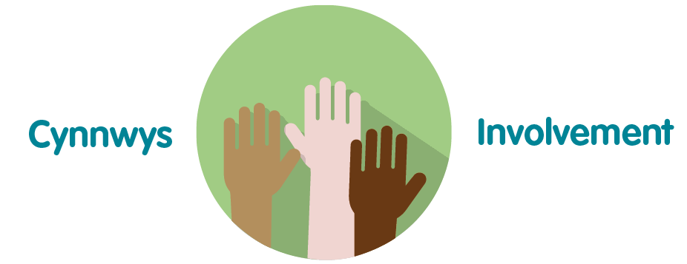 | The delivery of Public Health Wales’ response to the WFG Act has involvement across the full breadth of the organisation.

Recommendation

The Board is asked to:
- Approve the Well-being statement.
- Receive assurance that the organisation is responding to the legal requirements of the WFG Act.

