 |  |  |  |  | Name of Meeting  Board
Date of Meeting
27 July 2023
Agenda item:
4.4
Performance and Insight Report

Executive lead: | Huw George, Deputy Chief Executive/ Executive Director Operations and Finance
Contributors: | Huw George, Deputy Chief Executive and Executive Director of Operations and Finance; Meng Khaw, National Director of Screening & Health Protection; Neil Lewis, Director of People and Organisational Development; Rhiannon Beaumont-Wood, Executive Director of Quality Nursing and Other Allied Health Professionals; Angela Fisher, Deputy Director of Finance; Ioan Francis, Head of Performance
Approval/Scrutiny route: | Business Executive Team (19 July 2023)
Purpose
Our refreshed Month 3 Performance and Insight Report focuses on delivering actionable insights and assurance whilst identifying areas for further improvement across the following key themes;

- Governance and Accountability; including Board and Corporate Governance, Financial Governance, Workforce Governance, Quality and Improvement, and Service Delivery
- Strategy Delivery; including progress against our IMTP Milestones

The report is designed to be read in conjunction with the Performance and Assurance Dashboard. Further planned developments to strengthen our governance arrangements and provide additional assurance to our Board are set out in section 4.

Recommendation:
APPROVE |  | CONSIDER |  | RECOMMEND |  | ADOPT | ASSURANCE
The Board is asked to:

- Discuss and scrutinise the paper and provide feedback and comments.

Link to Public Health Wales Strategic Plan

Public Health Wales has an agreed strategic plan, which has identified seven strategic priorities and well-being objectives.

In order for Public Health Wales to deliver the strategic plan, effective performance management arrangements need to be in place to monitor and report on progress against achieving our strategic priorities to improve health outcomes. This intelligence is used to draw the Board’s attention to areas of underperformance and is fundamental for effective and efficient decision making.

This report contributes to the following:
Strategic Priority/Well-being Objective |  |  | All Strategic Priorities/Well-being Objectives
Summary impact analysis

Equality and Health Impact Assessment |  |  | An Equality and Health Impact Assessment is not required. Equality and Health Impact Assessments will be completed as part of delivery of the specific actions within the Plan.
Risk and Assurance |  |  | Our Strategic Risks are detailed within Our Strategic Plan and the Implementation Plan for the Test Trace Protect Strategy.
Health and Care Standards |  |  | This report supports and/or takes into account the Health and Care Standards for NHS Wales Quality Themes
 |  |  | All themes
Financial implications |  |  | An update on the organisation’s financial performance is enclosed
People implications |  |  | An update on the organisation’s people performance is enclosed

- Purpose / Situation

Our refreshed Month 3 Performance and Insights Report focuses on delivering actionable insights and assurance whilst identifying areas for improvement across the following key themes;
  - Governance and Accountability; including Board and Corporate Governance, Financial Governance, Workforce Governance, quality and improvement, and service delivery
  - Strategy Delivery; including progress against our IMTP milestones

This approach supports the Board and its Committees in discharging their responsibilities. The reporting of the key themes will see us continue to align with the Welsh Government’s A Healthier Wales quadruple aims and key measures set out in the 2022/23 NHS Wales Performance Framework.
The report is designed to be read in conjunction with the Performance and Assurance Dashboard (PAD) and the Public Health Rapid Overview Dashboard.
Further developments to provide additional assurance to our Board are set out in section 4.
- Background

Access to high quality, timely and robust performance information is essential in providing assurance to our Executive Team, Board and its Committees on our progress since the COVID-19 pandemic, delivery of public health services and functions, and our role in improving population health and well-being.
Having strengthened our performance reporting arrangements during the COVID-19 pandemic through the successful development and implementation of the PAD and the accompanying Performance and Insight Report, further work is in train to develop our suite of products further with the aim of providing additional assurance to our Board and to support decision making.
The June 2023 PAD can be accessed using the following Link, or by navigating from specific areas of interest in the report by selecting the following symbol , thus enabling direct access to the latest available performance information.
- Description/Assessment

Key points to consider in this month’s Performance and Insight Report are:
Governance and Accountability
- Following submission of the draft 2022-23 Annual Accounts to Audit Wales and Welsh Government on 5 May, Audit Wales issued an unqualified (clean) audit opinion on the accounts and there are no uncorrected misstatements. All Statutory Financial Duties and Administrative Requirements were met by the Trust.
- Six Internal Audits were finalised over the past quarter and reported to the Audit and Corporate Governance Committee (ACGC). Four External Audits were also received and considered by the ACGC. Actions from both Internal and External Audit Reports will be included in the Audit Action Tracker and the implementation of actions will be monitored by ACGC going forward.
- Our cumulative reported position at Month 3 2023/24 is a net surplus of £63k, with an anticipated breakeven position at year-end. The month 3 revenue position is being supported by £2.865m of non-recurrent COVID-19 funding.
- Our capital funding for 2023/24 is made up of £1.233m discretionary funding and £0.576m strategic funding, with an overall capital allocation for 2023/24 of £1.809m. Strategic capital includes £0.340m for decarbonisation schemes and £0.185m for fire compliance works, approved by the Estates Funding Advisory Board (EFAB). These bids were approved on the basis of a 30% contribution, £0.158m, from Public Health Wales’ discretionary capital funding.
- Performance on our Public Sector Payment Policy remains above statutory target at 96.91% (97.27% in month 3) and is expected to continue to exceed the 95% target for the remainder of the year. Year to date agency spend as a percentage of total pay equates to 2.5% with a year-end forecast of 2.5%.
- Sickness absence slightly decreased over the latest reporting period, with the rolling 12-month figure also decreasing at 4.22%. Short term sickness absence accounted for 74% of absences in June 2023, higher than the previous month.
- Compliance with the core suite of statutory and mandatory training remained above the 85% Welsh Government target at 91.15%, whilst appraisal compliance was reported at 72% in June 2023, up from 70% compared to the previous two months.
- The final notice from the Welsh Language Commissioner relating to the investigation associated with our websites was received on 9 June. We are continuing to liaise with departments to address and correct the issues raised and develop processes to avoid future issues. We are also looking at options for translation of all future web content, and quality assurance/audit processes to ensure consistency of the quality, and safeguard against problems arising in future.
- The Childhood Vaccinations in Wales Annual Report 2023 has been published and shows that although uptake in younger children remains broadly positive, there has been a slight decreasing trend over the previous two years.
- The new HCAI dashboards for 2023/24 was published in late June 2023, with the normal reporting schedule resumed from July 2023. Historical Financial Year data from 2010/11 will be included in a separate dashboard to be published next month. Reduction expectation progress will also be added once the WHC has been published.
- Four new Diabetic Eye screening locations in Aneurin Bevan have been secured which supports offer locally. For Newborn Hearing, clinics offered from the new screening centre in Llanishen have been well received, whilst a new Aneurysm Screening venue has been secured in Pontypool which will improve accessibility.
- One formal complaint was received in June 2023 relating to Diabetic Eye Screening Wales and the dissatisfaction with the lack of screening venues in the service user’s local area. The complaint was acknowledged within the two working day timeframe and is now under investigation. The two formal complaints received in May 2023 have been acknowledged and responded to within the 30-working day target.

Strategy Delivery
- Month 3 of IMTP 2023/24 reporting shows over 92% of all milestones are currently reported as on track or complete (down 0.7% from last month). There were an additional 40 milestones completed, bringing the total complete to 54 milestones, 16.8% of the plan. The profile of the plan over the full year shows that 83% of milestones due to be delivered in Quarter 1 are now complete. The remaining 9 milestones are either awaiting requests for change (RFC) approval or will be delivered later than expected.
- Thirteen requests for change were received in month three (see Annex for further detail). Two requests to suspend milestones require additional attention due to their importance. Six requests for a date change and five for a scope and date change, one of which pushes delivery to March 2025.
- So far this year 9% of milestones have received an RFC, an average of 10 per month. There have been 23 milestone date changes, moving delivery to later in the year. In summary, 12 milestones moved out of Quarter 1 to later in the year, and each of the remaining quarters have a net increase in milestones. If this continues at the same rate, 25% of all milestones will be delivered later than planned, causing significant challenges in later months.
- On average, an RFC to change the delivery date is requested 2.7 months before the original delivery date of the milestone. This, along with the fact that 92% of milestones reported as red, were reported as green in the previous month shows a lack of medium-term planning to identify risk and take action early and could mean missed opportunities to mitigate delays and further delaying the plan overall.
- Quarter 2 is the second largest period for milestone delivery after Quarter 4, with 23% of milestones due. Currently, 85.4% of Quarter 2 milestones are reporting as on track or complete, with the remaining 14.6% already at risk.

Further insights from the Performance and Assurance Dashboard can be found on pages 2-3, namely Key Performance and Insights Summary.
Performance and Assurance Dashboard (not publically available)
https://phw-tableau.cymru.nhs.uk/t/CorporateAnalyticsPreProduction/views/RecoveryDashboardLandingPage/LandingPage?:linktarget=_self&:embed=yes#1

Public Health Rapid Overview Dashboard (not publically available)
Public Health Rapid Overview Dashboard

- Future Developments

Having strengthened our performance reporting arrangements during the COVID-19 pandemic through the successful development and implementation of the PAD and the accompanying Performance and Insight Report, further work is in train to develop our suite of products further with the aim of providing additional assurance to our Board and to support effective decision making.
Planned improvements for the end of Quarter 2 2023/24 include a refreshed user focused PAD, phase 2 developments to the supporting insights report to capture a greater breadth of performance information across the organisation, and increased alignment of our reporting to our Board Committees.
Following the release of the NHS Wales Performance Framework 2023/24 by Welsh Government, an appraisal will be undertaken by the Performance and Value Team to ensure compliance with the key reporting measures that are applicable to Public Health Wales.
Governance arrangements will also be further strengthened over the coming months with the establishment of new Strategic and Technical groups to support the development and implementation of performance management and reporting arrangements beyond those initially planned for Quarter 2 2023/24.
In addition, as part of the development of the Board Assurance Framework, work is ongoing to map the areas of the PAD to the Board level assurance arrangements, and to consider how we can reflect the assurance considered at Committee level. This will include mapping across the elements of the PAD to the Committee’s work plans to provide a full assurance picture to the Board for each area and will identify any gaps in assurance / reporting arrangements.
Whilst this work is ongoing, we have added reference to the remit area for each of the themes within the Performance and Insight Report, to signal where the Board/Committee level assurance sits in terms of the Committee remits, which we will then use as a basis for the review of Board level assurance.

- Well-being of Future Generations (Wales) Act 2015

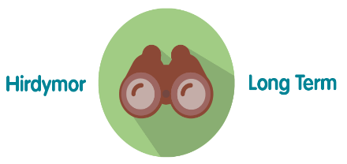 | Ensures Public Health Wales is able to successfully monitor the delivery of its functions; assess areas of underperformance; and can use this intelligence and knowledge to aid decision making.
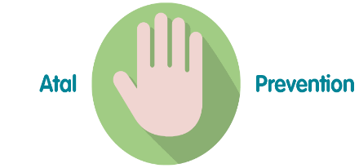 | Effective and efficient decision making by senior managers, Executive Team and the Board is paramount to successful performance of the organisation in order for it to achieve its purpose, whilst preventing the potential to cause harm through underperformance.
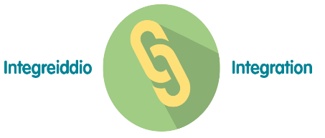 | The development of Public Health Wales’ Long Term Strategy and Integrated Medium Term Plan has been grounded in collaboration and integration across our workforce. To demonstrate that the organisation is achieving what it set out to achieve over the short, medium and long term, high quality monitoring and reporting of information is essential through the integrated performance report. This approach has been reflected in the approach to the pandemic response.
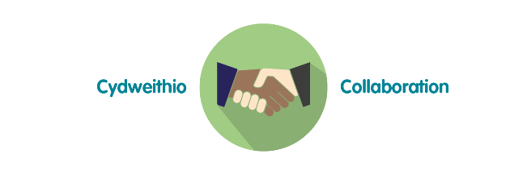 | Reporting of data and information through the integrated performance report requires collaboration across the organisation to ensure timely delivery of key service, quality, workforce and financial data. The potential for the development of business intelligence tools will require close working relationships with Directorates and especially Informatics to maximise potential.
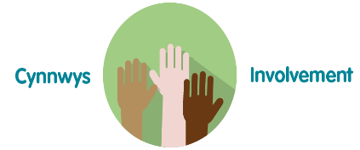 | To ensure compliance with the Welsh Audit Office Structured Assessment, agreeing and reporting Division / Directorate level performance measures will require involvement across the full breadth of the organisation. Monitoring and reporting against the strategic plan will involve working closely with staff to ensure accurate and timely intelligence for the Executive Team and Board.
- Recommendation

The Public Health Wales Board is asked to:

- Discuss and scrutinise the paper and provide feedback and comments.

