 |  |  |  | Name of Meeting  Quality, Safety and Improvement Committee
Date of Meeting
13 December 2023
 |  |  |  | Agenda item:
Executive lead: |  | Claire Birchall, Interim Executive Director Quality, Nursing and Allied Health Professionals
Author: |  | Angela Cook
Approval/Scrutiny route: |  | Claire Birchall
Purpose
To provide an update on a minor amendment to the All Wales Consents Policy, for endorsement.

Recommendation:
APPROVE | CONSIDER |  | RECOMMEND |  | ADOPT | ASSURANCE
The Committee is asked to:

Endorse the minor change to the All Wales Consent Policy, following review at a national level.

Purpose

An revised of the All Wales Consent Policy has been issued nationally, it was last endorsed by the Committee on 15 February 2023.
The purpose of this report is to present the update the Committee on the changes within this revised version, to present the minor amendment to the All Wales Consents Policy, for the Committees endorsement.

Background

Public health Wales adopted the All Wales consent policy 12 months ago .

Within that version the section Provision for patients whose first language is not English or Welsh states:

In order to safeguard the consent process, unless the healthcare professional is fluent in the patient’s language, an interpreter should always be used when seeking consent from the patient (except for minor, routine procedures). It is not appropriate to use children or family members to interpret for patients who do not speak English.

This has caused operational challenges for screening services and has led to failed appointments and a formal complaint in the last 3 months.

Description/Assessment

The Assistant Director Quality, Nursing and Allied Health Professional from Public Health Wales sought clarification on behalf of screening by the All Wales Consent Group and Welsh Risk Pool (WRP) on what was meant by ‘except for minor, routine procedures’ .

As a result the new model consent policy has been revised and published with this section amended to state the following (Paragraph 71)

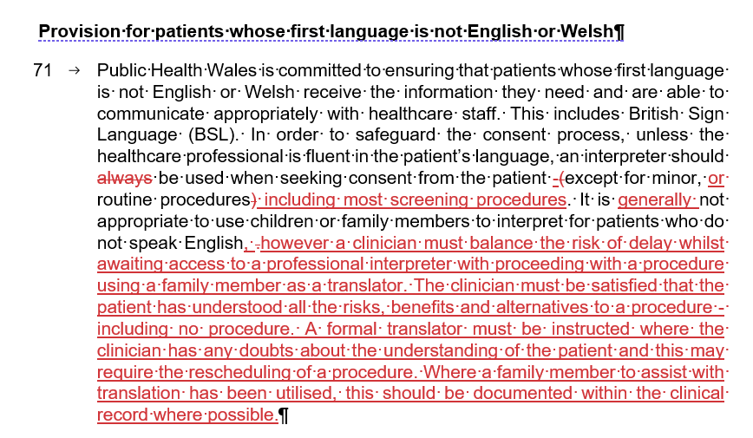

The Committee is asked to consider this updated text. The Team have provided reassurance that this change will support equitable access for service users, provide clarity for staff on when an interpreter is required and support the use of family members presenting with the patient to translate information at the time of their appointment. This will support prudent use of health services and reduce wasted appointments and the disruption to patients and the families/carers

There is no negative impact for Staff or service users as this is a positive improvement supported and welcomed by the screening Clinical Director and team.

The full Policy is attached at Appendix 1, with tracked changes for reference.

Recommendation

The Committee is asked to:

Endorse the minor change to the All Wales Consent Policy, following review at a national level.

