 |  | Reference Number: PHW-SCD15  Version Number: 1.0  Date of Next review: July 2023
A Career Framework for Health Professionals Regulated by the Health and Care Professions Council (HCPC) Nursing and Midwifery Council (NMC) and including Health Care Support Workers within Public Health Wales
Introduction and Aim
The development of a modern workforce and the processes needed to ensure career development and competency within roles, must be undertaken both to underpin sustainability through our succession strategy (‘Grow Your Own’), and improve service delivery. Shaping future careers, goes hand in hand with service design and the drive to provide high standards of service as it continually evolves in response to the changing needs of the population it serves.
The Career Framework has been designed to:
- Guide professional development seamlessly from pre-practitioner level, through newly qualified practitioner level, and on to experienced, expert practice.
- Improve career development and job satisfaction for our staff by encouraging individuals to learn new skills and take on extra responsibilities that enable them to progress within the organisation.
- Promote a more agile workforce through identifying core skills, knowledge and competencies that are transferrable between traditionally different existing roles, or to new and unique roles that may result from innovative service development
Linked Policies, Procedures and Written Control Documents
All corporate policies and procedures are available on the Public Health Wales website
Clinical Supervision Framework for Health and Care Professionals and Healthcare Support Workers 2023 (awaiting approval)
HEIW 2022 Professional Framework for Enhanced, Advanced and Consultant Clinical Practice in Wales
People and Organisational Development Supporting Learning and Development Process 2018
Public Health Wales Quality and Improvement Strategy 2021-2030
Scope
The overall purpose of this Framework is to support the development of the workforce across Public Health Wales by providing routes to progression by supporting workforce transformation. This reflects our strategic intention to strengthen the provision of effective high-quality care
Equality and Health Impact Assessment | An Equality and Health Impact Assessment can be found on the policies and procedures internet page.
Approved by | Business Executive Team
Approval Date | 19 July 2023
Review Date | 19 July 2026
Date of Publication: | 5 October 2023
Accountable Executive Director/Director | Executive Director Quality, Nursing and Allied Healthcare Professionals
Author | Caroline Whittaker, Professional Lead Nurse, Midwifery and Standards Manager - Quality, Nursing and Allied Health Professionals.  Edward Guy Professional Lead Healthcare Sciences and Allied Healthcare Professions Quality Nursing and Allied Health Professionals

Disclaimer
If the review date of this document has passed, please ensure that the version you are using is the most up to date either by contacting the document author or the Board Business Unit

Summary of reviews/amendments
Version number | Date of Review | Date of  Approval | Date published | Summary of Amendments
1.0 | 2023 | 18/07/2023 | 05/10/2023 | New Framework

1. Introduction
A Healthier Wales (2018) identified the need to develop a new Workforce Strategy for Health and Social Care in Wales, which includes planning for new clinical workforce models and supporting long-term career development.

Our workforce is at the heart of our ability to deliver excellent services and we require talented people with the right capability, capacity and commitment to implement each of our seven strategic priorities. Therefore, we need to continue to attract and retain talent and develop people to achieve their full potential.

The Public Health Wales Long Term Strategy and People Strategy identify the need to ensure we continue to shape, develop and enhance our workforce models to be more agile, in order to be able to adapt and meet the needs of the population we serve, through the delivery of our seven strategic priorities and objectives.

The development and co-creation of new models of service delivery are central to Welsh Government strategy for achieving Prudent Healthcare. These will inevitably impact the skills, knowledge and competencies required by staff across all grades, from support worker to consultant.

Our organisational values depict what everybody in our organisation should expect to see, hear and feel. In addition to these values, the organisation and its leaders have a duty to provide the right leadership, conditions, supporting environment and skills to ensure we have a motivated and sustainable workforce that can adapt to the challenges and priorities of the organisation.
2. Background
The development of a modern workforce and the processes needed to ensure career development and competency within roles, must be undertaken both to underpin sustainability through our succession strategy (‘Grow Your Own’), and improve service delivery. Shaping future careers, goes hand in hand with service design and the drive to provide high standards of service as it continually evolves in response to the changing needs of the population it serves.
The Career Framework has been designed to:
- Guide professional development seamlessly from pre-practitioner level, through newly qualified practitioner level, and on to experienced, expert practice.
- Improve career development and job satisfaction for our staff by encouraging individuals to learn new skills and take on extra responsibilities that enable them to progress within the organisation
- Promote a more agile workforce through identifying core skills, knowledge and competencies that are transferrable between traditionally different existing roles, or to new and unique roles that may result from innovative service development.
3. What is a career framework?
3.1 A career development framework lets employees know what steps they need to take to go where they want in their career. With a career development framework in place, there should be no surprises when they have performance reviews on what they need to do to get a promotion or move to a new role.
The Career Framework will provide:
- consistency – as an enabling tool that provides a common, consistent language to support career development
- a definition of the career level with characteristics and attributes ascribed to it that describe, for example, the amount of responsibility, complexity of thinking and level of decision making required
- competence – the core competencies of knowledge, skills and behaviours required at each level
- progression – providing individuals with a means to articulate their achievements and identify options available to develop their core knowledge and skills and progress their careers, both vertically and horizontally within the same or into the next career level
- transferability across roles
- Indicative education and training for each level of the career framework which will help staff to see what is required at each level of progress
Thus, the Career Framework should serve to support staff in making career choices by:
- underpinning their understanding of what is expected at each career level
- identifying core skills, knowledge and other competencies that are transferrable between roles requirements, resources and routes for career progression.
3.2 What it is not?
The Framework does not describe individual roles. Rather, it focuses on the core competencies required for each career level, regardless of specific role. This is both to identify what are the requirements for career progression within existing professional pathways, and what competencies and skills are transferrable across existing and new roles
3.3 Structure of the Career Framework:
The Framework sets out to define the generic core competencies relevant to each Practitioner level, together with the academic qualification level required for each of these, i.e., Support Worker/Associate Support Worker (qualification level 2-3), Assistant Practitioner (qualification level 4), Practitioner (qualification level 5/6), Advanced Practitioner (qualification level 7/8) and Consultant Practitioner (qualification level 8/9).
The Framework is designed to be used by all staff within Public Health Wales and will:
- Describe the knowledge and skills required, and level of responsibility at each Practitioner Level
- Illustrate career opportunities
- Support career movement in all directions
- Demonstrate career progression options based on skills and competencies (a description of the expected standards of performance)
- Allow people to identify their relevant existing skills and competencies, and those they would need to develop to move to a different role.
4. Alignment with other Profession-specific Career Frameworks
A number of professional bodies have developed career frameworks primarily to guide progression within their profession. The present career framework is intended to provide standardised guidance across all relevant professional groups working within Public Health Wales for the purposes stated in Section 3.1 and does not, therefore, aim to supersede existing profession-specific frameworks. Rather, it is intended to offer guidance to staff who may wish to consider at what level within a particular career framework would be a most appropriate entry-point based on their existing knowledge and skills, and to provide support to the employer around determining what skills and expertise development will be required to maximise agility within the workforce.
5. The Four Pillars of Practice
The Framework supports the development of core knowledge, skills and behaviours in four pillars of practice (Figure 1). For working at Qualification Levels 2-9 (It should be noted that Qualification Level may not necessarily be the same as Agenda for Change Band in all roles)
- Clinical practice/Professional practice: the knowledge, skills and behaviours needed to provide high quality healthcare that is safe, effective and person centred

- Education and Learning: the knowledge, skills and behaviours needed to enable effective learning in the workplace

- Leadership and Management: the knowledge, skills and behaviours needed to lead and to fulfil management responsibilities

- Evidence, Research and Development: the knowledge, skills and behaviours needed to use evidence to inform practice and improve services.
The emphasis on each pillar may vary according to the level of practice and the specific role. For example, the emphasis may be on the ‘Clinical Practice/Professional Practice’ pillar for a practitioner at Level 5, whereas at level 8, the ‘Leadership’ pillar may predominate as they may be taking on further leadership responsibilities commensurate with their role.
Similarly, a practitioner in a supervisory or training role may give more emphasis to developing the knowledge, skills and behaviours associated with the ‘Education and Learning’ pillar, than a practitioner at the same level working in a more clinical role. Depending on the individual’s role, they may not be required to demonstrate all knowledge, skills and behaviours all of the time, but they should have the capability to do so if required, both at their level of practice and all those in the preceding level of practice.
Figure 1-Four Pillars of Practice
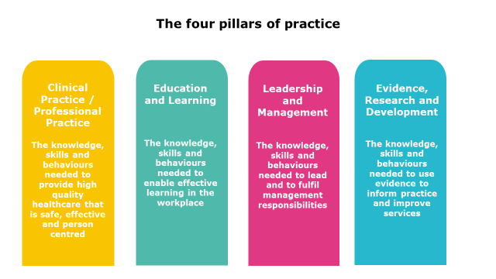

6. Practitioner levels and generic Job Role titles
It is envisaged that a generic set of Job Roles may be of assistance in future workforce mapping. For example, they could be used in the development of new service delivery models, as well as assisting individual members of staff in identifying the most appropriate entry level into an existing profession-specific career framework, i.e., ‘Equivalence’ assessment.
Figure 2 represents a generic overview of these various roles, based on Career Framework Level and emphasis across the ‘Four Pillars’, aimed at supporting ‘mapping’ of the various profession-specific Job Roles that exist within our workforce.

Figure 2 NHS Career Framework Level and Generic Support Worker/Practitioner Level
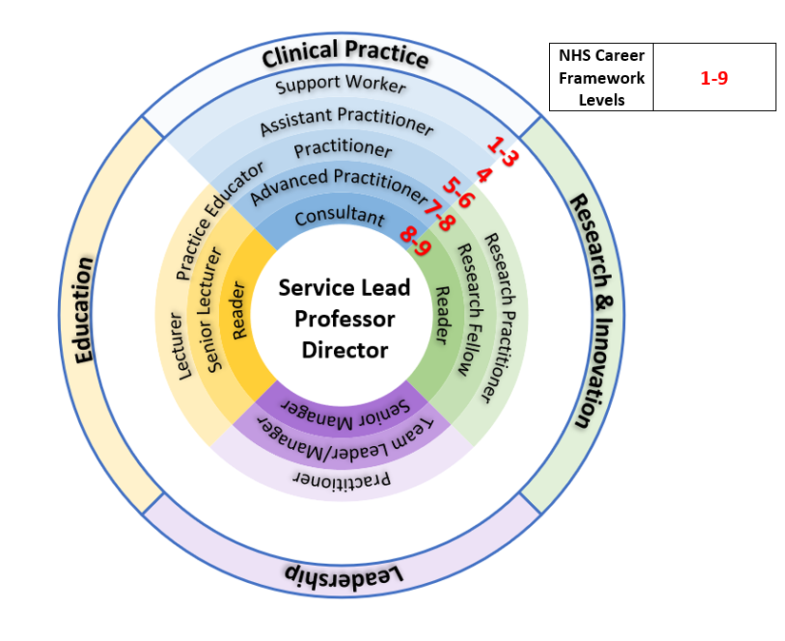

7. What is a competency?
7.1 The Career Framework focuses on generic competencies relevant to the level of practise. Within the Career Framework, competency articulates the required core knowledge, skills and behaviours that individuals need to bring to the workplace, to be able to work at a certain level of practice. This is more than just being able to consistently perform to defined standards in the workplace; it means also having the required underpinning knowledge and the right attitudes and behaviours to be able to undertake the role. This enables the individual to work in both stable environments with familiar and complex problems and, beyond this, to work effectively in situations that may be complex and require flexibility and creativity, as their career progresses.
In addition to role-specific competencies, there is a range of generic and core competencies that should be consistent across the same level of practise in different professional groups. Thus, while some people take on additional responsibility within their own area, others may retrain and move into different roles.
Figure 2 details the relationship between career level and practitioner level across the four domains. A full description can be found in “The core public health workforce Health Careers”. A summary of the skills required at each career level is shown below:
- Level 2
People require basic knowledge of facts of a field of work. They may carry out clinical, technical, scientific or administrative duties according to established protocols or procedures, or systems of work.
Example role: Healthcare Support Worker/Biomedical Support Worker
- Level 3
People require knowledge of facts, principles, processes and general concepts in a field of work. They may carry out a wider range of duties than the person working at level 2, and will have more responsibility, with guidance and supervision available when needed. They will contribute to service development and are responsible for self-development.
Example role: Senior Healthcare Assistant/Specialist Biomedical Support Worker
- Level 4
People require factual and theoretical knowledge in broad contexts within a field of work. Work is guided by standard operating procedures, protocols or systems of work, but the worker makes judgements, plans activities, contributes to service development and demonstrates self-development. They may have responsibility for supervision of some staff.
Example role: Assistant Practitioner

- Level 5
People will have a comprehensive, specialised, factual and theoretical knowledge within a field of work and an awareness of the boundaries of that knowledge. They are able to use knowledge to solve problems creatively, make judgements which require analysis and interpretation, and actively contribute to service and self-development. They may have responsibility for supervision of staff or training.
Example role: Practitioner
- Level 6
People require a critical understanding of detailed theoretical and practical knowledge, are specialist and / or have management and leadership responsibilities. They demonstrate initiative and are creative in finding solutions to problems. They have some responsibility for team performance and service development, and they consistently undertake self-development.
Example role: Specialist/Senior Practitioner
- Level 7
People have a critical awareness of knowledge issues in the field and at the interface, between different fields. They are innovative and have a responsibility for developing and changing practice and/or services in a complex and unpredictable environment.
Example role: Advanced Practitioner
- Level 8
People require highly specialised knowledge, some of which is at the forefront of knowledge in a field of work, which they use as the basis for original thinking and/or research. They are leaders with considerable responsibility, and the ability to research and analyse complex processes. They have responsibility for service improvement or development. They may have considerable clinical and/or management responsibilities, be accountable for service delivery or have a leading education or commissioning role.
Example role: Consultant/Senior Staff
- Level 9
People require knowledge at the most advanced frontier of the field of work and at the interface between fields. They will have responsibility for the development and delivery of a service to a population, at the highest level of the organisation.
Example role: Director/Very Senior Staff (e.g., Service Lead)
8. NHS Wales Training Support (Health Education Improvement Wales)
Health Education Improvement Wales (HEIW) aims to provide an integrated range of training and education across all staff groups within NHS Wales, with the aim of providing the opportunity, for any individual to develop their career seamlessly across all Career Framework Levels (from Level 2 to Level 9, and to Board Executive Level). Established in 2018 as a Special Health Authority HEIW sits alongside health boards and trusts as part of NHS Wales.
‘A Healthier Wales’ recognises that continuous shaping and development of the healthcare workforce is fundamental to the quality, delivery of care and achievement of the Welsh Government’s vision for the NHS in Wales.
In order to achieve this, HEIW provides a range of support for staff and its partner health boards and trusts within NHS Wales, that include (but are not limited to): apprenticeships (Level 2 and up); degree-level qualifications (Bachelor, Masters and Doctorate); profession-specific training; and core management and practitioner skills.
All NHS Wales organisations may apply for funding both for the training of new staff, and for the development of their existing workforce. Individual staff members are able to seek support, through their employer for bespoke training, and potential new employees may apply through one of the many training programmes supported by HEIW.

APPENDIX A

Healthcare Sciences Career Framework

- Clinical/Biomedical Sciences
- Radiography
Appendix A-1 The education, training and career pathway for Clinical/Biomedical Sciences
The table below describes the key career levels for the UK Healthcare Science workforce and provides reference as to how these map onto the core Career Framework (Figure 2). Key career levels are:
- Biomedical Support Workers: Band 2-4
- Medical Technical Officers: Band 2-5
- Biomedical Scientists: Band 5-8*
- Clinical Scientists: Band 6-9*
* Upper scales will reflect additional managerial and/or clinical responsibilities
Career Level | Role activities | Education and Training route
Assistant  (BMSW/MTO) | Undertake clearly defined task and protocol based, high volume, low risk activities. Training through workplace based structured training and Apprenticeships | Apprenticeships, NVQs (or equivalent) underpinned by an awards and qualifications framework
Associate  (BMSW/MTO) | Undertake more advanced and complex high volume low risk investigative tasks. Training through workplace training and Foundation degree | Foundation Degrees, Apprenticeships and NVQs (or equivalent) underpinned by an awards and qualifications framework
Practitioner/  Advanced Practitioner  (Biomedical Scientist) | Apply technology, in the delivery & reporting of quality assured tests, investigations & interventions. Activities outlined in ‘protocols -uses judgements & deals with ambiguity. Training through Practitioner Training Programme (PTP). | PTP (Practitioner Training Programme) – undergraduate degree with clinical placement
Practitioner/  Advanced Practitioner  (Clinical Scientist) | Complex scientific and clinical roles. High risk, low volume activities which require highly skilled staff able to exercise clinical judgement about complex facts and clinical situations. Training through Scientist Training Programme (STP) | STP (Scientist Training Programme) – postgraduate degree (Masters-level) with clinical placement
Consultant  (Clinical Scientist) | In-depth, highly complex role. Similar to medical consultant role as requires clinical judgement, scientific expertise, leadership and dealing with uncertainty in direct patient care. Training through Higher Specialist Training (HSST) programme. | HSST (Higher Specialist Scientific Training) at doctorate level

Appendix A-1 UK Healthcare Scientist Training Pathway
The figure below provides an overview of the national training pathway , indicating the relationships between the various career levels described above.
The PHW Microbiology Division career framework structure and pathways is shown on the next page and reflects the operational requirements for the current and proposed service delivery model.
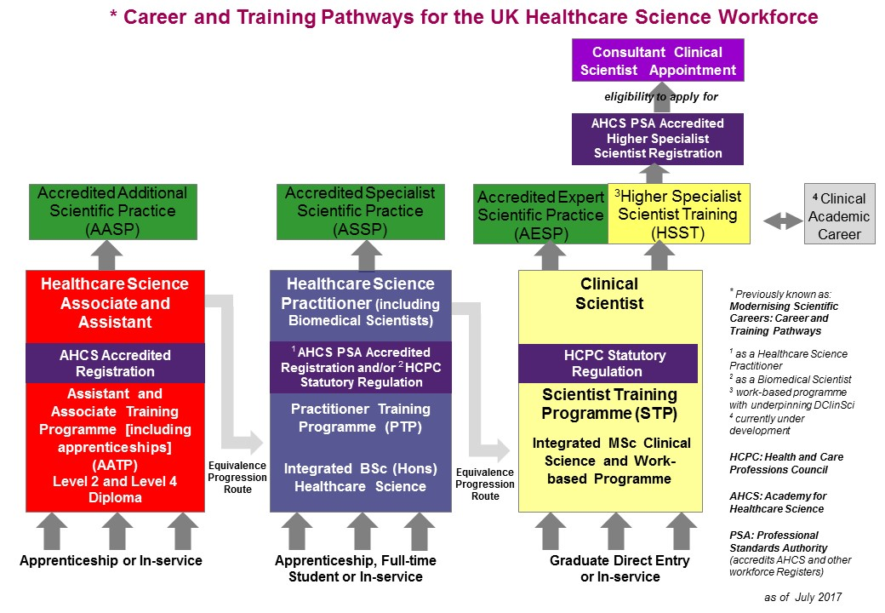
Microbiology Division
Career Framework – Healthcare Scientist
HEIW Training Fund sources
- STP
PTP
HSST
Apprenticeships
- Equivalence Funding
Advanced/Enhanced
/Extended Practise
Consultant BMS Band 8 (Route/
Competencies not yet defined)

Clinical

Managerial
Senior Clinical Scientist Band 7/8

BMS Band 8
Senior managerial responsibilities)

Consultant Clinical Scientist Band 8

:
Expert Training
Specialist/Senior BMS Band 6/7
(Senior Healthcare Practitioner)

Clinical Scientist Band 7

HSST

Specialist Training
STP
BMS Band 5/6
(Healthcare Practitioner)

PTP
BMSW Band 3
(Assistant Healthcare Practitioner) Assistant)

BMSW Band 4
(Healthcare Associate)

IBMS C of A
Part 2

IBMS C of A
Part 1

Accredited
Practice

HCPC-regulated Practise
BMSW Band 2
(Healthcare Assistant)

Higher
Apprenticeship
Lower Apprenticeship
BMSW Band 2
(Trainee Healthcare Associate)

Annex U Trainee Band 5
(Trainee Healthcare Practitioner)

Trainee Clinical Scientist Band 6/7
(Trainee Healthcare Scientist)

Trainee Clinical Scientist Band 6
(Trainee Healthcare Scientist)

BMSW Band 2
(Trainee Healthcare Assistant)

No formal Progression beyond Band 5
MTO
Band 4

MTO
Band 5

MTO
Band 2/3

Appendix A-2 The education, training and career pathway for Radiography
The key career levels for the UK Radiography workforce are:
Assistant practitioners are non-registered staff trained to high standards to perform a specific range of clinical imaging examinations or treatment procedures. Assistant practitioners’ work is delegated under the supervision of a registered radiographer or radiologist. Assistant practitioners underpin and enable what is referred to as a four-tier structure in radiography. The four-tier structure refers to different roles within the team: assistant practitioner; radiographer practitioner; advanced practitioner radiographer; consultant radiographer.
Radiographers are regulated professionals with the Health and Care Professions Council (HCPC). They are entitled to hold one of the protected titles Radiographer, Diagnostic Radiographer or Therapeutic Radiographer. Radiographers undertake a broad portfolio of either diagnostic examinations or radiotherapy procedures. They work in partnership with team members, patients and carers to deliver care that may include screening, diagnosis, treatment or health monitoring for patients. To register, radiographers must hold a relevant BSc(hons) or MSc qualification. To maintain registration with the HCPC Radiographers must undertake and keep a record of their continued professional development. In addition to HCPC standards, radiographers work to the standards of the Society of Radiographers code of professional conduct. The code includes expectations that radiographers act in accordance with values of respect, empowerment, empathy, trustworthiness, integrity and justice. Radiographers must always act with compassion: caring for patients is at the heart of what radiographers, assistant practitioners and support staff do.
Diagnostic radiographers work in areas that include X-ray, Ultrasound, Fluoroscopy, Computerised Tomography (CT), Magnetic Resonance Imaging (MRI), Nuclear Medicine, Angiography and Mammography.
The Society and College of Radiographers supports the extension of the scope of practice of members where adequate education, training, and audit of practice provide safe and effective services to meet local patient needs.
Advanced practitioner and consultant radiographers increase responsibility in their job roles respectively to a point where the core domains of consultant work are: 1) expert clinical practice; 2) professional leadership and consultancy; 3) education, training & development, practice & service development; 4) research & evaluation. (CoR website)

Career Framework - Radiography

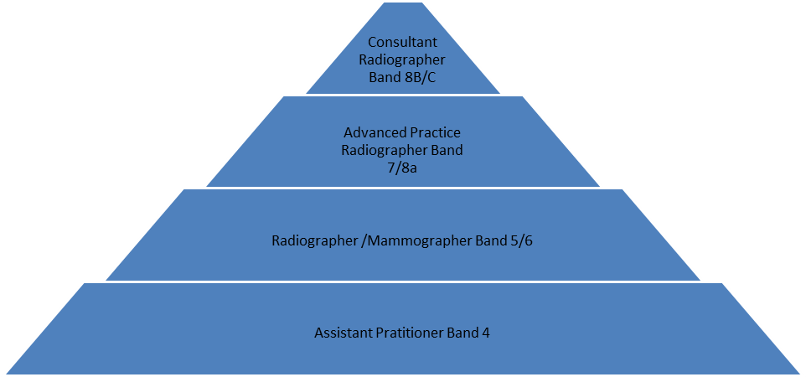

APPENDIX B

Nursing Midwifery Pathway

B-1 Scope of Professional Development
B-2 Career Framework Levels

Appendix B-1
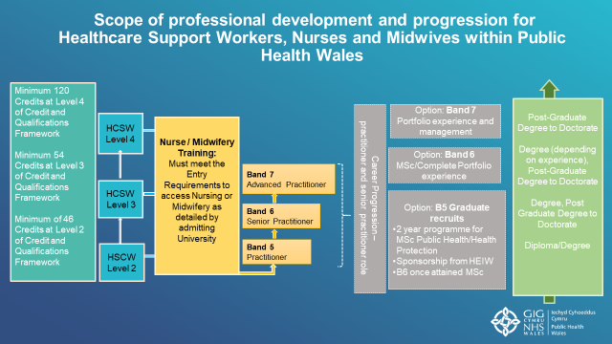

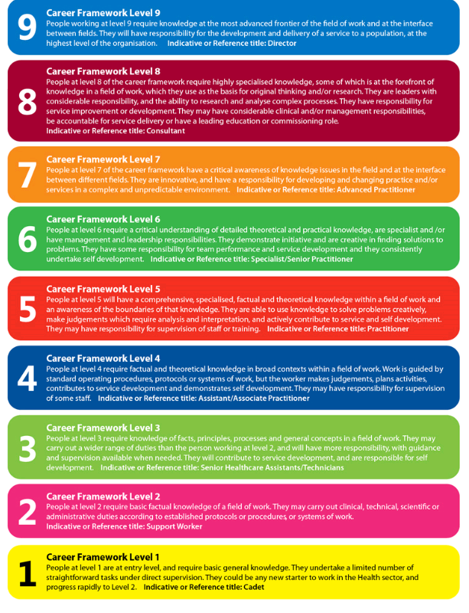
Appendix B-2-2 Career Framework Levels (Skills for Health 2020).

Enhanced Clinical Practitioner

Advanced Clinical Practitioner
Consultant Clinical Practitioner

A healthier Wales: long term plan for health and social care | GOV.WALES
https://phw.nhs.wales/about-us/our-priorities/long-term-strategy-documents/public-health-wales-long-term-strategy-working-to-achieve-a-healthier-future-for-wales/
Public Health Wales People Strategy 2020-30. Our workforce to achieve a healthier future for Wales https://phw.nhs.wales/about-us/board-and-executive-team/board-papers/ board-meetings/2019-2020/23-january-2020/board-23-january-2020-agendaand-papers/5-2-230120-people-strategy-for-public-health-wales/
Our Values. Public Health Wales https://phw.nhs.wales/working-for-us/our-values/

