 |  | Reference Number: PHW-SCD18  Version Number: 1  Date of Next review: July 2026
Clinical Governance Framework

Introduction and Aim

The Clinical Governance framework supports the introduction and compliance with the Health and Social Care Act (Quality & Engagement) (Wales) Act (2020). The framework aligns to Quality as an Organisational strategy and the Duty of Quality with an emphasis on continues improvement and learning.

Linked Policies, Procedures and Written Control Documents
All corporate policies and procedures are available on the Public Health Wales website

Clinical Supervision Framework
Career Framework

Scope
This Framework is relevant to Services where the primary focus is concerned with enabling individuals and populations to maximise and protect their health and well-being through the prevention, investigation and treatment of ill-health.

Equality and Health Impact Assessment | An Equality and Health Impact Assessment can be found on the policies and procedures internet page.
Approved by | Business Executive Team
Approval Date | 19 July 2023
Review Date | 19 July 2026
Date of Publication: | 5 October 2023
Accountable Executive Director/Director | Executive Director Quality, Nursing and Allied Healthcare Professionals and Executive Director for Health Protection and Screening Services and Medical Director
Author | Caroline Whittaker, Professional Lead Nurse, Midwifery and Standards Manager - Quality, Nursing and Allied Health Professionals.  Professor Edward Guy, Professional Lead Health Care Science and Allied Health Professions - Quality, Nursing and Allied Health Professionals.  Angela Cook, Assistant Director Quality, Nursing and Allied Health Professionals.

Disclaimer

If the review date of this document has passed please ensure that the version you are using is the most up to date either by contacting the document author or the Board Business Unit
Summary of reviews/amendments
Version number | Date of Review | Date of  Approval | Date published | Summary of Amendments
1.0 | 2023 | 18/07/2023 | 05/10/2023 | New Framework

Contents

1. Introduction 4
2. Scope 7
3. Responsibilities 9
4. Expectations 11
5. Reporting and Monitoring 12
6. Implementation of Learning 16
Appendix 1: Quality and Clinical Audit 18
Appendix 2: Clinical Effectiveness and Research 20
Appendix 3: Risk Management, Including Putting Things Right 22
Appendix 4: Information Management 30
Appendix 5: Staff Management 31
Appendix 6: Training and Education 33
Appendix 7: Patient/ service user/ public involvement 35
Appendix 8: Public Health Wales Quality and Quality Enabling Statement 39

1. Introduction

1.1 Public Health Wales - Who we are and what we do

Public Health Wales is the National Public Health Organisation for Wales. Our purpose is working together for a healthier Wales. We help all people in Wales live longer, healthier lives. With our partners, we aim to increase healthy life expectance, improve health and well-being, and reduce inequalities for everyone in Wales, now and for future generations.

Together, our teams work to prevent disease, protect health, provide system leadership, specialist services and public health expertise. We are the primary source of public health information, research, and innovation, to help everyone in Wales live healthier lives.

1.2 Long-Term Strategy

Our Long-Term Strategy for 2023 – 2035 sets out our vision for achieving a healthier future for Wales by 2035. Public Health Wales is committed to working towards a Wales where people live longer, healthier lives and where all people have fair and equal access to the things that lead to good health and well-being. We will do this through focusing on the delivery of our six strategic priorities. (Figure 1).

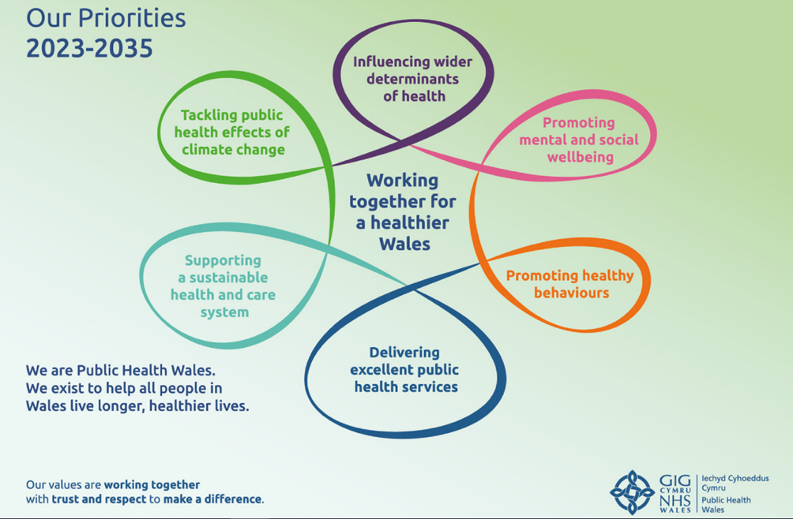
Figure 1: Visual of Public Health Wales Strategic Priorities, Mission, and Values.

1.3 Duty of Quality – Introduction

The Duty of Quality for all healthcare organisations was introduced in Wales from 1 April 2023, where Welsh Government committed to providing safe, effective, and person-centre health services through the implementation of The Health and Social Care (Quality and Engagement) (Wales) Act 2020, and The Health and Social Care (Community Health and Standards) Act 2003. The Act places an overarching Duty of Quality of health services on Welsh Ministers and health bodies in Wales. In conjunction with the Duty of Quality, the organisation must consider its organisational responsibilities in relation to the Duty of Candour (Appendix 3). Quality needs to be a system-wide way of working to continuously, reliably, and sustainably meet the needs of the population that we serve.

In discharging the duty of quality, NHS bodies are required to take into account the Health and Care Quality Standards when making decisions about health services so that improved outcomes are secured. Welsh Ministers and NHS bodies should ensure that decisions they make in relation to services and functions are safe, timely, effective, efficient, equitable, and person-centred. These quality dimensions provide a framework to assess quality and guide improvement. Therefore, it is important to explain what the quality dimensions aspire to achieve, what they are intended to mean in Wales and further define intentions for Public Health Wales as detailed below in Figure 2:

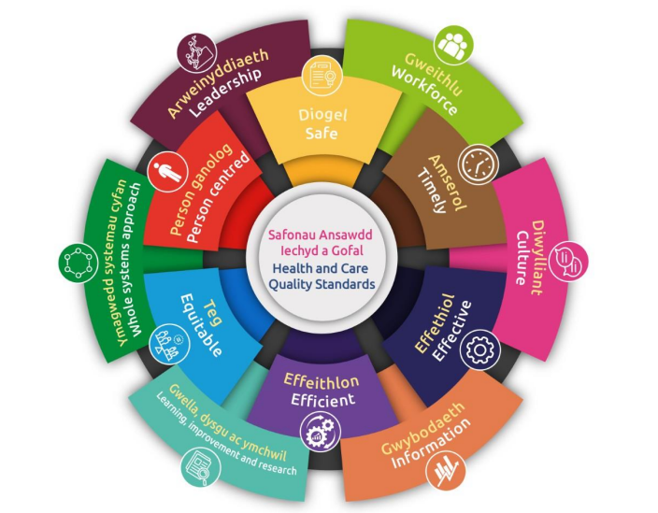
Figure 2: Visual to illustrate the six domains of quality supported by six quality enablers. Together these comprise the Health and Care Quality Standards

1.4 Quality as an Organisational Strategy

To enable the organisation to embed quality and deliver strategic improvements, we have adopted Quality as an Organisational Strategy (QoS). The aim of QoS is to enable the organisation to provide focused services and products and to create an environment where our staff can enjoy and take pride in their work.

There five core elements of QoS:

- Purpose Activity. A clear purpose statement has been developed, that will shape and guide future work and focus.

- System Activity. We have commenced work to map our organisation as a system, which will drive focus on clarity on how we can effectively support the delivery of our strategy.

- Obtaining Information. We will focus on establishing systems to obtain information from our users, customers, and partners to drive quality and performance improvements.

- Planning Activity. We will undertake a planned programme of improvement work focused on increasing the value and impact of our services and functions.

- Managing Improvement Methods. We will utilise a range of methods to support delivery of our strategy and to drive improvements.

Public Health Wales must embed QoS and clinical governance at the core of what we do. By using the structures and processes of clinical governance, we will ensure that standards and quality are continually monitored and improved.

1.5 Why do we need a Clinical Governance Framework?

A number of high-profile and damaging incidents have occurred in health and care organisations in the UK over the years such as Dr Harold Shipman, Nurse Lucy Letby and Mid Staffordshire NHS Foundation Trust. Members of the public have lost their lives or were harmed because of significant failures of health and care organisations to provide the right care. It has been identified through claims and inquiries, that health and care organisations failed to act when patterns of harm were identified.

Health and care organisations have a moral responsibility to put systems in place to avoid such incidents such as those detailed above. The Francis Report (2013) identified that problems were generally attributable to a lack of leadership, ineffective communication, poor organisation and teamwork, and a lack of means for accessing quality of care.

2. Scope

Clinical Governance is a shared Executive level responsibility between the Executive Director of Quality, Nursing and Allied Health Professionals and the Executive Director for Health Protection and Screening Services and Medical Director. Both will oversee the management of clinical governance arrangements in Public Health Wales. To be accountable for health and care quality arrangements, a health and care organisation is required to manage:

• the quality and safety of care and services provided by its staff

• the organisation for the ultimate purpose of continually assuring and improving the quality and safety of services for the public.

2.1 Definition

“Clinical Governance is the system through which NHS organisations are accountable for continuously improving the quality of their services and safeguarding high standards of care by creating an environment in which clinical excellence will flourish”.

Clinical governance is the framework for accounting for improving and safeguarding the quality and safety of services. It is an umbrella term covering activities that help sustain and improve standards and can be examined through seven pillars. The pillars are recognised as;

- Audit (Quality and Clinical Audit). The audit process is to ensure that clinical practice is continuously monitored and that deficiencies in care/ service delivery are remedied.

- Clinical effectiveness and research. Services should be evidence based and designed to deliver the best outcome for those we work with and for.

- Risk management. Systems should be in place to understand, monitor and minimise risk to safeguard those we work with and for.

- Information management. Data needs to be secure, up to date and accurate, and used effectively to measure quality of services.

- Education and training. Staff need appropriate training and support available to maintain their competency and to develop new skills, so they are continuously up to date.

- Staff management. The safe and appropriate recruitment and management of staff.

- Patient/ service user/ public involvement. Involvement and feedback from both those we work with and for is used to develop and improve services and the quality of the experience of the service delivered.

Through the application of the pillars of clinical governance, Public Health Wales will strive to achieve excellence and meet the expectations of the Health and Care Quality Standards; effectively demonstrating continual monitoring and improving the quality and safety of our services. (Figure 3).

Further information regarding Public Health Wales requirements for each of the pillars can be found at Appendixes 1 to 7.

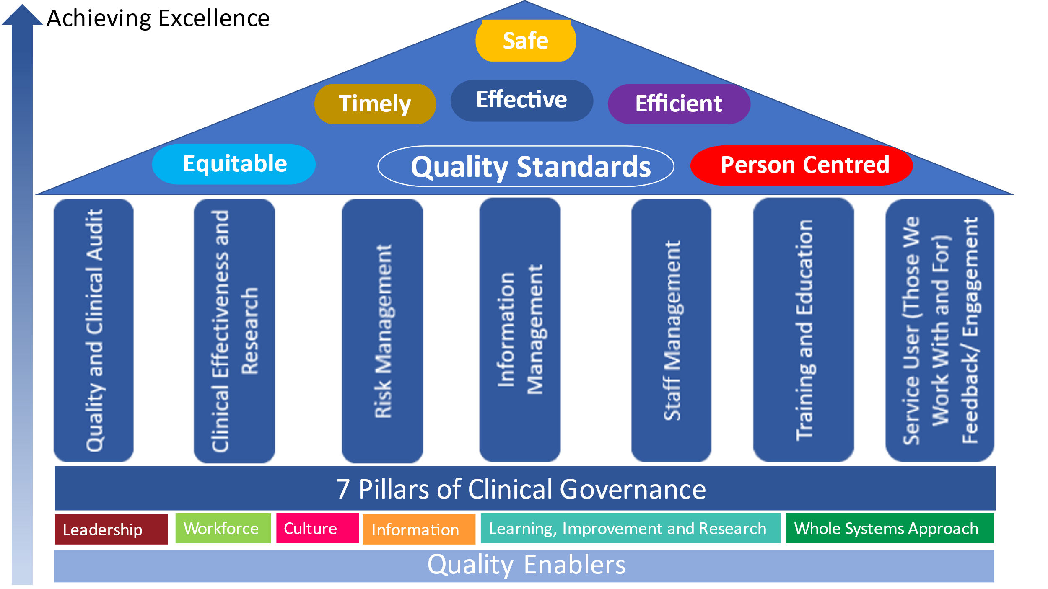
Figure 3: Visual representation of the interaction between clinical governance, Health and Care Quality Standards and Quality Enablers.

2.2 Boundaries of the framework

As an organisation, our services and functions are diverse in nature. Working in collaboration with areas across the organisation, the boundaries of the clinical governance framework have been defined as being pertinent to:

“Services where the primary focus is concerned with enabling individuals and populations to maximise and protect their health and well-being through the prevention, investigation and treatment of ill-health”.

The framework will support Quality as an Organisational Strategy and improve the understanding of how information will be available for always on reporting and the Annual Quality Report; identifying how learning can be shared and inform the wider organisational operating frameworks.

Although this Framework is pertinent to those defined clinical services, the Duty of Quality applies to all health service functions in both clinical and non-clinical services. Therefore, all staff have a responsibility for complying with the duty within their role and service or function.

3. Responsibilities

The Directorate Leadership/ Management teams are accountable for the delivery of the Clinical Governance agenda within their Directorate and have the responsibility to ensure that the governance values are embedded within their Divisional groups. The organisation will establish an organisational clinical governance committee, where directorates will report on activity. The Business Executive Team (BET)will provide the operational oversight with assurance to the Board being provided by both Quality, Safety and Improvement Committee (QSIC) and BET:

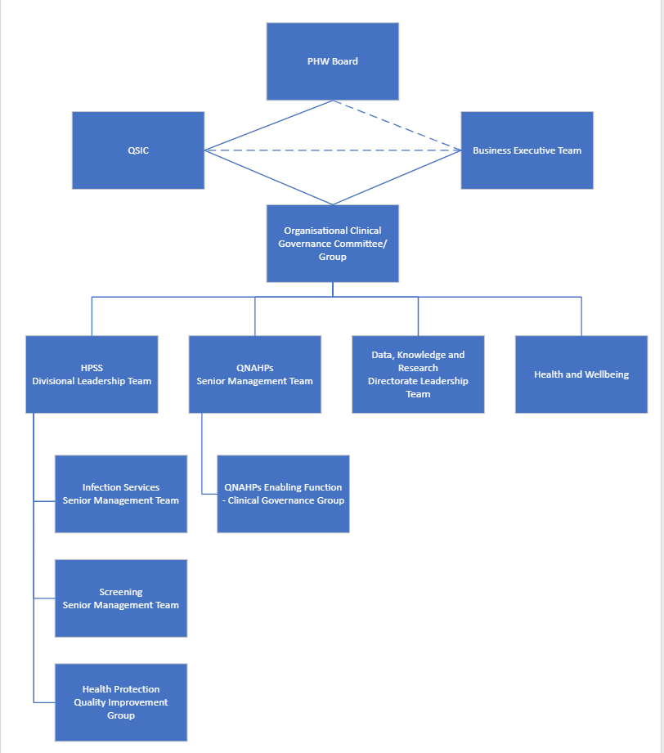
Figure 4: Visual representation of Responsibility and Accountability Structures in Public Health

Within the clinical governance structures there are committees, sub committees and groups; each have delegated responsibility to deliver Public Health Wales’s strategic objectives and goals via compliance with performance and quality indicators and monitoring of associated risks.

4. Expectations

4.1 Quality statements

As an organisation, Public Health Wales has adapted the Domains of Quality statements contained within the Duty of Quality for safe, timely, effective, efficient, equitable and person-centred. This allows us to ensure the statements are pertinent to our organisational strategy, focusing attention on how we will fulfil our statutory obligations for those we work with and for, whilst paying particular attention to how our services will meet the needs of the population. These must be considered in line with the statements as set in the Duty of Quality.

A system-wide approach to quality requires a culture that embeds continuous learning and improvement at its heart. This should be underpinned by a clear definition and understanding of what good quality looks like utilising national and benchmarked standards, peer review and audit.

4.2 Quality Enabler Statements

The quality enablers underpin and influence this blueprint to ensure a system-wide approach to improving quality. The six quality enablers below complement the implementation of a methodology and approach to managing quality, as set in the Quality and Safety Framework (2021). The statements are taken directly from The Duty of Quality documentation, where healthcare is mentioned, it is recognised that this terminology is not truly reflective of Public Health Wales, but it is relevant to us as an organisation.

Contained at Appendix 8 is the Public Health Wales Quality Statements for the Domains of Quality and the Duty of Quality Statements for the Quality Enablers. These combined statements, form the twelve Health and Care Quality Standards. This allows the organisation to focus its attention on how we will fulfil our obligations.

Full definitions of the Duty of Quality – Quality and Quality Enabler Statements, can be found at pages 18-23: https://www.gov.wales/sites/default/files/publications/2023-04/duty-of-quality-statutory-guidance-2023_0.pdf

5. Reporting and Monitoring

5.1 Annual Quality Report

Public Health Wales is required to publish an Annual Quality Report on the steps it has taken to comply with the duty to exercise its functions with a view to securing improvement in the quality of health services. The report must include an assessment of the extent of any improvement in outcomes achieved by virtue of those steps.

The annual quality report should include a look back at what has been achieved, including where things may not have gone well, together with a forward look about the organisation’s quality priorities and ambitions for the upcoming year, alongside how progress will be monitored. There should be continuity between annual reports across subsequent years.

Utilising the seven pillars of clinical governance, Public Health Wales will be able to support the requisite information to facilitate reporting and undertake their assessment for the annual quality report.

Each Directorate will share areas of good practice and learning across the organisation both, when things go well and when things could be improved. We must ensure that information is available and shared appropriately for all who need it. We turn data to knowledge by triangulating quantitative and qualitative performance, experience, and outcome measures to understand the quality of services, efficacy of improvement work and impact of decisions made.

5.2 Measures and Data Sets

Directorates and Divisions will ensure that they have agreed clinical governance measures and agreed data sets in place to monitor performance, which will be reported to the clinical governance committee.

We will monitor, report, and escalate indicators through our governance structures to ensure that appropriate action is taken at every level in terms of learning, improvement, and accountability. (Figure 5). Further information is available regarding reporting in each of the domains in Annexes 1 – 7.

Figure 5: Visual Representation of Using Data to Knowledge.

5.3 Routine

Monitoring is required to be undertaken by those areas defined within the boundaries of this Framework to ensure the organisation is meeting the Duty of Quality requirements. Below is a visual representation of the seven pillars of clinical governance and examples of the types of activity that should take place within these areas to ensure we are accountable.

To be accountable for services and staff, organisations must:

- Know if the right things are being done in the right way and action is being taken. If not, they must use quality improvement processes, including quality and clinical audit and quality management systems to monitor activities.

- Know and act on what’s right. Searching, critically appraising, and implementing evidence-based practice and contributing to research.

- Know and act on feedback and experience from those we work with and for. Learning from them to shape services to provide service user (person-centred) care and acting on complaints.

- Know and act on how to keep those we work with and for safe. Proactively extending good safety practices, and reactively reporting and analysing incidents. Learning from complaints, deaths, and feedback.

- Know and act on how to do things right. Using appropriate and effective staff appraisal and continuing professional development systems and activities.

- Be supported to do the right thing, the right way, in the work environment. Having effective leadership of teams and making changes in systems and practices to improve quality and safety.

As an organisation, each Directorate/ Division must be able to provide evidence in each of these areas to support the reporting requirements of the Duty of Quality and demonstrate that this activity is taking place e.g., through Directorate/ Divisions through Clinical Governance meetings. If these are undertaken correctly, Public Health Wales will easily demonstrate that its services and functions are meeting the 12 Health and Care Quality Standards (which encompass the quality standards and quality enablers). (Figure 6).

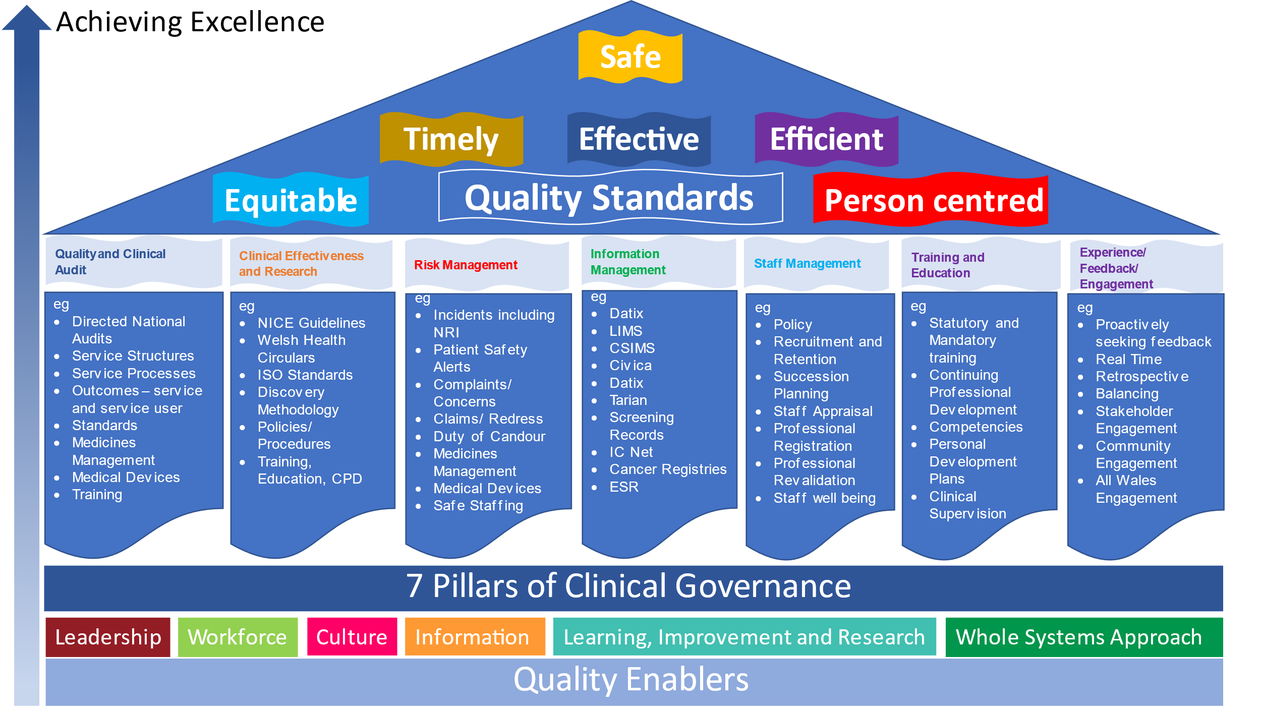
Figure 6: Visual Representation of Integration of Pillars of Clinical Governance, Duty of Quality and Supporting Evidence

5.2 How will we Achieve the Quality Standards?

Ensuring we are SAFE  - Learning from incidents  - Learning from claims and complaints  - Continuous Improvement  - Compliance with Patient Safety Alerts  - Medicines management  - Medical Devices management  - Safeguarding  - Meeting infection prevention control standards  - Demonstrating safe staffing levels  - Assurance audits (e.g., failsafe audits, accreditation audits)  - Health and Safety Legislation |  | Ensuring we are TIMELY  - Appointment scheduling  - Pathway Administration  - Responding to and learning from incident/ concerns/ complaints in a timely manner  - Shared learning from external reviews and audits  - Responding to staff concerns in a timely manner  - Timely Incident Management Response to incident outbreaks  - Duty of Candour compliance  - Timely updating of policy, procedure and guidance based on best available evidence
Ensuring we are EFFECTIVE  - Evidence based clinical services  - Compliance with policies and procedures  - Validate methodologies to inform service redesign  - Achieving best practice (e.g., NICE, Welsh Health Circulars, UKHSA, etc)  - Risk management including identification and escalation  - Incident Management  - Quality and clinical audit |  | Ensuring we are EFFICIENT  - Demonstrating safe staffing levels  - Proactive workforce planning  - Supporting staff to remain in work  - Building capacity and capability in our workforce  - Reduce variation in services and functions  - Maximise use of buildings/ estate  - Maximise flow of service users  - Quality and clinical audit
Ensuring we are EQUITABLE  - Meeting equity standards  - Ensuring appropriate accessibility of our services  - Compliance with policies and procedures  - Using data to address inequities  - Reasonable adjustments for those we work with and for  - Completion, acting on and evaluation of relevant Impact Assessments  - Obtaining feedback  - Safeguarding  - Meeting language standards  - Recognition of the rights of children |  | Ensuring we are POPULATION/ PERSON-CENTRED  - Involving those we work with and for  - Listening to and acting on feedback  - Proactively seeking feedback and experience  - Learning and sharing learning from feedback  - Informed consent  - Privacy and confidentiality

5.3 Quality and Clinical Audit

Quality and clinical audit is one of the pillars of the clinical governance framework and an important quality assurance tool. It is complimentary to other improvement methodologies and is a useful way of learning about what is working well and not so well. It aims to improve quality and provide assurance by measuring existing practice against evidence-based standards. Horizon scanning is to be undertaken to identify population threats and opportunities, whilst ensuring that our interventions are evidence based. We will utilise digital platforms to monitor and report outcomes.

All areas as defined within the scope of the Clinical Governance Framework are to ensure there is a programme of audit within all of those areas, which will be reported and monitored through the Quality and Clinical Audit Annual Plan. Further information regarding the Annual Plan and audit is available at Appendix 1.

6. Implementation of Learning

Public Health Wales is committed to being a high performing, learning organisation and will take every opportunity to learn by recognising and sharing good practice through innovation and enabling change.

High performing organisations are those which are open and honest when mistakes or errors occur and can demonstrate learning and improved outcomes as a result. We seek to support an open and learning environment and not a blame culture, we have a great deal of expertise within the organisation and sharing this expertise through a matrix approach means we can call on others to help and support. Asking for help should never be seen as a sign of weakness, collective efforts are much more likely to help us succeed. We don’t have to be experts in everything; however, we do need to recognise when support and assistance from others will assist us in overcoming hurdles which we are bound to encounter.

The emphasis should always look to systems failures not individual failures. There are many tools we can use from the wider quality and improvement toolbox that can be used to support findings when things go wrong, eg. Systems Engineering Initiative for Patient Safety (SEIPs), Ishikawa (Fishbone) Diagram, 5 Why’s.

There are many ways to identify where we need to improve, including the Duty of Candour and our learning systems under Putting Things Right Regulations, which require us to learn from complaints, incidents, concerns, and claims. Data, performance data, audits, project closure reports are other examples of rich sources of information which can be used to determine where we need to improve. Further information regarding Public Health Wales requirements for Risk/ Putting Things Right can be found at Appendix 2.

All areas as defined within the scope of the Clinical Governance Framework are to ensure there are programmes in place for sharing learning. Not just within their own Services/ Teams but across the organisation.

As a learning organisation, Public Health Wales will have:

- Strong and collaborative structures that support an open and transparent culture

- Will have a well-established learning system that reviews success and failure, and supports effective planning

- A learning climate, with mature systems of feedback that inform improvement, and enables teams to innovate and test new ideas.

- An Improvement Hub to support and build organisational capacity and capability to enable continuous improvement in our services informed by our learning system.

Appendix 1: Quality and Clinical Audit

Quality and Clinical Audit forms part of an assurance process, which can sustain and improve standards, subsequently improving the quality of services provided. Quality is defined as continuously, reliably, and sustainably meeting the needs of the population that we serve. Quality and clinical audit is an effective tool to assess perceived or known areas of risk and vulnerability. Priority should be given to areas most critical to operational and organisational aims and objectives.

Quality and clinical audit aims to improve quality and provide assurance by measuring existing practice against evidence-based standards, for example: The National Institute of Health and Care Excellence (NICE). Quality and clinical audit is a tool that can be utilised to inform practice and involves the measurement of the effectiveness against agreed and proven standards/evidence. Where indicated, changes are implemented, and further monitoring is used to confirm improvement (Healthcare Quality Improvement Partnership 2011).

Quality and clinical audit is intended to answer the question “Does this service, programme or function reach the expected standard?” and:

- Measures the quality of a service, function or programme being delivered.
- Identifies whether the best standards (where appropriate) are being delivered.
- Measures practice against explicit criteria and defined standards or guidance.

Sometimes there is no standardised approach for a process or practice. Consequently, a baselining activity may be undertaken to measure the current practice, with no reference to a standard, with the purpose to use this to aid the development of a service/function and introduce standardisation of a process. This may be included in the Public Health Wales Annual Quality and Clinical Audit Plan, with the expectation that an audit is undertaken once the standardised process is implemented.

Quality and Clinical Audit does not include research (to study a subject in detail, especially in order to discover new information or reach a new understanding and is managed through the governance process); nor evaluation (which sets out to assess the effectiveness or efficiency of an
existing or new service/programme/function that is evidence based).

Public Health Wales is required to have an Annual Quality and Clinical Audit Plan in place for each financial year. Directorates and Divisions are required to identify audits to be included in the annual plan. The annual plan incorporates Externally (National (Wales and UK)) and Internally reported audits.

External Audits Definition | Internal Audit Definition
Public Health Wales will agree an annual planned programme of quality and clinical audit activity in response to a statutory duty to participate in relevant national quality and clinical audits. These include audits within the National Quality and Clinical Audit and Patient Outcomes Programme (NCAPOP), those required by Welsh Government, and those required by UK National Screening Programmes. These audits are undertaken and  reported to external bodies. Public Heath Wales will consider the recommendations of national quality and clinical audits and implement those relevant to the organisation’s activities. | Locally generated audits which are reported internally are those audits of quality and clinical / public health practice undertaken within Public Health 7 Wales, and where appropriate should “reflect nationally agreed best practice definitions”

Further information regarding the organisational Quality and Clinical Audit Procedure, Annual Plan and resources can be found at the following links

- https://phw.nhs.wales/about-us/policies-and-procedures/policies-and-procedures-documents/clinical-governance-and-infection-control-policies/quality-and-clinical-audit-procedure/

- https://nhswales365.sharepoint.com/sites/PHW/SitePages/Quality-and-Clinical-Audit.aspx?from=SendByEmail&e=YO0HDUN9uEqi1CNDuf7kMg&at=9

Appendix 2: Clinical Effectiveness and Research

Clinical effectiveness is an umbrella term that is about providing clinical care in accordance with what is known, or believed to be good practice, and achieving the best possible outcomes. It can be defined as:

The extent to which specific clinical interventions, when deployed in the field for a particular patient or population, do what they are intended to do. That is, maintain and improve health and secure the greatest health gain from the available resources.

Clinical effectiveness includes the following activities:

- Searching literature and other sources to find out exactly what makes up clinically effective practice

- Appraising all available information critically to decide on its validity and relevance to day-to-day practice

- Disseminating appraised information to the staff who are delivering the service

- Leading or helping the design and implementation of changes in practice that will result in more clinically and/ or cost-effective care

- Supporting or carrying out research studies to decide on what makes up good practice

- Sharing with others knowledge and experience gained in implementing clinically effective practice

- Enabling those we work with and for to learn about new clinical treatments and approaches

- Designing and carrying out clinical audits to see if clinical staff are providing what is determined to be good practice on a day-to-day basis

A flow diagram is below detailing how the activities required to provide clinically effective services.

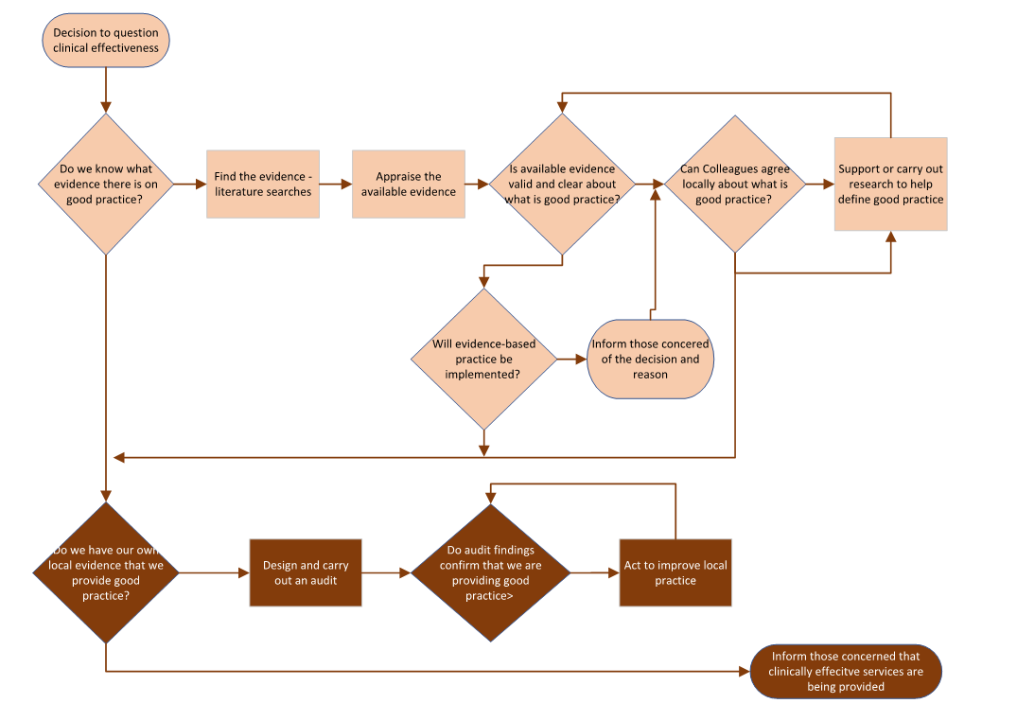
Yes
Yes
No
Yes
No
Yes
Yes
No
No
No
No

Appendix 3: Risk Management, Including Putting Things Right

Risk Management

Public Health Wales is committed to the effective management of risk throughout the organisation, developing and maintaining appropriate systems to allow such management. The organisation is required to clearly define the roles and responsibilities of all staff when it comes to the management of risk, and these can be found within the Organisational Risk Management Policy (PHW56) and in the Risk Management Procedure (PHW56-TP01), or where appropriate in the relevant process document. All staff are required to understand their role and responsibilities and to comply with the requirements of the organisation.

All staff will be expected to use the appropriate corporate systems for risk management. At the time of developing the Risk Management Policy, risk is managed through the Datix platform and the use of risk registers (for operational risk) and the Board Assurance Framework for strategic risks. Whilst there is no specific mandatory training requirement for staff in Corporate Risk Management, those staff who have specific responsibilities will have the appropriate training in order to allow them to carry out the roles. In conjunction with completing Risk Registers on Datix, there is now a question contained within the Datix fields to request users to consider “is this a clinical risk?”. All those involved with managing risk are required to consider this question and check the box appropriately.

Clinical risk management is specifically concerned with improving the quality and safety of health-care services. This is undertaken by identifying the circumstances and opportunities that put those we work with and for at risk of harm and acting to prevent or control those risks. To do this, organisations are required to:

Clinical Risk Management  - Identify the risk  - Assess the frequency and severity of the risk  - Reduce or eliminate the risk  - Cost the risk | Performance Requirements  - Accurate record keeping  - Risk and risk management is routinely discussed at meetings, incorporating patient safety  - Respond to service users and families after an adverse event  - Respond appropriately to complaints  - Maintain own health and well-being | Gather Information  - Incident monitoring  - Adverse Events – including nationally reportable incidents  - Complaints and concerns  - Compliments

Using the processes above, Public Health Wales will be able to:

- Highlight any weaknesses and vulnerabilities in existing and potential new policies, systems, practices, and procedures.
- Focus on reducing or mitigating risks to those we work with and for and allow the organisation to promote innovation to reduce risk.
- Improve decision making about how to deliver safe and consistent services and functions.
- Have a consistent approach to handling risks for all parts of the organisation.
- Assist staff with the knowledge and skills to plan for uncertainty, cope with the impact of unexpected events and avoid unwanted surprises.
- Promote a proactive, risk-aware culture across the organisation.
- Increase confidence in those we work with and for, that services and functions we deliver have well-considered contingency plans.
- Provide assurance to the organisation management that effective processes are in place to identify, understand and manage key risks.

*Further information regarding Risk Management can be found on the corporate pages for Risk Management, Health and Safety, and Estates Policies available here: https://phw.nhs.wales/about-us/policies-and-procedures/policies-and-procedures-documents/risk-management-health-and-safety-and-estates-policies/

Putting Things Right

Public Health Wales has a team dedicated to Putting Things Right. In this section we will encompass an oversight of their functions and requirements in those areas. The team are responsible for:

- Incidents
- Complaints/ Concerns
- Claims/ Redress
- Duty of Candour

For the purposes of this Framework, only incidents, complaints/ concerns and the Duty of Candour will be discussed.

Incidents

Public Health Wales recognises that even with the best of intentions, mistakes can and do happen. Mistakes can lead to unintended consequences on both the organisation and the people we serve. For that reason and in order to try and ensure the safety of service users, staff, and other people with whom we come into contact, Public Health Wales strives to be a learning organisation, where incidents are managed quickly and effectively with minimum impact, and lessons are learned so that the risks of incidents re-occurring are reduced. In Public Health Wales this is called Incident Management.

The organisation will manage incidents by maintaining an Incident Management System, which will include methods and procedures for identifying, assessing, managing, reporting and where necessary escalating incidents. All staff are required to comply with the Incident Management Policy (PHW 32) and follow the Incident Management Procedure (PHW32 TP01) procedures which accompany it. The Incident Management Procedure is the main document which details the responsibilities of individual staff members, and this Policy must be read in conjunction with this document.

Incidents can be detected in a number of ways, although the ways depend on people involved to recognise the event to be reported. The methods and types of events reported can include:

- Staff report any event they feel is reportable, using a generic definition.

- Staff report specific events defined in advance as reportable at the time they are a party to or observe the specific event happening.

- Staff report events defined as Never Events *NB this list is reviewed frequently and will require personnel in the organisation to review via the Welsh Government Website.

- Externally reportable events e.g., Reporting of Injuries, Diseases and Dangerous Occurrences Regulations 2023 (RIDDOR), Ionising Radiation (Medical Exposure) Regulations (IR(ME)R).

The benefits of incident reporting are multifactorial and help the organisation to:

- Encourage and support staff to inform the organisation of situations that could be compromising the quality and safety of services or functions, or potentially contributing to reputational damage.

- Identify patterns of things that happen that can impede the provision of quality and safety of services and functions.

- Carry out timely analysis of the things that don’t go the right way, to learn how organisational systems and processes might be compromised or failing.

- Allocate resources to resolve the circumstances or situations that are compromising the quality or safety of services or functions or reputational damage.

- Disseminate learning across the organisation about things that might not be safe at present and how they can be improved.

- Celebrate success and learning from when things go right.

Patient Safety Incident Reporting

The NHS Wales Executive National Policy on Patient Safety Incident Reporting and Management (2023) Incident reporting and shared learning go hand in hand to help improve the quality and safety of patient care, one of the aspirations of A Healthier Wales. This updated policy empowers organisations to take ownership and accountability for incident reporting and management and sets out clear expectations for patient safety incident reporting across NHS Wales. The updated policy and supporting documents can be accessed through at the following link and should be used with immediate effect. https://executive.nhs.wales/performance-and-assurance/

The Nationally Reportable Incident (NRI) forms will be updated to help improve the quality of information received by the NHS Wales Executive. Using the policy, thematic analysis of patient safety reporting and outcomes will be monitored at National level across NHS Wales.
Documents to support incident investigation are available from the Putting Things Right Team SharePoint pages, available at this link: https://nhswales365.sharepoint.com/sites/PHW_PTRIG/SitePages/Complaints.aspx

*Further information regarding Incident Management can be found on the corporate pages for Risk Management, Health and Safety, and Estates Policies available here: https://phw.nhs.wales/about-us/policies-and-procedures/policies-and-procedures-documents/risk-management-health-and-safety-and-estates-policies/

Complaints & Raising Concerns

A complaint is one way those we work with and for can describe their experience of a healthcare service, function, or organisation. It is generally an expression of dissatisfaction about an act, omission, or decision of a healthcare organisation; verbal or written; and whether justified or not, it will require a response.

The organisation will manage complaints by maintaining a Complaints Management System, which will include methods and procedures for identifying, assessing, managing, reporting and where necessary escalating complaints. All staff are required to follow the Putting Things Right Complaint Procedure (PHWXX). All staff are to consider if the complaint meets the threshold for the Duty of Candour to be applied and follow the instructions provided in the procedure.

These can be divided into two categories:

Term | Meaning | Timelines
Informal | An expression of dissatisfaction about an act, omission or decision that can be resolved quickly to meet the needs or expectations of the complainant. | - Immediately, on the spot, if able  - Within 48 working hours  - Ombudsman guidelines maximum 10 days
Formal | An expression of dissatisfaction which a patient or relative wishes to raise formally and for which a formal response from the organisation is expected. | - Acknowledged within 2 working days of receipt  - Grade 1-2 - 14 Working Days  - Grade 3-4 - 14 Working Days  - Grade 5 - 20 Working Days (exceptional cases may breach this)

To determine if the complaint is informal or formal, please refer to the procedure documentation, where there is a flowchart to guide determination.

An effective complaint handling system within an organisation supports it to:

Promote a learning culture:

- See complaints as an opportunity to develop and improve its services and people.
- Set clear expectations to embed an open, non-defensive approach to learning from complaints.
- Regularly talk to its managers, leaders, those we work with and for about what it has learned from complaints and how it has used learning to improve services for everyone.
- Give colleagues the support and training they need to deliver best practice in handling complaints.

Welcome complaints in a positive way:

- Recognises them as important insight into how to improve services.
- Creates a positive experience by making it easy for those we work with and for to make a complaint.
- Gives colleagues the freedom to resolve issues quickly.

Be thorough and fair:

- Gives an open and honest answer as quickly as possible, considering the complexity of the issue.
- Makes sure those we work with and for who make complaints have their say and are updated accordingly.
- Ensures that those looking into issues are dealt with in a fair and objective way, based on the facts.

Provide fair and accountable responses that:

- Set out what happened and whether mistakes were made.
- Fairly reflect the experiences of everyone involved.
- Clearly set out how the organisation is accountable.
- Give colleagues the confidence and freedom to offer fair remedies to put things right.
- Take action to make sure that any learning is identified and used to improve services.

As detailed with the Public Health Wales Complaints procedure the following can be raised as a complaint:

- Anyone can raise a complaint about any service, function, decision and/or intervention provided by Public Health Wales.

Under the Putting Things Right (PTR) Regulations (Regulation 14), the following cannot be raised as a complaint:

- A complaint notified by a member of staff relating to their contract of employment - these matters would be dealt with under the organisation’s People & Organisational Development policies and procedures.
- A complaint that has been investigated by the Public Services Ombudsman for Wales.
- A complaint which arises out of an alleged failure of the Organisation to respond to a Freedom of Information request. Such complaints would be dealt with by the Information Commissioner’s Office (ICO). Disciplinary action that the Organisation intends to take as a result of the investigation of a complaint (in line with this policy).
- An Early Resolution complaint notified verbally, either in person, or on the telephone which is resolved within 48 hours.
- A complaint that has previously been notified and resolved which the Organisation does not consider reasonable to reopen.
- Complaints, in respect of which court proceedings have already been issued. If court proceedings are issued when a complaint is already under investigation in accordance with the Regulations, all further investigation of the complaint must stop (Regulation 14(1)(i)).

If any of the above are raised as a complaint, Public Health Wales must inform the person raising the complaint of the reason why their complaint cannot be considered, as the above are exempt from the PTR Regulations.

Claims

As highlighted above, this will not be discussed. All personnel are to be aware of the Public Health Wales policy and procedure in relation to Claims. Document links are below:

- https://phw.nhs.wales/about-us/policies-and-procedures/policies-and-procedures-documents/risk-management-health-and-safety-and-estates-policies/claims-management-policy/
- https://phw.nhs.wales/about-us/policies-and-procedures/policies-and-procedures-documents/risk-management-health-and-safety-and-estates-supporting-documents/claims-management-procedure/

*Further information regarding Claims Management can be found on the corporate pages for Risk Management, Health and Safety, and Estates Policies available here: https://phw.nhs.wales/about-us/policies-and-procedures/policies-and-procedures-documents/risk-management-health-and-safety-and-estates-policies/

Duty of Candour

Openness and honesty should be at the heart of every relationship between those providing treatment and care and those experiencing it. In the NHS, we strive to provide high quality, safe and compassionate care to all of our service users. However, even when we do our best, people may sometimes experience harm. That’s why we have the Duty of Candour. Our goal is to create a culture of trust and openness, so that those we work and for feel confident in the care they receive from the organisation.

The Duty of Candour is a legal requirement for NHS Organisations in Wales to be open and honest with service users receiving care and treatment. This is outlined in the Health and Social Care (Quality and Engagement) (Wales) Act 2020.

The Duty of Candour applies if the care we provide has, or may have, contributed to unexpected or unintended moderate or severe harm, or death. This duty builds on our Putting Things Right process for raising concerns or complaints.

What do we Mean by Moderate or Severe Harm?

Duty of Candour Summary Procedure

- On first becoming aware that the duty of candour applies, the NHS must notify the service user or a person acting on their behalf. This contact should be ‘in person’, which means by telephone, video call or face to face.
- The purpose of the ‘in person’ notification is to offer an apology, provide an explanation of what is known at that time, offer support, explain the next steps, and provide point of contact details.
- The service user or person acting on their behalf will be sent a letter within five working days, confirming what was said in the ‘in person’ notification.
- The NHS will undertake an investigation to find out what happened and why, and how we can prevent it from happening again.
- This will take place according to the NHS Wales ‘Putting Things Right’ Procedure.
- The named point of contact provided as part of the Duty of Candour procedure will give you more information about this process and what happens next.
- If you do not want us to contact you, or if you would prefer someone to act on your behalf, please let us know and we will make the necessary arrangements.

*Further information regarding The Duty of Candour can be found on the corporate pages for Risk Management, Health and Safety, and Estates Policies available here: https://phw.nhs.wales/about-us/policies-and-procedures/policies-and-procedures-documents/risk-management-health-and-safety-and-estates-policies/

Patient and Staff Safety – Aligned with NHS Wales Executive National Policy on Patient Safety Incident Reporting and Management (2023)

Public Health Wales is committed to the protection of those it works with and for through systems that ensure that alerts, safety notices and other guidance requiring attention are distributed and acted upon within the required timescales. Organisational policy document, Alerts, Safety Notices and Other Guidance Policy PHW 30 and Alerts, Safety Notices and Other Guidance Procedure PHW 30/ TP01 provide clear direction. All alerts/ safety notices are communicated effectively across the organisation by cascading all safety related information received from the Welsh Government, MHRA etc, using a consistent approach throughout Public Health Wales. The policy does not replace the duty and professional accountability of staff to report any adverse incident with a medical device, hazardous product, or unsafe procedure.

The policy supports compliance with the following key legislative and regulatory obligations:

- Medical Devices Regulations 2002.

- Medical Devices (Amended) Regulations 2008.

- Health and Safety at Work Act 1974.

- Health and Safety at Work Regulations 1999.

- Supply of Machinery Safety Regulation 2008.

- Provision and Use of Work Equipment Regulation 1998.

- Lifting Operations and Lifting Equipment Regulation 1998.

Those areas of the organisation that Alert and Safety Notices are forwarded to for review and action are required to submit a response, in line with the procedure. This is to ensure that the Public Health Wales Board and NHS Executive/ Safety Delivery Unit are provided assurance that Public Health Wales are compliant with the recommendations contained within.

*Further information regarding Alerts, Safety Notices and Other Guidance can be found on the corporate pages for Risk Management, Health and Safety, and Estates Policies available here: https://phw.nhs.wales/about-us/policies-and-procedures/policies-and-procedures-documents/risk-management-health-and-safety-and-estates-policies/

Appendix 4: Information Management

Our information and data management systems must be secure and up to date, meeting the requirements of Information Governance. It applies to all forms of information processed by our organisation; and covers all business functions and the information, information systems, networks, physical environment, and relevant people who support those business functions.

We must ensure that information is available and shared appropriately for all who need it. We turn data to knowledge by triangulating quantitative and qualitative performance, experience, and outcome measures to understand the quality of services, efficacy of improvement work and impact of decisions made. We monitor, report, and escalate indicators through our governance structures to ensure that appropriate action is taken at every level in terms of learning, improvement, and accountability.

Assurance

When using data, all staff must comply with the NHS Wales Information Governance Policy*.

*Further information regarding information governance can be found at Information Governance, Information Management and Technology Policies available here: https://phw.nhs.wales/about-us/policies-and-procedures/policies-and-procedures-documents/information-governance-information-management-and-technology-policies/

Appendix 5: Staff Management

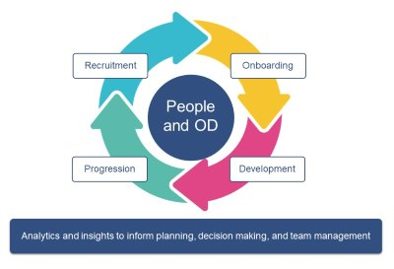

The safe recruitment and management of staff plays a critical role in enabling Public Health Wales to create a vibrant, inclusive, and healthy culture where all our people are supported to thrive. As an organisation Public Health Wales is committed to creating and nurturing a positive, flexible, and sustainable work environment.

Our aspiration is to be an exemplar organisation for wellbeing, where our staff are supported to ensure their experience of work enables them to be healthier, happier in work, and able to be at their best. The key aim is to enhance organisational effectiveness by continually improving the context in which people work at organisation, team, and individual levels whiles ensuring the optimum use of resources to maintain the highest levels of excellence.

Staff Recruitment

When recruiting staff please follow the Public Health Wales Recruitment and Retention Policy. By following this policy Public Health Wales can be assured that they are operating within the confines of NHS Wales and Public Health Wales processes and policies, providing, and following fair, consistent, and effective approach to recruitment and selection.

There are six pre-employment checks to verify that an individual meets the pre-conditions of the role they are applying for. These are:

- Identity check

- Criminal records check

- Work health assessment

- Professional registration and qualification check

- Right to work check

- Employment history and reference check
Staff Appraisal, Management and Retention

An effective appraisal system is a systematic way to identify how staff are currently performing in their defined roles. They identify strengths and weaknesses in performance, both in individual staff and across all staff carrying out similar roles. Most critically, appraisal systems should serve the function of assuring the Board that all the people who are work in the organisation are currently competent, particularly those staff who have direct contact with the public.

A good appraisal system provides the benefits of:

- Identifying the degree of which its workforce has the skills, knowledge, values, and behaviours needed to help the organisation to meet its strategic and business objectives

- Informs the management of the organisation of areas of strong and weak performance in the workforce, so that they human resources strategy can address areas of weak performance across the organisation

- Helps the people working in the organisation to plan and carry out their personal continuing development, based on structured appraisal of actual performance and the needs of the organisation (this will be covered in Appendix 6).

Staff who have access to support, development, and opportunities to be encourages to achieve their individual ambitions is crucial to retention.

Those who are professionally registered are required to maintain their registration in line with the relevant Professional Body. Professional registration checks will be carried out by managers across the organisation.

For further information on staff recruitment and retention, please refer to the Public Health Wales People and Organisational Development pages for further advice and guidance. https://nhswales365.sharepoint.com/sites/PHW_POD

Appendix 6: Training and Education

Public Health Wales recognises the important link between development of staff and development of the organisation; learning is key to competent, effective, and safe delivery of work and responsibilities, as well as engagement, progression, and improvement.​​​​​​​

All staff working within the NHS in Wales must be able to demonstrate that they have attended/ completed minimum core training to ensure their own safety and that of others and have essential knowledge over a number of topics that help us deliver the service we should.
Professional development supports progression to continually develop knowledge, expertise, and human skills in order to uphold high standards. Investing in our staff by supporting and managing their learning and growth ensures relevance in the present and preparing for their future.
Public Health Wales will enable employees to be equipped with the skills and knowledge required in order to effectively deliver and to have a sense of growth, achievement, and progression. There are a variety of incentives available that range from personal development sessions and face to face courses, to online resources.

There are a number of Career Frameworks across the organisation which set out the governance mechanisms to inform the skills and career development required for each stage of the relevant career. They support current and future role development by standardising the scope of the roles, and through recognised learning pathways they provide the underpinning knowledge and skills to practice safely. Examples of the Career Frameworks across the organisation are:

- Healthcare Support Worker Career Framework and Allied Health Professionals

- Practitioner Registration: Ready, Set, Go

- Career Framework for Health Professionals Regulated by the Health and Care Professions Council (HCPC), Nursing and Midwifery Council (NMC) and including Health Care Support Workers Within Public Health Wales

Clinical Supervision

Clinical Supervision is a term used to describe the formal process of professional support, reflection and learning that contributes to individual development through critical self-examination and self-regulation and provides a structured approach to deeper reflection on clinical and professional practice. Clinical supervision is an essential component of Public Health Wales Clinical Governance Framework and our organisational commitment to delivering excellent and safe services.

Public Health Wales has set out its direction within the Clinical Supervision Framework for Health and Care Professionals and Healthcare Support Workers. The aim of the Framework is to ensure that there are core principles in place to underpin clinical supervision arrangements and to ensure a consistent approach in how it is applied with appropriate training and skills acquisition for those leading and providing Clinical Supervision.

Clinical Supervision creates a safe space for healthcare professionals and other practitioners to reflect on their practice with the intention of learning, developing, and improving knowledge, competence, and confidence in their role.

The main target audience for the framework are those who are in clinical or supporting roles. This includes practitioners who provide healthcare interventions directly, or to inform interventions which may be carried out by another health professional e.g., Health Protection, Screening and Microbiology. This framework can be utilised in a wide range of settings and adapted to that particular service or function.

*Further information on Career Frameworks and Clinical Supervision can be found on Public Health Wales Intranet sites. (add links when published)

Appendix 7: Patient/ service user/ public involvement

People are at the centre of everything healthcare organisations do. It is imperative that people’s views and experiences, from a range of equality groups, are gathered and acted upon to shape and improve services. This is not only from service users, but also their representatives and the staff within the organisation. Organisations need to be open and honest with all stakeholders about experience, feedback, and public involvement/ engagement.

Service User Experience

A service user is someone who uses or has access to health services, in any setting, including their families and unpaid carers. Service user experience is what it feels likes to be a user of the NHS. Involving experience of health care is a key priority for NHS Wales and subsequently, Public Health Wales, with the aim to improve the experience and quality of care for individuals and families.

The subject of experience has been justified as a valid indicator of quality because of its intrinsic value and that healthcare services are expected to be humane and compassionate. However, this concept has caused concern within healthcare organisations as it could cause them to focus on the wrong priorities. Measures of patient experience is subjective and qualitative. It must be recognised that service users are accurate sources of information and arguably, more informed and engaged services users, result in better relationships between organisations and their service users.

An effective experience and feedback programme will aim to:

- Ensure organisations have methods available to enable all experiences feedback at a time and location of people’s choosing.
- Enable timely resolution of issues raised.
- Key themes and trends arising from experience/ feedback of all types can be monitored.
- Provide evidence-based assurance that the key components of the experience and feedback are being assessed and that action is taken to deliver improvements.

Experience Feedback Methods

People, communities, and stakeholders provide feedback in a wide variety of ways. Some may be specifically designed by organisations to encourage feedback, however there are many other sources. It is important people, communities and stakeholders feel that their views, positive, negative, or neutral, are welcomed, that notice will be taken, and improvements made where necessary.

A range of methods are available to gain feedback. Much of the published experience relates to hospital settings although most of them are also applicable to people and communities in other settings. It is important that organisations use feedback and experience from all sources to gain a balanced view of the quality of the organisations service, programmes, and functions. The feedback and experiences gathered can and should be used to support all quality improvement developments. A summary of methods is shown below:

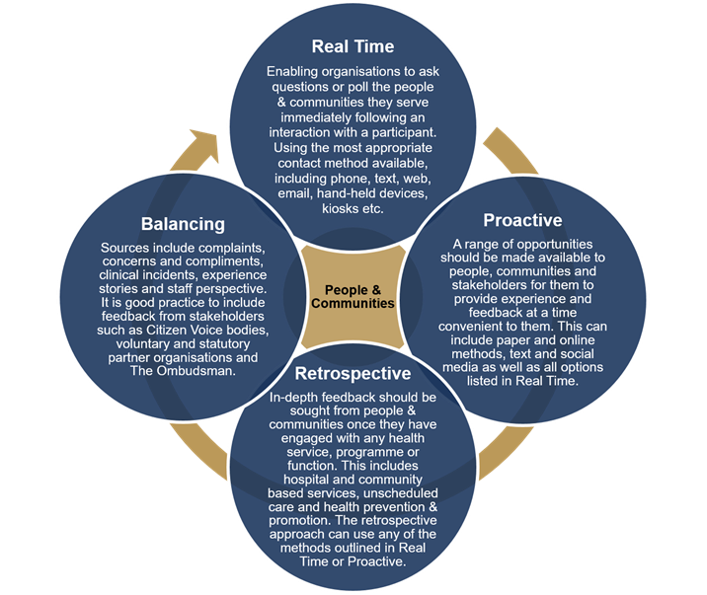
Civica

In Public Health Wales, Civica is the central system for capturing and analysing the feedback and experiences of the people we work with and for. It is used to understand real-time feedback and experiences about services, programmes, and functions, which in turn supports prioritisation and drives quality improvements. Civica was procured in partnership with all NHS Wales organisations to create a ‘Once for Wales’ approach.
Civica – Benefits

Civica is used to conduct surveys through paper or a mixture of survey applications like Survey Monkey, Microsoft forms or Google forms. Civica is bringing many benefits, including the potential to:

- Be the single solution to all people, communities, and stakeholders experience and feedback whether that is a bespoke workshop, mass survey, conference feedback or large-scale population work such as the ‘How are you doing’ survey.

- Transform the organisations’ ability to capture, analyse and act on experience/feedback. It opens up the opportunity for all those we work with and for to leave experience and feedback at a time and location of their choosing.

- The system is cloud based and can be accessed via any web browser. It can produce easy read, picture-based surveys, and create children-friendly templates.

- The system has the ability to have directorate, team or programme level dashboards, automated reporting, action flagging, sentiment analysis, trend graphs, heat mapping and key word highlighting.

Public Involvement/ Engagement

‘Our Approach to Engagement’ in Public Health Wales was launched in 2021. It was driven by three pieces of legislation:

- Equality Act 2010.
- Well-being of Future Generations Act (Wales) 2015.
- Health & Social Care (Quality and Engagement Act) 2020.

It has a pivotal role to play in optimising the role of Public Health Wales to protect and improve the health and well-being of the population of Wales. Its core principles are:

- Engagement with the people we work with and for is a core public health activity.
- It is essential in delivering against our strategies.
- It is the responsibility of us all.
- We are creating new ways to support teams to benchmark where they are at present and provide suggestions on how to improve.

The Spectrum of Public Participation is an internationally recognised model developed to help clarify the role of the public in planning and decision making, and how much influence the community has over planning or decision-making processes. The model identifies five levels of community engagement below:

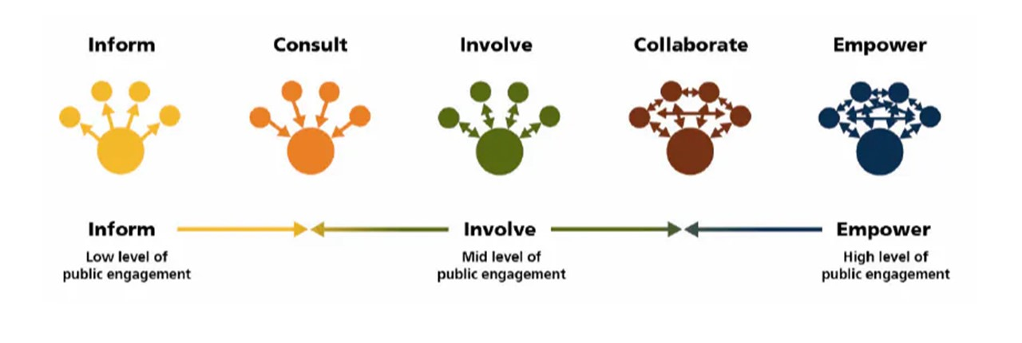

The diagram above represents the different levels of engagements that organisations can engage their communities, with the farthest right of the spectrum highlighting greater community influence on decision making.

For public involvement/ engagement to be undertaken well, Public Health Wales has committed to the following:

- Committed Workforce: Staff who understand and appreciate the benefits of engagement so that they are predisposed and committed to take on these activities.
- Skills & Capability: Staff with the right skills and appropriate training opportunities so that engagement activity is delivered in an inclusive and empowering way, with impact and consistency, across the organisation.
- Relationship Building: Strong relationships with the public and stakeholders who can work with us to support our reach.
- Tools & Resources: A suite of tools that enable our teams to undertake engagement activity effectively, confidently, and consistently.
- Monitoring & Evaluation: Clear demonstration of impact of engagement activity to drive improvements and strong feedback loops with those who engage with us.

Appendix 8: Public Health Wales Quality and Quality Enabling Statement

Quality Statements

Safe | PHW | We provide high quality, reliable and safe services, highlighting excellent practice and learning when things go wrong. We will ensure that our staff are suitably skilled and knowledgeable to protect the health, safety, and welfare of those we work with and for.
Timely | PHW | Those we work with and for have easy access to high-quality services, advice, and guidance for public health interventions, at the right time and place to meet the required need.
Effective | PHW | Those we work with and for have access to screening, specialist advice, treatment and support that provides the best outcome for them. We ensure that our services are transformative, evidence based, with across life pathways covering prevention, health protection and treatment to promote quality of life.
Efficient | PHW | We will make the most effective use of our resources, ensuring we build capacity and capability across the organisation to achieve best value healthcare in an efficient way. We will only do what is needed to gain the most benefit, ensuring services represent the best value for money that will improve outcomes for those we work with and for in a sustainable way, avoiding waste.
Equitable | PHW | PHW will continually strive to ensure that people have every opportunity to live healthy and happy lives, regardless of age, gender, sexual orientation, race, language preference, disability, religion or belief, socio-economic status, or political affiliation, and that our services are designed and developed based on the diverse needs of the people we serve.
Person (Population) Centred | PHW | Our services will meet the needs of those we work with and for, ensuring their preferences and values guide decision making. We will care about the wellbeing of those we work with and for, ensuring all are treated with kindness, empathy, respect, and dignity.

Enabling Statements

Leadership | Duty of Quality | Our health care system has visible and focused leadership at all levels, with its activities driven by the organisations’ vision and values for quality. Our leaders and managers take a long-term, stakeholder-centric view to develop a clear organisational vision. They have the appropriate skills and capacity to create the conditions for a functioning quality management system. We ensure our governance, leadership and accountability is effective in sustainably delivering care.
Workforce | Duty of Quality | Our healthcare system recruits, retains, develops, and extends roles to ensure we have enough, confident people with the right knowledge and skills available at the right time to deliver safe care. We value our people and the commitment and resilience they demonstrate in the care they provide. We care about their wellbeing, protect their rights, and support them to feel well and happy at work; and provide them with the tools, systems, and environment to work safely and effectively. Our workforce planning focuses on investing in our people and nurturing, growing, and transforming our workforce to create a sustainable workforce for the future.
Culture | Duty of Quality | Our healthcare system creates the right climate and culture to nurture and encourage quality and system safety, valuing people in a supportive, collaborative, and inclusive workplace so that our people feel psychologically safe to raise concerns and try out new ideas and approaches. Relationships within teams and with the people we serve are effective and based on transparency, accountability, ethical behaviour, trust and just culture, where people can thrive.
Information | Duty of Quality | Our healthcare system ensures information is available and shared appropriately for all who need it. We turn data to knowledge by triangulating quantitative and qualitative performance, experience, and outcome measures to understand the quality of services, efficacy of improvement work and impact of decisions made. We monitor, report, and escalate indicators through our governance structures to ensure that appropriate action is taken at every level in terms of learning, improvement, and accountability.
Learning, Improvement and Research | Duty of Quality | Our healthcare system creates the conditions and capacity for an organisation and system-wide approach to continuous learning, quality improvement and innovation, which it actively promotes. We use new knowledge to influence improvements in practice and to inform our decision-making. We ensure our learning and improvement activity is linked to our strategic vision to deliver transformational, organisation-wide change. We commit to participating in research because research-active organisations provide improved quality of care and outcomes for people.
Whole Systems Approach | Duty of Quality | Our healthcare system ensures safety in healthcare goes beyond individual patient safety. We will look within and beyond our organisational boundaries to learn how we can continually, reliably, and sustainably meet the evolving needs of people. We will strengthen relationships and work with all of our partners to achieve good outcomes. Our policies incorporate the broader ambitions within the seven well-being goals and five ways of working in the Well-being of Future Generations Act.

Public Health Wales. (2023). Working Together for a Healthier Wales. Our Long-Term Strategy 2023-2035. https://phw.nhs.wales/about-us/working-together-for-a-healthier-wales/phw-long-term-strategy-pdf/ Accessed online 2 June 2023.
Welsh Government. (2023). Duty of Quality Statutory Guidance https://www.gov.wales/sites/default/files/publications/2023-04/duty-of-quality-statutory-guidance-2023_0.pdf. Accessed 3 May 2023.
Welsh Government. (2023). Duty of Quality Statutory Guidance https://www.gov.wales/sites/default/files/publications/2023-04/duty-of-quality-statutory-guidance-2023_0.pdf. Accessed 3 May 2023.
UK Government. (2003). Health and Social Care (Community Health and Standards) Act 2023. https://www.legislation.gov.uk/ukpga/2003/43/contents. Accessed 3 May 2023.
Francis, R. QC. (2013). Report of the Mid Staffordshire NHS Foundation Trust Public Enquiry. Ref: ISBN 970102981476, HC2012-12. https://assets.publishing.service.gov.uk/government/uploads/system/uploads/attachment_data/file/279124/0947.pdf Accessed online 12 May 2023.
HM Government. (2011). Clinical governance guidance. https://gov.uk.government/news/clinical-governance-guidance. Accessed online 17 May 21.
CQC Compliance. (2023). Pillars of Clinical Governance. https://cqc-compliance.com/clinical-governance/#:~:text=Clinical%20governance%20is%20a%20system,safeguarding%20high%20standards%20of%20care. Accessed online 3 May 2023.
Welsh Government. (2021). Quality and Safety Framework: Learning and Improving. https://www.gov.wales/sites/default/files/publications/2021-09/quality-and-safety-framework-learning-and-improving_0.pdf. Accessed online 17 May 23.
Public Health Wales. (2021). Quality and Improvement Strategy 2021 – 2030. https://phw.nhs.wales/about-us/policies-and-procedures/policies-and-procedures-documents/strategy/phw-quality-and-improvement-strategy-2021-2030-e-pdf/ Accessed 14 June 2023.
Welsh Government. (2023). NHS Wales Complaints and Concerns: Putting Things Right. https://www.gov.wales/nhs-wales-complaints-and-concerns-putting-things-right Accessed online 14 June 2023.
Health Quality Improvement Partnership (2011) New Principles of Best Practice in Quality and clinical audit’, Radcliffe Publishing: Oxford
Healthcare Quality Improvement Partnership. (2020) Best Practice in Clinical Audit Guidance. https://www.hqip.org.uk/resource/best-practice-in-clinical-audit/#.XNrF8MeWyUk. Accessed 19 May 23.
World Health Organisation. Understanding and Manging Clinical Risk: Teaching Guides. https://cdn.who.int/media/docs/default-source/patient-safety/curriculum-guide/resources/ps-curr-teach-guides/topic-06_understanding-and-managing-clinical-risk_teaching-slides.pdf?sfvrsn=f4469_9. Accessed 17 May 23
Welsh Government. (2022). Never Events: Policy and Incident List. Welsh Health Circular. https://phw.nhs.wales/about-us/policies-and-procedures/policies-and-procedures-documents/risk-management-health-and-safety-and-estates-supporting-documents/incident-management-procedure-2-1/ Accessed 18 May 23.
Welsh Government. (2023). NHS Wales Executive National Policy on Patient Safety Incident Reporting and Management. Welsh Health Circular WHC/2023/017. https://www.gov.wales/sites/default/files/publications/2023-05/policy-on-patient-safety-incident-reporting-and-management.pdf Accessed 19 May 23.
Berwick, D. (2009). What Patient Centred Should Mean: Confessions of an Extremist. Health Aff (Millwood) w555-65, doi: 10 1377/hlthaff.28.4.w655.
UK Government. (2010). Equality Act. UK Public General Acts. https://www.legislation.gov.uk/ukpga/2010/15/contents. Accessed 22 May 23.
Organizing Engagement. Spectrum of Public Participation. https://organizingengagement.org/models/spectrum-of-public-participation/. Accessed 21 May 23.

