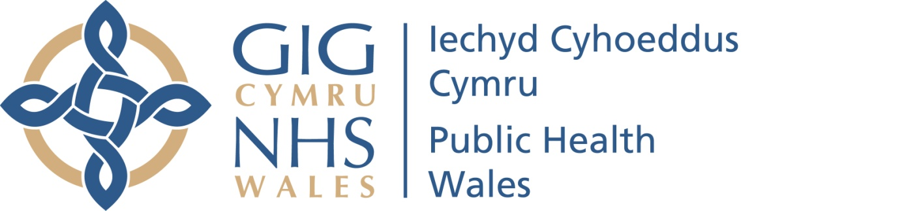
Safeguarding Group Meeting
Terms of Reference and Operating Arrangements
Date: 13 April 2022 | Version: 2
Review Date: Annually
- Introduction

The Safeguarding Group Meeting is established in accordance with Public Health Wales (PHW) scheme of delegation. The Business Executive Team (BET) is supported by the cross organisational Safeguarding Group chaired by the Executive Director for Quality, Nursing and Allied Health Professionals as the lead Executive responsible for organisational Safeguarding arrangements, to oversee organisational arrangements and monitor progress in relation to the corporate safeguarding agenda. The Quality, Safety and Improvement Committee (QSIC) is the main Board Committee (on behalf of the Board) to oversee and take assurance on Safeguarding arrangements within Public Health Wales and is chaired by the Vice Chair of Public Health Wales. Both BET and QSIC monitor progress and receive key elements of assurance through the Safeguarding Maturity Matrix annual improvement plan, annual Safeguarding Report and other relevant reports. These terms of reference set out the membership, remit responsibilities and reporting arrangements of the Group
- Purpose

The purpose of the Safeguarding Group Meeting is to provide:

- Evidence based polices, procedures and guidance and timely advice to support PHW in discharging its statutory responsibilities under relevant legislation to safeguard and promote the welfare of children and vulnerable adults.

- Assurance to the Board in relation to the PHW’s arrangements for all safeguarding arrangements in accordance with its stated objectives and the requirements and standards determined by the NHS and relevant Legislation in Wales. This Safeguarding Group Meeting will contribute to the reporting on progress of any work plans/Improvement plans and provide assurance to BET and subsequently to QSIC.

- Consider prior to approval by the Board, relevant policies, procedures and other written control documents in accordance with the Trust’s Scheme of Delegation.

- Delegated Powers

With regard to its role in providing advice and assurance to the Board, the Safeguarding Group Meeting will:

  - provide a forum to consider all issues relating to Safeguarding within Public Health Wales and to take decisions on areas delegated by the Business Executive or Board

  - seek assurances that there is the appropriate culture and arrangements in place to enable the organisation to discharge its statutory and Legislative responsibilities about:
- Safeguarding Adults and Children
- Violence against Women, Domestic Abuse and Sexual Violence
- Any areas which relate to the Safeguarding agenda

To achieve this, the Safeguarding Group Meeting will support the development and monitoring of the application of relevant policies and procedures. The group will support the progress and quality assurance processes relating to the submission of the annual Safeguarding Maturity Matrix designed to continually improve Safeguarding within the organisation and will contribute to the progress of the Safeguarding group workplan.

The Safeguarding Group Meeting will advise the Business Executive and the Board/Board Committee on the application adoption of relevant policies, standards and best practice, against which the organisation can be regularly assessed:

- Ensure arrangements are in place to provide relevant performance reports in support of improvements and progress in the adoption of other relevant standards.

The Safeguarding Group Meeting will seek assurance with regard to the requirements of the relevant Health Care Standards or any subsequent requirements which may be introduced by NHS Wales relating to Safeguarding.

- Sub-Committee/Groups

The group may establish if necessary sub-groups to support the delivery of its role.

- Accountability
The Executive Director of Quality, Nursing and Allied Health Professionals is the Executive lead for organisational safeguarding arrangements.
The Safeguarding Group is accountable to, and reports to the Business Executive Team.
The Group is provides assurance to the Board (via the Quality Safety and Improvement Committee) through bi-annual reporting.

- Membership, Attendees and Quorum

6.1 Members

Membership of the Group
• Executive Lead (Chair)
- Assistant Director of Quality, Nursing and Allied Health Professionals
- Named Lead for Safeguarding
- Directorate/ Division Leads as required (specific Divisional representation for those services/functions providing direct services. i.e., Screening, Health Protection and Microbiology).

- Workforce & Organisational Development Professional and Organisational Development
- Designated Professional, National Safeguarding Team
• Assistant Director of Integrated Governance
Business Manager
• Subject matter specialists as required

• Administration Support (Secretary)
By invitation: the Chair may also invite any other organisational representatives or others from outside the organisation to attend all or part of a meeting to assist it with its business
6.2 Quorum

The quorum of the group will be 50%, which must include Chair or Vice Chair
7. Frequency of Meetings

Meetings shall be held no less than quarterly and otherwise as the Chair of the Committee deems necessary.

- Relationships and accountabilities with the Board and its Safeguarding Group Meeting

The Safeguarding Group Meeting must have an effective relationship with the Business Executive Team Meeting and the Quality, Safety and Improvement Committee so that it can understand the system of assurance for the Board as a whole. It is very important that the Safeguarding Group Meeting remains aware of its distinct role and does not seek to perform the role of other committees. Assurance is provided through this scheme of delegation through the Executive Director for Quality, Nursing and Allied Health Professionals.

