 |  | Reference Number: PHW 74- TP01  Version Number: v2  Date of Next review: 31 July 2025 (TBC)
Quality and Clinical Audit Procedure

Introduction and Aim
Public Health Wales (PHW) recognises that quality and clinical audit is an important mechanism for providing assurance in the provision of safe, timely, effective, efficient, equitable, and person-centred services, programmes and functions, and is an important way of learning about what is working well and identify areas for improvement. The aim of the procedure is to standardise how quality and clinical audit is undertaken within the organisation.

Linked Policies, Procedures and Written Control Documents
Putting Things Right Policy Quality and Improvement Strategy
Incident Reporting Policy Health and Care Standards (2015)
Claims Management Policy
Scope

This procedure is applicable to all staff with responsibilities for Quality and Clinical Audit.

Quality and Clinical Audit supports the Public Health Wales Quality and Improvement Strategy to drive quality, improvement and innovation which impacts positively on health outcomes and the wellbeing of the population of Wales. Audit is one of the seven pillars of clinical governance which forms a framework to sustain and improve standards throughout organisations.

The audit process is one mechanism by which practice can be continuously monitored and deficiencies in delivery can be remedied. Having a more coherent and comprehensive approach to audit reflects our strategic intention to strengthen our approach to clinical governance and compliment other quality improvement activity. Quality and clinical audit is one tool utilised to provide assurance.

Public Health Wales is committed to aligning audit across the organisation and this procedure is to be considered in conjunction with audit activity completed with Audit Wales, Internal Audit, and peer review, which are subject to separate audit plans.

This procedure does not extend to research (to study a subject in detail, especially in order to discover new information or reach a new understanding and is managed through the governance process); nor evaluation (which sets out to assess the effectiveness or efficiency of an existing or new service/programme/function that is evidence based).

This procedure does not extend to Internal and External Audits, which are managed under a separate process.

Equality and Health Impact Assessment | This has been completed and no impact has been identified.
Approved by | Leadership Team
Approval Date | 20 July 2022 (TBC)
Review Date | 20 July 2025 (TBC)
Date of Publication: | To be confirmed following approval.
Accountable Executive Director/Director | Rhiannon Beaumont-Wood, Executive Director Quality, Nursing and Allied Healthcare Professionals.
Author | Jessica Taylor, Quality Improvement and Clinical Audit Support Officer, Quality, Nursing and Allied Healthcare Professionals.

Disclaimer
If the review date of this document has passed, please ensure that the version you are using is the most up to date either by contacting the document author or the Board Business Unit

Summary of reviews/amendments
Version number | Date of Review | Date of  Approval | Date published | Summary of Amendments
V1 |  | 31/07/19 |  | New procedure
V2 | May 2022 | TBC | TBC | Addition of flowcharts for process for registering an audit and for completing an audit  Addition of priority levels and guidance on the use of these  Updated Appendix 2 (report template)  Requirement added for Delivery Confidence Assessment to be reported to Business Executive Team quarterly

Introduction
Public Health Wales seeks to be a high performing organisation achieving excellent results and sustained improvements by determining and focusing on what is important organisationally and what matters to people and our population.
Quality and clinical audit is one of the pillars of the framework for clinical governance and an important quality assurance tool. It is complementary to other improvement methodologies and is a useful way of learning about what is working well and not so well. Public Health Wales will take every opportunity to learn by recognising and sharing good practice through innovation and enabling change.
Public Health Wales is committed to aligning audit across the organisation and this procedure is to be considered in conjunction with audit activity completed with Audit Wales, Internal Audit, and peer review. However these audit activities are subject to separate audit plans and more detail is provided in Appendix 1.

Purpose
The purpose of this procedure is to ensure that Public Health Wales meets its mandatory obligations in relation to quality and clinical audit and to set out a framework for staff who are, or who wish to undertake quality and clinical audit within Public Health Wales to support an organisational culture of improvement.

What do we mean by Quality and Clinical Audit?

Audit is one of the seven pillars of clinical governance and forms part of an assurance process, which can sustain and improve standards, subsequently improving the quality of services provided. Quality is defined as continuously, reliably and sustainably meeting the needs of the population that we serve. To achieve this, we must ensure our services and functions are safe, effective, person-centred, timely, efficient and equitable. Quality and clinical audit is an effective tool to assess perceived or known areas of risk and vulnerability. Priority should be given to areas most critical to operational and organisational aims and objectives.

Quality and clinical audit aims to improve quality and provide assurance by measuring existing practice against evidence-based standards, for example: The National Institute of Health and Care Excellence (NICE). Quality and clinical audit is a tool that can be utilised to inform practice and involves the measurement of the effectiveness against agreed and proven standards/evidence. Where indicated, changes are implemented, and further monitoring is used to confirm improvement (Healthcare Quality Improvement Partnership 2011).
Quality and clinical audit is intended to answer the question “Does this service, programme or function reach the expected standard?” and:

- Measures the quality of a service, function or programme being delivered.
- Identifies whether the best standards (where appropriate) are being delivered.
- Measures practice against explicit criteria and defined standards or guidance.
Sometimes there is no standardised approach for a process or practice. Consequently, a baselining activity may be undertaken to measure the current practice, with no reference to a standard, with the purpose to use this to aid the development of a service/function and introduce standardisation of a process. This may be included in the Quality and Clinical Audit Plan, with the expectation that an audit is undertaken once the standardised process is implemented.
Quality and Clinical Audit does not include research (to study a subject in detail, especially in order to discover new information or reach a new understanding and is managed through the governance process); nor evaluation (which sets out to assess the effectiveness or efficiency of an existing or new service/programme/function that is evidence based). For more information, see Research and Development.

Annual Quality and Clinical Audit Plan
Public Health Wales is required to have a Quality and Clinical Audit Plan in place for each financial year. Directorates/divisions are to identify audits to include within the annual plan.
The following are examples of areas that could help identify topics for audit:

- Directorate and divisional risk registers and issue logs.
- Identified improvement plans from the Health Care Standards annual review and assessment.
- Lessons learnt from clinical/programme incidents, concerns and claims.
- Feedback and experience provided by the people with work with and for
- National quality and clinical audits (Public Heath Wales may contribute when required).
- Externally imposed standards. e.g. to demonstrate the required standards required for UK National Screening Programmes are being met.
- Wanting to know more about a particular issue, which could be used to inform further improvement activity e.g. in response to an external review/piece of work.
- Areas of public health practice.
- Health and Safety.
Individuals planning to undertake a specific audit will need to consider the following when developing their plans:

- Is the audit being undertaken on subjects that will benefit the delivery of services, programme or functions and improve quality and/or address risk?
- Does the audit routinely include specific measures of quality, that is, standards, criteria or indicators? Do they refer to current evidence where evidence is likely to exist?
- Would the data collection and collation process be transparent and likely to produce reliable data that the wider team would be willing to act on?
- Would the audit completed be worth the time and effort taken to carry them out?
- Would the audit carried out lead to improvements in practice? If not, what barriers to implementing change should be considered?
- Would the audit confirm good practice or serve any other important purpose?
- Could data collection be routinely and quickly repeated to see if an improvement have been made?
The plan includes two categories of Audit:

Externally reported audits
Public Health Wales will agree an annual planned programme of quality and clinical audit activity in response to a statutory duty to participate in relevant national quality and clinical audits. These include audits within the National Quality and Clinical Audit and Patient Outcomes Programme (NCAPOP), those required by Welsh Government, and those required by UK National Screening Programmes. These audits are undertaken and reported to external bodies. Public Heath Wales will consider the recommendations of national quality and clinical audits and implement those relevant to the organisation’s activities.

Internally reported audits (to be determined by the Directorate/Division)
Locally generated audits which are reported internally are those audits of quality and clinical / public health practice undertaken within Public Health Wales, and where appropriate should “reflect nationally agreed best practice definitions”.

Process for registering an audit in the Annual Quality and Clinical Audit Plan
Figure 1 outlines the overall process for identifying a new audit and registering it in the organisational Annual Quality and Clinical Audit Plan.
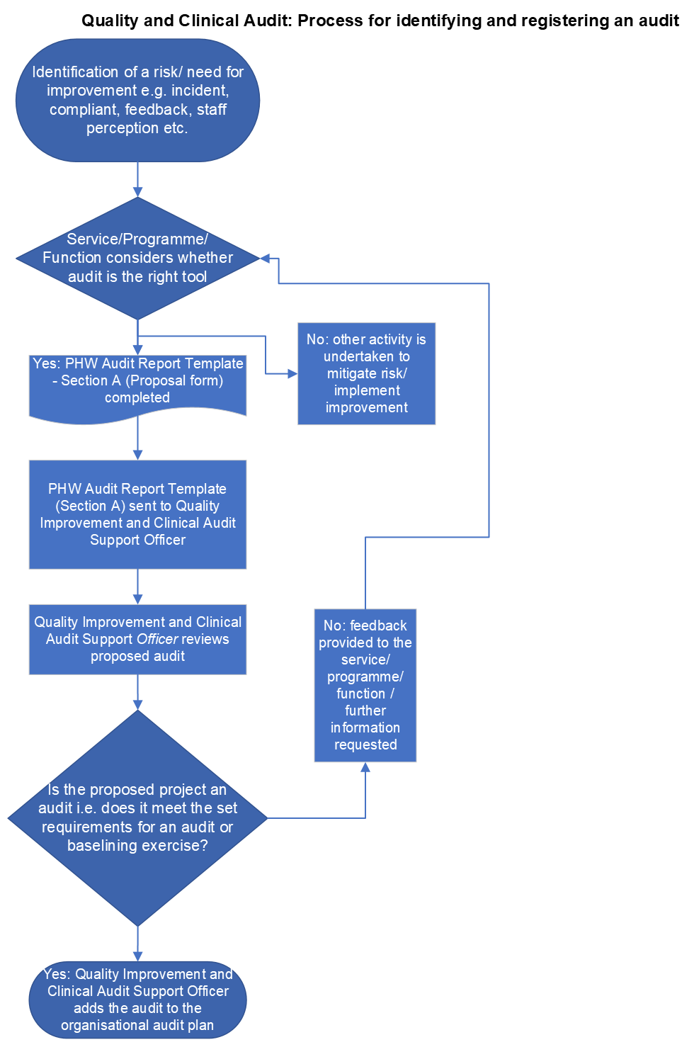
(Figure 1)

Registering an audit for the Annual Quality and Clinical Audit Plan
All quality and clinical audits must be registered in the organisational Annual Quality and Clinical Audit Plan. For an audit to be registered, Section A of the PHW Audit Report Template (Appendix 2) must be completed and submitted to the Quality Improvement and Clinical Audit Support Officer. This will then be reviewed to ensure the proposed project meets the requirements of a quality and clinical audit (see 1.1) before the audit is added to the plan.

Prioritising audits within the Annual Quality and Clinical Audit Plan

An effective quality and clinical audit programme should reflect key national, organisational and local drivers to support the organisational clinical governance framework and quality improvement, whilst providing assurance against key risks. A system of prioritisation ensures drivers for improvement and risk mitigation are balanced with projects that are important at the directorate/ division/service level. All quality and clinical audits should contribute to strategic or operational priorities.

Compiling and prioritising the annual quality and clinical audit plan at the start of the year does not limit new projects from being added to the plan and prioritised appropriately. Indeed, new ‘must-do’ audits may be added in response to concerns that arise. Similarly, staff-led innovative ideas may be proposed throughout the year to be considered.

The National Healthcare Quality Improvement Partnership ‘Developing a Clinical Audit Programme’ guidance (HQIP, 2016) has been used to inform the following priority levels.
One of the below four priority levels is to be assigned to all quality and clinical audits:
- Priority level one: External ‘must do’ quality and clinical audits
- Priority level two: Internal ‘must do’ quality and clinical audits
- Priority level three: Directorate / division level priority quality and clinical audits
- Priority level four: Staff member interest quality and clinical audits

Priority level one – external ‘must do’ quality and clinical audits
These are audits which are mandated by external bodies and reported externally. For instance, these may include audits required by Welsh Government, audits required for external accreditation schemes, or audits of externally imposed standards, e.g. to demonstrate compliance with the required standards for UK National Screening Programmes.

Priority level two – internal ‘must do’ quality and clinical audits
These are audits based on high risk, high cost or high-profile topics. For instance, these quality and clinical audits may arise from:
- Significant risk issues
- Serious incidents
- Claims
- Persistent / local concerns arising from trend analysis of complaints and/or incidents
- Priorities identified via patient and public involvement initiatives
- Evidence of a significant issue from service user and consumer feedback
- Issue that could have significant impact on service delivery

Priority level three - directorate level priorities
There may be audits which are important at the directorate / division / service level, which do not meet the criteria of high-risk, high-cost or high-profile, which would fall into the third priority level. These audits play a critical role in quality improvement. These quality and clinical audits may arise from:
- Evidence of variation in practice
- Concerns and incidents (not considered high-risk or serious)
- Audits undertaken as part of clinical speciality networks
- Areas identified through Health and Care Standards reporting where further improvement could be made (i.e. a score of 4 or 5).

Priority level four – staff member interest audits
These are audits proposed by individual members of staff, which may be for personal interest of an improvement that could be made, for training or revalidation purposes. Focus on making improvement should still be central to these proposed audit projects. These audits should be reviewed by Quality Leads / Business Leads (as appropriate) to determine if the topic concerned is high-risk or high-cost, or a directorate level priority, and therefore should be granted a higher priority level.

Re-audits
When a re-audit is undertaken, the priority level of the re-audit should be reviewed and assigned accordingly. The priority level does not necessarily have to remain the same as that applied to the original audit. For example, an audit may have been undertaken that was a Priority Level 3, however the findings evidence significant variation in practice that presents a significant risk. Improvements are implemented, and a re-audit is undertaken at Priority Level 2, as this is now addressing a high-risk concern.

Undertaking Quality and Clinical Audit

Figure 2 outlines the overall process for undertaking a quality and clinical audit.

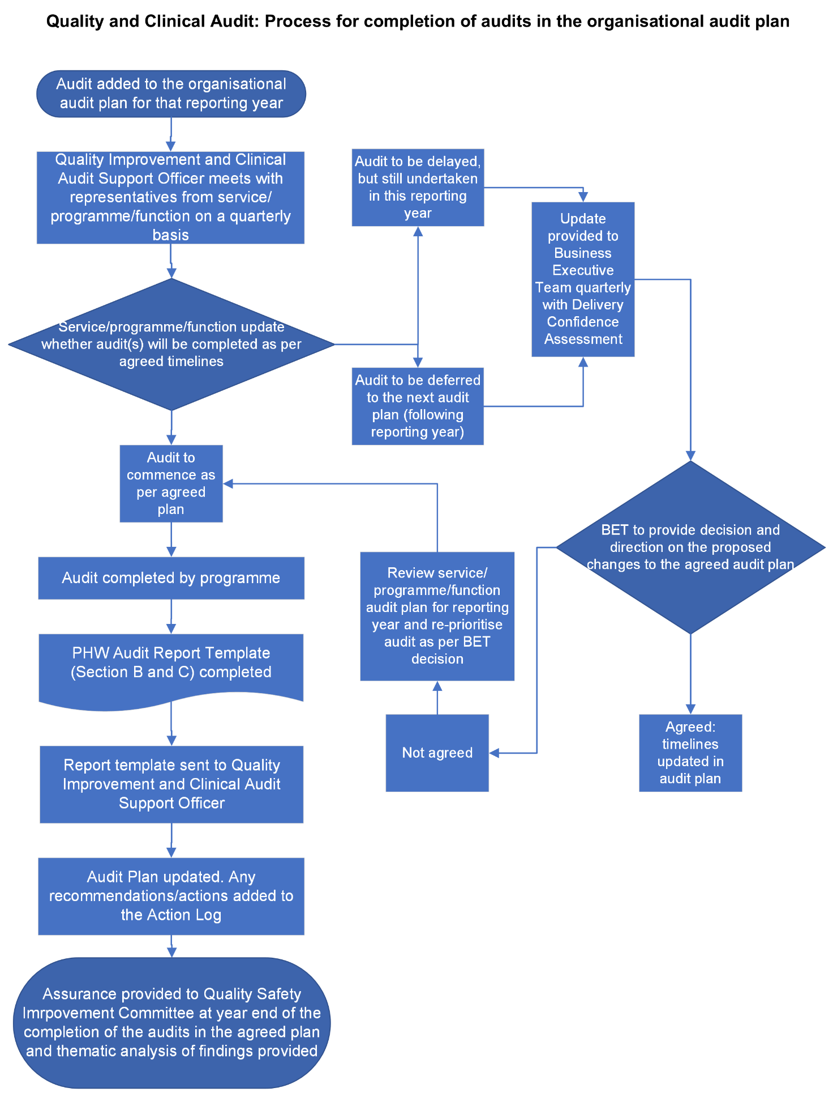
Figure 2

Roles and Responsibilities

Quality Safety and Improvement Committee (QSIC)
QSIC seeks assurance on the quality and clinical audit plan, it’s fitness for purpose and the delivery of the plan. It seeks assurance that the appropriate arrangements are in place to prevent, detect and rectify irregularities or deficiencies in the quality, safety and effectiveness of services, functions and programmes. QSIC also seeks detail on the quality and clinical outcomes and improvements made as a result of clinical audit.

Business Executive Team (BET)
BET takes assurance of the overall management of Quality and Clinical Audits and authorises proposed changes to the agreed annual quality and clinical audit plan.

Quality, Nursing, and Allied Health Professionals (QNAHPs) Directorate
QNAHPS is responsible for creating the framework for the annual Quality and Clinical Audit Plan, whilst providing oversight and maintaining quality and clinical audit database and reporting to the Quality Safety and Improvement Committee.

Executive Director
Ensure that the Quality and Clinical Audit are incorporated into Directorate and Divisional plans

Divisional Leads
Divisional leads in each Directorate are responsible for annual planning and co-ordination of their audits for inclusion on the “annual plan” and registering the plan with QNAHPs

Quality Improvement and Clinical Audit Support Officer
A copy of the approved proposed local audit is to be forwarded to the Quality Improvement and Clinical Audit Support Officer, Quality Nursing and Allied Healthcare Professionals Directorate.

Reporting Process
QNAHPs will collate the audits and submit the Annual Quality and Clinical Audit Plan to the Executive Director Quality Nursing and Allied Healthcare Professionals prior to approval by the Business Executive Team and to the Quality, Safety and Improvement Committee. At 6 and 12 months, respectively QNAHPs will produce an interim progress report and a year-end position report on the quality and clinical audit plan to provide assurance of the progress of the plan to the Business Executive Team and the Quality, Safety and Improvement Committee.
The Quality Improvement and Clinical Audit Support Officer will meet with representatives from each programme/service/function on a quarterly basis to obtain progress updates on the agreed audits.
Once the Annual Quality and Clinical Audit Plan has been approved, a quarterly Delivery Confidence Assessment will be submitted to the Business Executive Team. If any audits are at risk of not being completed in the agreed timeframe, the Business Executive Team will need to approve deferring these audits to the following reporting year.

Sharing learning from audits
In addition to reporting audit findings within Directorates, the completed PHW Audit Report Template (Sections B and C) must be submitted to the Quality Improvement and Clinical Audit Support Officer. A thematic analysis of completed audits will then be produced for the Business Executive Team and the Quality, Safety and Improvement Committee at year-end.
QNAHPs will facilitate the sharing of learning from audits across the organisation through a central repository and proactively sharing examples of good practice and improvement.

Action Plans
One of the main purposes of quality and clinical audit is to deliver improvements in standards and outcomes of practice. Where the results of an audit indicate sub-optimal practice or an improvement opportunity, a draft action plan should be produced by the Lead responsible for the initial audit in Section C of the PHW Audit Report Template (Appendix 2). This should be specific, measurable and realistic with identified leads and a realistic timescale for each action. Actions for each service/programme/function will be collated by QNAHPs and added to an organisational audit Action Log. Progress against these actions will be monitored quarterly and reported bi-annually to the Business Executive Team and subsequent assurance to the Quality, Safety and Improvement Committee.

Training
Public Health Wales will make available suitable training and education in quality and clinical audit. Once individuals have attended training, there is the opportunity for further self-guided study taking approximately six hours, which will provide accreditation for the Advanced Clinical Audit Training Qualification.
This will raise the profile of quality and clinical audit and build capability and capacity; thus, acting as a contributory driver for quality improvement.

Governance and Ethics

Equality
The process for determining the choice of local quality and clinical audit and or service evaluation projects must not inadvertently discriminate against any groups in society based on their race, disability, sex, age, sexual orientation, gender reassignment, religion and belief.

General Data Protection
All quality and clinical audit activity must take account of the General Data Protection Regulation (GDPR) 2018 and the Caldicott Principles (1997, 2013). This means that you should:

- Justify the purpose(s).
- Don’t use personal confidential data unless it is absolutely necessary.
- Use the minimum necessary personal confidential data.
- Access to personal confidential data should be on a strict need-to-know basis.
- Everyone with access to personal confidential data should be aware of their responsibilities.
- Comply with the law.
The duty to share information can be as important as the duty to protect patient confidentiality.

Ethical Approval
Generally quality and clinical audit projects do not require formal approval from a Research Ethics Committee; but must be conducted within an ethical framework, to ensure that no harm is caused to service users or staff and that data collection is reliable. It is good practice for audit proposals to be shared with the Research and Knowledge Directorate for helpful comments.

Accountability

Delegation
Quality and clinical audit is a potential mechanism for providing assurance on the quality of programmes or services provided and can be effective as part of a broader quality improvement subset of tools. The National Director Health Protection and Screening Service, Executive Medical Director and the Executive Director of Quality, Nursing and Allied Healthcare Professionals are the joint Executive Leads for quality and clinical governance, which includes ensuring an annual cycle of quality and clinical audit is presented to the relevant Board Committee.

Compliance
All staff who are involved in quality and clinical audit activity undertaken within Public Health Wales and expected to comply with this procedure.

Professional Revalidation
Quality and Clinical staff participating in quality and clinical audit who intend to use this as evidence for professional revalidation, must ensure any references to the audit are anonymised i.e. participants are not identifiable.

Appendix 1: Role of Audit Wales; Internal Audit; and Quality & Clinical Audit
 | Role | Plan details | Governing body
Audit Wales | As the external auditor, Audit Wales undertakes:  - financial audit as set out in the Public Audit (Wales) Act 2004  - Performance audit as set out in the Government of Wales Acts 1998 and 2006 and under the Public Audit (Wales) Act 2004 | Financial audit work plan  Performance audit work plan to satisfy that the body has made proper arrangements for securing economy, efficiency and effectiveness in its use of resources.  - NHS Structured Assessment  - All wales Thematic Reviews  - Implementing previous audit recommendations | Audit and Corporate Governance Committee
Internal Audit | Provides the Accountable Officer and Board with an independent and objective annual opinion on the overall adequacy and effectiveness of the organisation’s framework of governance, risk management and control.  Additionally, the findings and recommendations from internal audit reviews may be used by Trust management to improve governance, risk management and control within their operational areas. | Internal Audit Plan developed in accordance with the Public Sector Internal Audit Standard 2010 – Planning  Risk based planning approach recognising the need for the prioritisation of audit coverage to provide assurance on the management of key areas of risk.  There are 8 internal audit domains:  - Corporate Governance, risk and regulatory compliance  - Strategic planning performance management and reporting  - Financial governance and management  - Clinical governance quality and safety  - Information governance and security  - Operational service and functional management  - Workforce management  - Capital and estates management | Audit and Corporate Governance Committee
Quality and Clinical Audit Plan | Quality and clinical audit is an important mechanism for providing assurance in the provision of safe effective care for those who use our services. It is also a useful way of learning about what is working well and not so well. | The plan is developed in collaboration across the organisation  Quality, Safety and Improvement Committee seeks assurance on the overall plan, it’s fitness for purpose and it’s delivery.  The role of QSIC is to seek assurance on:  - Does Public Health Wales have a Quality and Clinical Audit plan - and is it fit for purpose?  - Is it completed on time?  - Does it cover all relevant issues?  - Is it making a difference and leading to demonstrable change?  - Is change supported by recognised improvement methodologies?  - Does the organisation support clinical audit effectively?  Quality, Safety and Improvement Committee also seeks detail on the clinical outcomes and improvements made as a result of clinical audit.  Internal Audit provide assurance on the Quality and Clinical Audit Plan as part of a specific internal audit. | Quality, Safety and Improvement Committee (assurance, monitoring and oversight)

Appendix 2: PHW Audit Report Template
Please see below.
Enter Audit Title Here

Audit Proposal and Report of Findings
Directorate: Click to enter text. | Division: Click to enter text. |  | Programme/Team: Click to enter text.
Audit Lead: Enter name and role
Audit Project Team: Enter name(s) and role(s)
Audit reference no.: Added by Quality Team

Section A: Audit Proposal

Timescale:
 | Proposed start date: | MM/YY
 | Timescale for data collection: | MM/YY - MM/YY
 | Timescale for data analysis: | MM/YY - MM/YY
 | Proposed deadline for final report: | MM/YY

Rational for the audit (why):
Provide a summary of why the audit is to be undertaken and what do you wish to achieve. If this is a re-audit, please include details of the previous audit(s) and what improvements have been made.
Rationale:
Click here to enter text.
Is this a re-audit:
Yes / No If yes, include details of previous audit

Priority Level
Please select one
☐Priority level one: External ‘must do’ quality and clinical audits
☐Priority level two: Internal ‘must do’ quality and clinical audits
☐Priority level three: Directorate / division level priority quality and clinical audits
☐Priority level four: Staff member interest quality and clinical audits

Standard being measured against (what)
What agreed best practice/standard are you measuring against e.g. NICE Guidance, national guidance, local SOP etc.

Click here to enter text.

Methodology (how)
Outline type of cases/audit units to be included, the total sample size, and the time period from which the sample has been selected.

Click here to enter text.

Section B: Audit Results

Findings:
[Delete before submission.
Include:
- The audit criteria being measured: these are statements that are used to measure your identified standard. These form the basis of your audit tool, and will come from your selected standard. E.g. All diabetic patients must have an annual review
- Number of cases measured for each criteria, shown as N=x
- Exceptions: note any exceptions to the criteria (not always applicable)
- Compliance: Number and percentage of cases audited that were compliant.
- Re-audit: if this is a re-audit, include the previous findings as comparison.

The below table can be used to display your findings. You may also wish to use charts.]

Criteria | Compliance |  | Exceptions | Previous audit results (if re-audit)  2020-21
Criteria | No. | % | Exceptions | No. | %
E.g. All diabetic patients must have an annual review (N=125) | 120 | 96 | N/A | 105 | 84

Assessment:
What overall observations can be drawn from your findings? Detail any key themes arising from the audit process, in terms of good practice, and areas for improvement. If this is a re-audit, have the implemented changes made a demonstrable improvement?

Click here to enter text.

Recommendations:
If there was any non-compliance identified in your findings, it is expected that actions will be taken to implement change with the intention to bring about improvement in order to meet the standard.
Please outline these recommendations and actions to be taken in Section C.
Re-audit is highly recommended once changes are implemented.

Section C: Recommendations and Action Plan
Audit Title |  | Audit reference
Action Plan Lead | Name | Role

Recommendations |  | Action Required | Action by date | Person responsible | Comments/action status  (Provide examples of action in progress, changes in practices, problems encountered in facilitating change, reasons why recommendation has not been actioned, etc.)
1.
2.
3.
4.

Public Health Wales Quality and Improvement Strategy 2021-2030
Institute of Medicine. Crossing the Quality Chasm: A New Health System for the 21st Century. Washington, D.C: National Academy Press; 2001.
Health Quality Improvement Partnership (2011) New Principles of Best Practice in Quality and clinical audit’, Radcliffe Publishing: Oxford
Health Quality Improvement Partnership (2016) Best Practice in Quality and clinical audit, HQIP
The National Healthcare Quality Improvement Partnership ‘Developing a Clinical Audit Programme’ guidance (HQIP, 2016)
3 Health Quality Improvement Partnership (2016) Best Practice in Quality and clinical audit’, HQIP

