 |  |  |  | Name of Meeting  Quality, Safety and Improvement Committee
Date of Meeting
20 July 2022
Agenda item:
5.2
Quality and Clinical Audit Procedure
Executive lead: |  | Rhiannon Beaumont-Wood, Executive Director Quality, Nursing and Allied Healthcare Professionals
Author: |  | Jessica Taylor, Quality Improvement and Clinical Audit Support Officer, Quality Nursing and Allied Healthcare Professionals Directorate
Approval/Scrutiny route: |  | Rhiannon Beaumont-Wood, Executive Director Quality, Nursing and Allied Healthcare Professionals  Business Executive Team (5 July 2022)
Purpose
The Procedure is being presented to the Quality Safety and Improvement Committee for approval in accordance with the Policies, Procedures and Other Written Control Documents Management Procedure.
The Procedure was been reviewed in line with the set review date of July 2022.
Recommendation:
APPROVE | CONSIDER |  | RECOMMEND |  | ADOPT | ASSURANCE
The Quality, Safety and Improvement Committee is asked to:

- Approve the revised Quality and Clinical Audit Procedure.

Link to Public Health Wales Strategic Plan

Public Health Wales has an agreed strategic plan, which has identified seven strategic priorities and well-being objectives.

This report contributes to the following:
Strategic Priority/Well-being Objective | 6 - Supporting the development of a sustainable health and care system focused on prevention and early intervention
Strategic Priority/Well-being Objective | 7 - Building and mobilising knowledge and skills to improve health and well-being across Wales
Summary impact analysis

Equality and Health Impact Assessment | An Equality and Health Impact Assessment was completed and no impacts were identified.
Risk and Assurance | Welsh Government expects that all NHS organisations in Wales participate in quality and clinical audit. Healthcare organisations are required to have a cycle of continuous quality improvement that includes clinical audit to provide assurance and mitigate risks.
Health and Care Standards | This report supports and/or takes into account the Health and Care Standards for NHS Wales Quality Themes
Health and Care Standards | Theme 3 - Effective Care
Financial implications | None.
People implications | There is no anticipated impact on the workforce of Public Health Wales NHS Trust.

Purpose / situation

The Quality and Clinical Audit Procedure is being presented to the Quality Safety and Improvement Committee for approval in accordance with the Policies, Procedures and Other Written Control Documents Management Procedure.

Background

Public Health Wales seeks to be a high performing organisation achieving excellent results and sustained improvements by determining and focusing on what is important organisationally and what matters to people and our population. Quality and clinical audit is one of the pillars of the framework for clinical governance and an important quality improvement and assurance tool. It is complementary to other improvement methodologies and is a useful way of learning about what is working well and not so well. Public Health Wales will take every opportunity to learn by recognising and sharing good practice through innovation and enabling change.

A Quality and Clinical Audit Procedure was developed in 2019 to ensure that Public Health Wales meets its mandatory obligations in relation to quality and clinical audit, and to set out a framework for staff who are, or who wish to, undertake quality and clinical audit.

Description/Assessment

Each financial year an annual Quality and Clinical Audit Plan has been compiled, which aids the monitoring of the implementation of the Quality and Clinical Audit Procedure as it enables the monitoring of the uptake of quality and clinical audit across the organisation.

The original procedure provided templates for an audit proposal form and action log, however use of these templates was not consistent. Furthermore, an audit undertaken in January 2022 of the different audit report templates used across the organization demonstrated there was little consistency in the way audit results were reported and key information such as the standards being audited against was often missing. Consequently, the revised procedure includes a standardised template for proposing new audits, reporting findings and documenting actions to be used for all quality and clinical audits.

The revised procedure has been updated to include a prioritisation system for new audits, which promotes the prioritisation of audits linked to high risk areas. This prioritisation system is based on the National Healthcare Quality Improvement Partnership’s (HQIP) ’Developing a Clinical Audit Programme’ Guidance. This change also enables a more risk-based approach to quality and clinical audit, which has been recommended by Audit Wales.

The revised procedure includes new flowcharts to aid staff understanding of the procedure and the process for registering and undertaking a quality and clinical audit. Included in the updated process is a requirement for a Delivery Confidence Assessment to be reported to the Business Executive Team quarterly if any audits may require removal from the annual audit plan and/or deferral to the following financial year’s plan. This enhances the accountability for delivery of the agreed annual audit plan.

  - Consultation

Wide consultation has taken place to ensure that the procedure meets the needs of our stakeholders and the Trust. The consultation undertaken specific to this document was as follows:-

- The document was added to the Policy Consultation pages on the intranet between 8th June 2022 and 6th July 2022;
- The document was shared with those who currently lead on quality and clinical audits

Where appropriate, comments were taken on board and incorporated within the draft document. No significant issues were identified during the consultation.

  - Committee/Groups that have received or considered this document

The Business Executive Team and the Quality, Safety and Improvement Committee have been asked to consider and approve this document.

  - Implementation plan

The updated procedure reflects many changes to practice that have already been implemented, such as the introduction of the standardised audit report template and prioritisation system on the 1st April 2022. The updated procedure therefore formalises these changes and provides additional guidance in the form of the process flowcharts. Therefore no additional resources or training is required as a result of the implementation of the revised procedure, nor are any barriers or associated risk to implementation anticipated.

  - Dissemination

The primary source for dissemination of the Quality and Clinical Audit Procedure within the organisation will be via the intranet. It will also be made available to the wider community and our partners via the internet site.

Well-being of Future Generations (Wales) Act 2015

The procedure contributes to Goal 3 “Support the NHS to deliver high quality, equitable and sustainable services”. This work has been put together following the five ways of working, as defined within the sustainable development principle in the Act, in the following ways:

 | An annual audit plan is conducted to support services to engage in activities to continuously improve by evaluating, developing and implementing innovative ways of working. The plan demonstrates the organisations commitment of continuous improvement
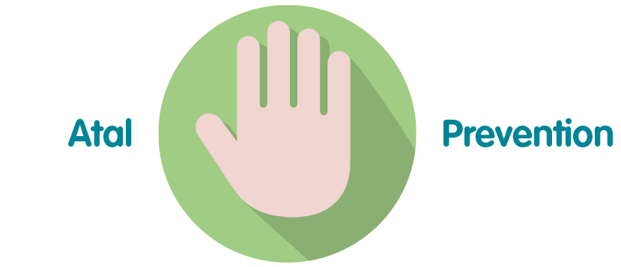 | Where possible Public Health Wales seeks to validate the efficacy of its practice and to make continuous improvements. Quality and Clinical audit is integral to supporting this work.
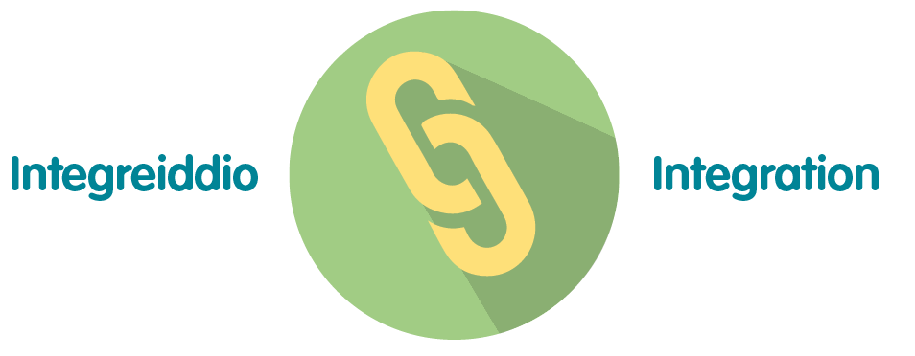 | Quality and Clinical audit impacts a number of the wellbeing goals, including “A Resilient Wales” and “A More Equal Wales”
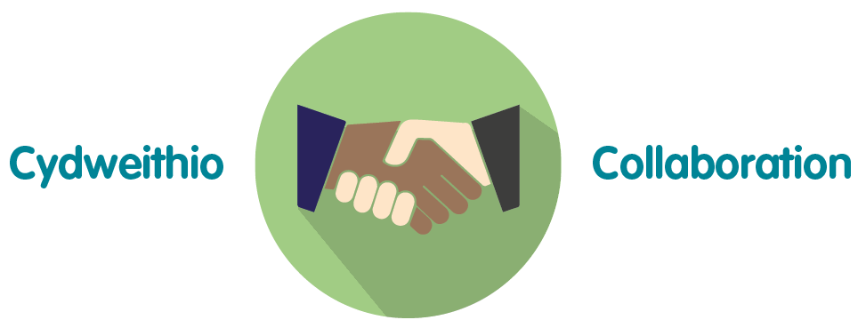 | The annual quality and clinical audit plan contains work across UK and Wales and includes other NHS bodies working together with Public Health Wales NHS Trust to provide the best outcomes
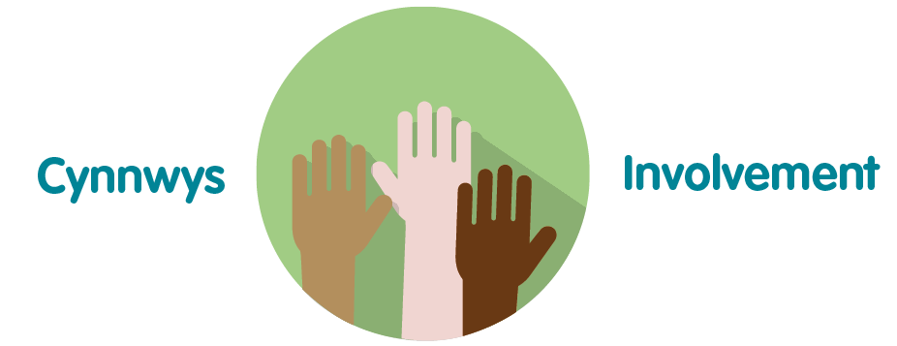 | Quality and Clinical Audit Procedure is an important aspect of the organisation’s governance arrangements, and, as such, helps the organisation to improve the quality and safeguard the high standards of the services provided by Public Health Wales

Recommendation

The Quality, Safety and Improvement Committee is asked to:

- Approve the revised Quality and Clinical Audit Procedure.

