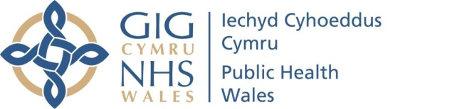 |  |  |  | Name of Meeting  Quality, Safety and Improvement Committee
Date of Meeting
20 July 2022
Agenda item:
5.2.2
CLAIMS MANAGEMENT POLICY AND PROCEDURE
Executive lead: |  | Rhiannon Beaumont-Wood, Executive Director,  Quality, Nursing and Allied Health Professionals
Author lead: |  | Francesca Thomas, Head of Putting Things Right
Author: |  | Stefanie Harvey-Powell, Legal Services Manager
Approval/Scrutiny route: |  | Rhiannon Beaumont-Wood, Executive Director,  Quality, Nursing and Allied Health Professionals  Business Executive Team (circulated electronically on 8 July 2022)
Purpose
The purpose of this report is to present the revised Claims Management Policy and Procedure for approval.in accordance with the Policies, Procedures and Other Written Control Documents Management Procedure.
Recommendation:
APPROVE | CONSIDER |  | RECOMMEND |  | ADOPT | ASSURANCE
The Quality, Safety and Improvement Committee is asked to:
- Approve the updated Claims Management Policy and Procedure

Link to Public Health Wales Strategic Plan

Public Health Wales has an agreed strategic plan, which has identified seven strategic priorities and well-being objectives.

This report contributes to the following:
Strategic Priority/Well-being Objective | All Strategic Priorities/Well-being Objectives
Strategic Priority/Well-being Objective | 7 - Building and mobilising knowledge and skills to improve health and well-being across Wales
Strategic Priority/Well-being Objective | Choose an item.
Summary impact analysis

Equality and Health Impact Assessment | An Equality & Health Impact Assessment has been completed. The impact of this policy is largely positive. The positive effect could be enhanced with a document which is aimed at service users. This option will be explored with the Welsh Government who are currently reviewing the ‘Putting things Right’ leaflet
Risk and Assurance | Ensuring claims are handled effectively and efficiently, with a view to minimising the financial risk to the Trust in terms of how much compensation is paid to Claimants.
Health and Care Standards | This report supports and/or takes into account the Health and Care Standards for NHS Wales Quality Themes
Health and Care Standards | Governance, Leadership and Accountability
Health and Care Standards | Person Centred Care
Health and Care Standards | Choose an item.
Financial implications | N/A
People implications | N/A

Purpose / situation

The Claims Management Policy and Procedure are due for review and updating this year (2022).

The purpose of this report is to present the revised Claims Management Policy and Procedure for approval.in accordance with the Policies, Procedures and Other Written Control Documents Management Procedure.

Background

The Claims Management Policy and Procedure have been reviewed and updated to provide clearer guidance on the processes that the Legal Services Manager must utilise. The documents now clearly identify who must provide authority to progress claims.

Description/Assessment

The Claims Polices and Procedure was scheduled for review. A review and general updating has been completed to support readers to navigate the claims process and procedures and provide further clarity on process required for the Legal Services Manager.

  - Consultation

The Claims Management Policy has been circulated for consultation in line with the required timescales.

  - Committee/Groups that have received or considered this document

The relevant groups have considered the document prior to submission for approval.

  - Implementation plan

No new actions have been identified in relation to the updated version of the Claims Management Policy.

  - Dissemination

The primary source for dissemination of this policy document within the organisation will be via the Trust intranet. It will also be made available to the wider community and our partners via the Trust internet site.

Well-being of Future Generations (Wales) Act 2015

This work has been put together following the five ways of working, as defined within the sustainable development principle in the Act, in the following ways:

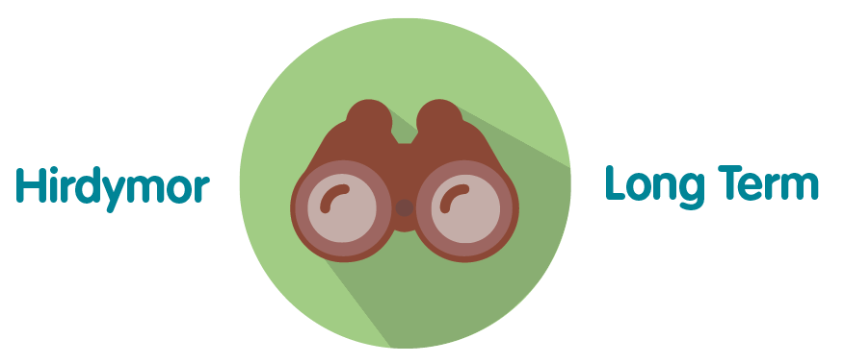 | The Claims Management Policy and procedure is updated every 3 years and will not need to be updated again until 2025
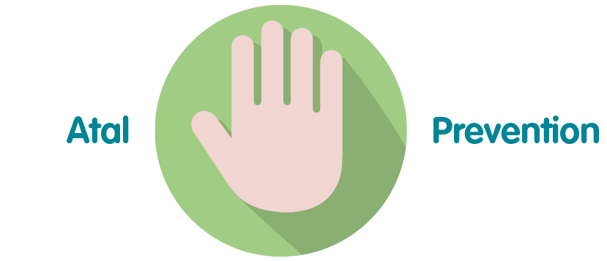 | Lessons learned in the claims procedure with clinical departments, aim to provide useful education, to prevent similar claims being brought in the future, thereby reducing the financial liability of the Trust.
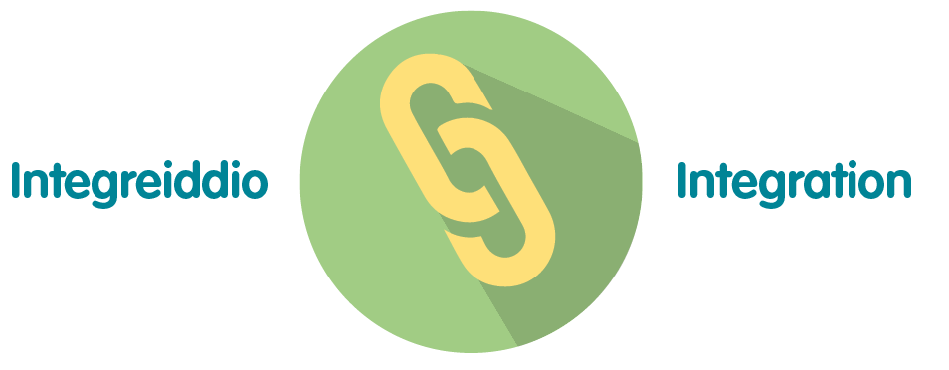 | Unlikely to impact upon well-being goals or on the objectives of other public bodies.
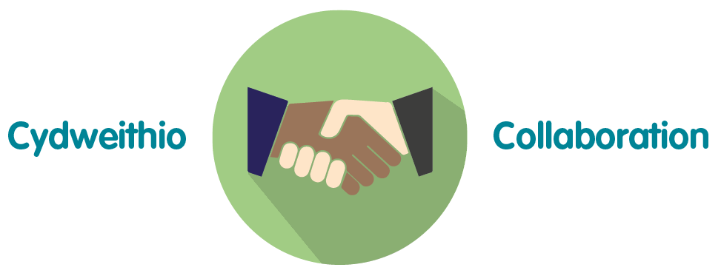 | The previous and updated policy requires the Legal Services Manager to work collaboratively with the Director of Screening Programmes, Heads of Programme, Programme Lead Clinicians, Head of Putting Things Right and the Executive Director of QNAHPS in order to ensure that all courses of action are properly authorised.
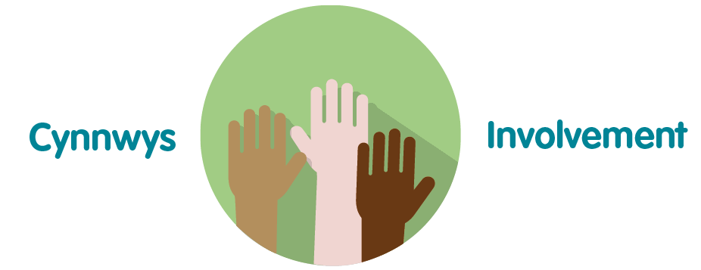 | Unlikely to impact wellbeing goals.

Recommendation

The Quality, Safety and Improvement Committee is asked to:

- APPROVE the Claims Management Policy & Procedure

