(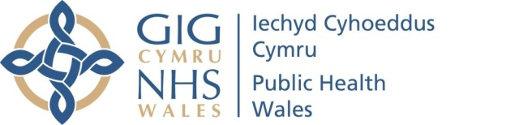 |  |  |  | Name of Meeting  Quality, Safety and Improvement Committee
Date of Meeting
20 July 2022
Agenda item:
4.2
Putting Things Right Report Quarter 1 2022/2023
Executive lead: |  | Rhiannon Beaumont-Wood, Executive Director, Quality, Nursing and Allied Health Professionals
Author: |  | Frankie Thomas, Head of Putting Things Right
Approval/Scrutiny route: |  | Business Executive Team
Purpose
This paper introduces the Putting Things Right report for Quarter 1 2022-2023.
Recommendation:
APPROVE | CONSIDER |  | RECOMMEND |  | ADOPT | Assurance
The Quality, Safety and Improvement Committee is asked to:

- Consider the report for information.

Link to Public Health Wales Strategic Plan

Public Health Wales has an agreed strategic plan, which has identified seven strategic priorities.

This report contributes to all strategic priorities.
Summary impact analysis

Equality and Health Impact Assessment | An Equality and Health Impact Assessment is not necessary as no decision is required.
Risk and Assurance | N/A
Health and Care Standards | This report supports and/or takes into account the Health and Care Standards for NHS Wales Quality Themes
Health and Care Standards | Governance, Leadership and Accountability
Health and Care Standards | Person Centred Care
Health and Care Standards | Theme 1 - Staying Healthy
Financial implications | There are significant risks in failing to manage the ‘Putting Things Right’ process effectively, including the risk to service users and staff because of failing to learn lessons from events, and the financial and legal sanctions possible from causing avoidable harm.
People implications | N/A

Introduction

The Putting Things Right (PTR) narrative report has been adapted to support the presentation and utilisation of the Performance and Assurance Dashboard (PAD) with providing assurance on our organisational performance against PTR. This is in line with the strategic direction the organisation is taking, in presenting information in a more accessible way in a digital format. However, this is an iterative process and we continue to strive to improve areas including timing and the format of the data being presented digitally.

This report highlights areas of the organisation where concerns have been raised or identified and summarises overall performance against targets where applicable.

Comparative data is not available for all areas within this report following the migration of the incident management system to Datix Cloud on the 1 April 2022. This new system is configured differently to its predecessor Datix Web therefore it is not possible at the current time to analyse and compare data sets in the same format particularly in relation to incidents. The intention is to provide more comparative data in future reports if feasible.

- Nationally Reportable Incidents/No Surprises/Never events

This section contains an outline of the number of Nationally Reportable Incidents, No Surprises and Never Events submissions for the quarter.

Number in Quarter | Q3  2021-2022 | Q4  2021-2022 | Q1  2022-2023
Nationally Reportable Incidents reported to Delivery Unit | 1 | 2 | 0
No Surprises reports submitted to Welsh Government | 2 | 1 | 3
No Surprises reports submitted and subsequently upgraded by Welsh Government to a Nationally Reportable Incident | 0 | 0 | 0
Never Events | 0 | 0

No Surprises

Incident Type | Area | Reference
No Surprises | Health Protection and Screening Services | Datix Reference: 262
This No Surprises Incident related to a court ruling made on the 27 April 2022, which ruled that two policies prepared by the Secretary of State for Social Care and Public Health England regarding Care Homes during the pandemic which were deemed to be unlawful.
Public Health Wales investigated this ruling in relation to the similar guidance which was issued by them during the Covid-19 pandemic. Legal advice was sought, and all aspects of this ruling have now been considered from Public Health Wales’ perspective and no further action was required.

Incident Type | Area | Reference
No Surprises | Health Protection and Screening Services (Diabetic Eye Screening Data Breach) | Datix Reference: 102
The No Surprises related to letters being sent out as part of stakeholder research that was inviting service users to take part in a survey. One page of the communication document was in Welsh and the other page in English. The issue arose from the automailer that was not known during the printing and posting process. This led to some letters being sent with one page of the communication having one participant’s details on and the other page having the details of a different participant. Upon identification appropriate advice was sought from Information Governance and an Incident Management Team convened. The screening programme have now updated their Standard operating Procedures to ensure this issue does not occur again.

Incident Type | Area | Reference
No Surprises | Health Protection and Screening Services (Data Breach) | Datix Reference: 526
The No Surprises incident occurred during routine actions relating to a list of patients a PII was inadvertently emailed to a member of the public. This incident was immediately escalated to line manager and attempts made to use the email recall functionality to prevent the recipient from receiving the email. The unintended recipient of the email was contacted accordingly and agreed to the verbal request made which was to delete the received email item appreciating that they were not the intended recipient. Following the incident, a follow up request was made in writing to the unintended recipient. A Incident management Team was convened with representation from Information Governance.
Following the identified learning, recommendations were made to reduce risk of this type of event occurring again which included staff to avoid the use of a “recent files” option for attaching items and instead to select the desired document from an exact file location from the computer.

- Incident Management

During quarter four, a total of 610 incidents were reported during this period, which is a 7% decrease compared to the 657 reported in the previous Quarter.
98% of incidents reported in Quarter four occurred within Health Protection and Screening Services.

The most frequent types of incident by category for this quarter are:

- Assessment/Investigation/Diagnosis incidents
- Equipment/devices

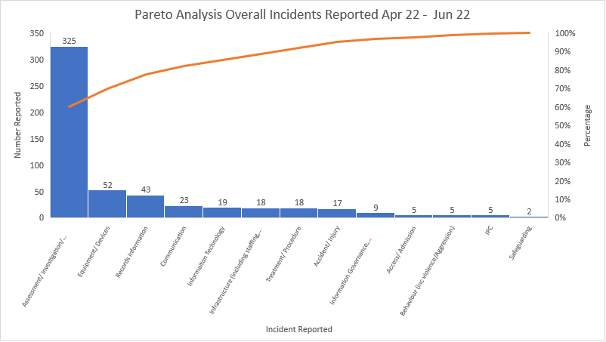

Breakdown of Assessment/Investigation/Diagnosis incidents

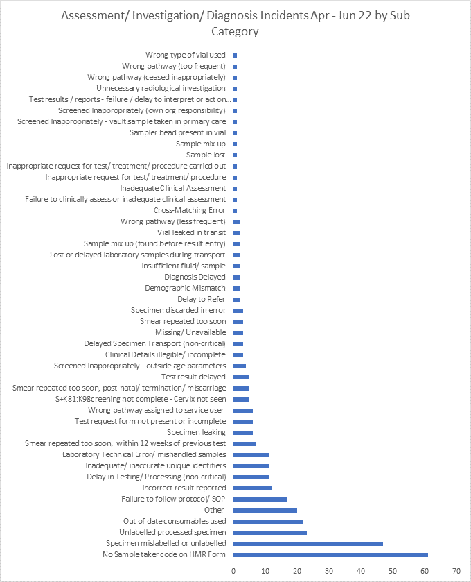

The above chart highlights that the highest sub-categories for these incidents were ‘no sample taker code’ on the reporting form followed by specimen mislabelled or unlabelled.

During the reporting period 66 error non incidents were reported and 41 of these were categorised by sub-type as laboratory errors.
- Redress Management

When investigating a concern which includes an allegation that harm has or may have been caused, Public Health Wales is required to consider whether there is a qualifying liability in tort. This means consideration must be given as to whether there has been a breach of our duty of care and whether that breach of duty is causative of any harm or loss to that person.

All Redress cases received by Public Health Wales related to screening services as these are our only patient facing services.

There was 1 Redress case received in Quarter for Cervical Screening Wales. Further detailed information regarding this case can be seen in the Quarter 1 Claims and Redress report.

4. Complaints Management

Early Resolution Complaints (Informal)

Public Health Wales will endeavour to deal with any complaints received by way of early resolution where possible. The chart below demonstrates the number of early resolution complaints received in Quarter one.

Informal complaints are not currently captured on the Performance Assurance Dashboard.

On average eight early resolution complaints are received each month.

The Early Resolution complaints received in Quarter one were in the following areas:

April 2022

- Breast Test Wales – One complaint regarding clinical treatment/assessment at the appointment
- Bowel Screening Wales – one complaint relating to communication issues

May 2022

- Abdominal Aortic Aneurysm Screening Wales – Two complaints in relation to communication issues and issues with appointment location.
- Diabetic Eye Screening Wales – one complaint in relation to delay in receiving an appointment
- Bowel Screening Wales – one complaint in relation to access to the screening programme (due to age range)
- Health Protection – one complaint received regarding staff attitude and behaviour
- Cervical Screening Wales – one complaint received in relation to delay in receiving test results.

Formal Complaints

During Quarter one, 11 formal complaints were received, which is a decrease (63%) from 30 received in Quarter four.

This significant decrease however relates to higher number of complaints received in Quarter four that are usually received and related to the Public’s dissatisfaction with the extension interval to the Cervical Screening Wales routine screening period announced in January 2022.
All formal complaints received within Quarter one occurred in the Health Protection and Screening Services Division.
The below graph shows the area where the complaints received in Quarter one occurred:

The highest number of complaints in Quarter one were received by Breast Test Wales and 3 (60%) of these related to appointment issues.

Three complaints received during Quarter one were received by Health Protection. Two of these complaints related to staff attitude and behaviour. A further complaint was received in relation to Equality and a statement made by Public Health Wales which was included in a BBC Wales article in relation to Monkeypox virus.

The Performance Assurance Dashboard shows 100% compliance was achieved in April and June for acknowledging complaints within 2 working days. One Diabetic Eye Screening Wales acknowledgement letter was missed due to a delay in the complaint being reported.

The below table demonstrates the percentage of complaints for Quarter four. 100% of complaints received during April and May have been responded to within the 30-working day timescale.

Month | Complaints due for response | Acknowledged within 2 w/d | Responded within 30 w/d
April 22 | 3 | 3 (100%) | 3 (100%)
May 22 | 5 | 4 (80%) | 5 (100%)
June 22 | 3 | 3 (100%) | 30 days not yet due for all

All complaints received in June 2022 are currently under investigation with the relevant service areas.

- Compliments

During Quarter one, 539 compliments were received an increase of 31% compared to the previous Quarter.

Compliment types and themes for this Quarter are categorised as follows:

- The Positive attitude / behaviour of staff
- Positive comments relating to the service
- Professionalism of the staff

The ratio of compliments to formal complaints has increased to 49:1 from a position of 41:1 in the previous Quarter.

- Concerns Management System Update

- Datix Cloud successfully went live on 1 April 2022 for the incident, complaint, claims and redress modules.
- Training is available for all staff on a monthly basis to ensure staff understand how to use the new system for reporting incidents and complaints
- Training is also available on a monthly basis for staff identified as appropriate complaint and incident investigators for their specialist areas
- The Datix web (previous) system currently remains operational for the reporting of safeguarding incidents and microbiology error non-incidents.
- Microbiology error non-incidents are incidents identified by a failsafe procedure so that an incident is prevented and not realised in terms of harm

