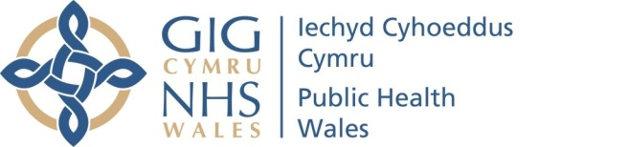 |  |  |  | Name of Meeting  Quality, Safety and Improvement Committee
Date of Meeting
18 May 2022
Agenda item:
4.6
Internal Flu Vaccine Campaign
End of Year Report 2021/22
Executive lead: |  | Rhiannon Beaumont-Wood, Executive Director, Quality, Nursing and Allied Health Professionals
Author: |  | Rebecca Bicknell, Lead Nurse for Infection Prevention and Control
Approval/Scrutiny route: |  | Rhiannon Beaumont-Wood, Executive Director, Quality, Nursing and Allied Health Professionals
Purpose

The purpose of this paper is to provide the Committee with the final report on the Internal staff Influenza Vaccine Campaign for 2021-22 and take assurance.

Recommendation:
APPROVE | CONSIDER |  | RECOMMEND |  | ADOPT | Assurance
The Committee is asked to:

- Consider and take assurance from the Internal Influenza Vaccine Campaign end of year report for 2021/22

Link to Public Health Wales Strategic Plan

Public Health Wales has an agreed strategic plan, which has identified seven strategic priorities.

This report contributes to all strategic priorities.
Summary impact analysis

Equality and Health Impact Assessment | An Equality and Health Impact Assessment is not necessary as no decision is required.
Risk and Assurance | N/A
Health and Care Standards | This report supports and/or takes into account the Health and Care Standards for NHS Wales Quality Themes
Health and Care Standards | Theme 1 - Staying Healthy
Health and Care Standards | Theme 2 - Safe Care
Health and Care Standards | Theme 7 - Staff and Resources
Financial implications | N/A
People implications | N/A

Purpose/Situation

The Internal Influenza Vaccine Campaign end of year report for 2021/22 which ran from the end of September 2021 to Early March 2022 is presented to the Quality, Safety and Improvement Committee for approval.

The end of year report seeks to provide the Committee with assurance that the organisation is meeting its responsibilities to ensure that the health and wellbeing of staff is supported.

Background

Influenza (flu) vaccine is one of the most effective, safe methods to help prevent influenza infection, thus reducing pressure on health and care settings as it lowers the incidence of that disease in a given population. In 2021-22 the influenza vaccine was administered to more people than ever before as part of the national programme. Influenza activity globally was low; due to the Covid-19 interventions.

During the winter of 2021-22 staff were faced with the co-circulation of Covid-19 booster vaccinations for all age groups from Health Boards and influenza. This was due to the prevalence of the Omicron variant first reported in November 2021.

No Welsh Government 'target' was set for flu vaccine uptake, but there was an 'ambition' to achieve 80% flu vaccine uptake in frontline NHS Wales staff and social care workers.

- Assessment
Due to the success of previous influenza campaigns a mixed model approach was adopted using peer vaccinators, a small cohort of Bank Nurses and service level agreements with Health Boards.
The influenza vaccine was offered to all Public Health Wales (PHW) employees during the 2021/2022 campaign. Employees were able to access influenza sessions within Public Health Wales buildings throughout Wales, by using an on line booking appointment; which was communicated via the staff intranet.
A comprehensive evaluation of the internal influenza campaign will take place in collaboration with representatives from the Vaccine preventable disease programme (VPDP) and resources shared to evaluate the campaign. This will establish key areas for improvement to inform next season’s delivery.

- Risks and Issues

  - Influenza Campaign operational leadership
Operational leadership and coordination was provided by the Corporate Infection Prevention and Control (IP&C) lead nurse, whom commenced in post in November 2021 and additional support provided from the corporate nursing team and Health Protection. Operational leadership for the COVID-19 staff vaccination was handed over to health boards but monitoring of staff uptake and vaccination status is ongoing.
4.2 Work from home advice/ remote working
The campaign has faced a significant challenge due to staff working from home or remote working. This has reduced the opportunity for opportune or ad-hoc vaccination on sites. There is anecdotal evidence that some staff have felt reluctant to attend a clinic based at a PHW building due to working remotely, despite reassurances provided by the Health and Safety Teams of COVID19 safe working environments.

4.3 Vaccine availability and provision for staff

A mixed model approach was implemented in response to low clinic uptake. This comprised of clinics based at key PHW sites across Wales, the provision of community pharmacy vouchers and the ongoing option of vaccination via SLAs with the Health boards (for certain groups of staff). Bespoke vaccination clinics were also offered for departments to increase uptake.

The decision to purchase community pharmacy vouchers was discussed and agreed at the influenza vaccine delivery group meeting. It was noted that in December 2021 some staff found obtaining their influenza vaccine at local community pharmacies difficult due to supply issues, this was fed back by the Lead Nurse for IPC (Corporate) to NIAG (National Influenza Action Group).
4.4 Reporting
Manual consent forms were used during vaccination and then retrospectively uploaded to the Welsh Immunisation System by key members of the Influenza team. The information governance procedure for PHW was followed during this process.

Staff were encouraged as part of the communication plan to self-report having their influenza vaccine if not in house using a self-reporting form shared via the staff intranet page.

Vaccine uptake data was obtained via SLA agreements from Health Boards for staff who were vaccinated on behalf of PHW. However the lack of the one system approach by the Health Boards across Wales (to record vaccine uptake) lead to unreliable reporting figures from those vaccinated.

4.5 Seasonal Uptake

Influenza vaccine uptake for all staff in PHW was 46.2% and 43.8% within front line staff for 2021-22. When compared with other Health Boards and Trusts at Figure 1, the uptake of influenza vaccine across the NHS was low for 2021-22 season

Figure 1
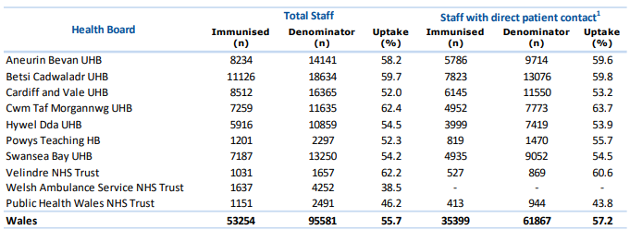

- Quality Improvement
In collaboration with the recommendations of the National Influenza Action Group (attended by the Lead Nurse for IPC) monthly actions have been taken to improve the internal influenza campaign for the year 2022-23.
The improvement will be formed from the staff questionnaire which was issued to PHW employees to obtain their views on the current delivery of the programme. The views from this questionnaire were analysed for trends and will be used in conjunction with wider literature to understand the barriers to vaccine uptake, to inform next season.
Only 173 (7.2 %) responses were received out of a workforce of over 2,400 employees, so it is difficult to generalise the results across the whole workforce, but it provided an indication at Figure 2

Figure 2- Indicative responses from the 173 responses
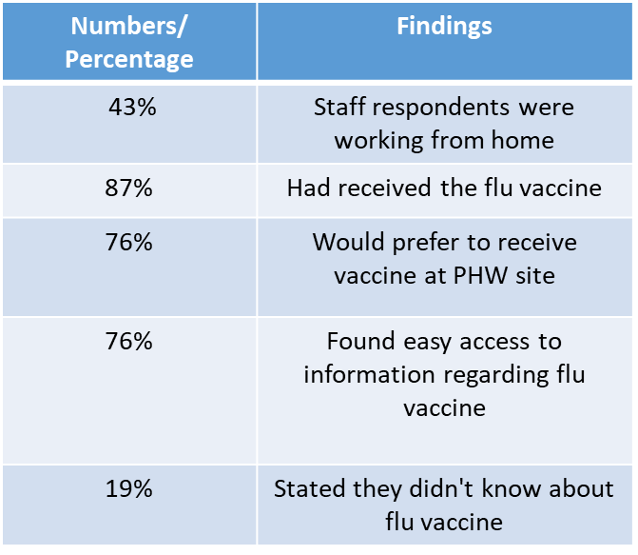
Analysis from the 173 Responses
- 76% stated they would prefer to receive the vaccine at a Public Health Wales site which indicated sessions needed to be run within Public Health Wales locations for 2022-23

- 19% stated they didn’t know about the flu vaccine despite a well-publicised internal communicated plan

- 10% of respondents' who normally receive the flu vaccine but didn’t for the 2021-22 season found issues with using the flu voucher a barrier to vaccination this was due to pharmacy stock or confusion surrounding the voucher being accepted
6. Well-being of Future Generations (Wales) Act 2015
The report contributes to Goal 3 “Support the NHS to deliver high quality, equitable and sustainable services”. The below information follows the five ways of working, as defined within the sustainable development principle in the Act, in the following ways:

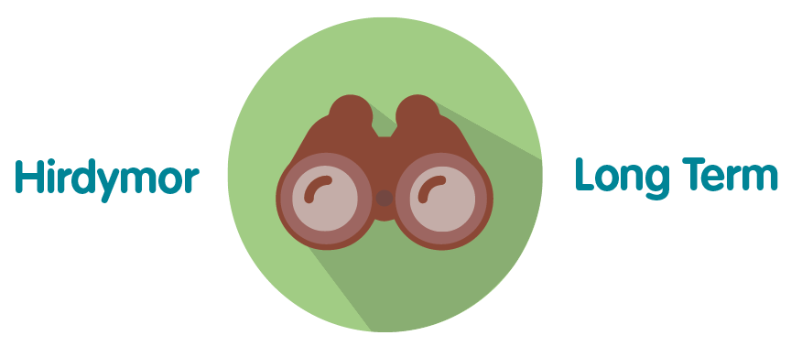 | The end of year report seeks to provide the Board and relevant Board Committees with assurance that the organisation is meeting its ambition of delivery the flu vaccine to all staff within Public Health Wales.
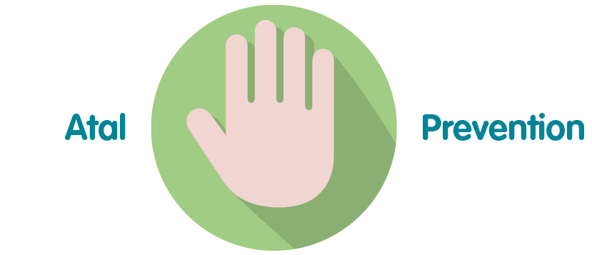 | Public Health Wales seeks to take a proactive approach by offering and providing access to a flu vaccination to all staff within Public Health Wales preventing illness in which could impact on service delivery.
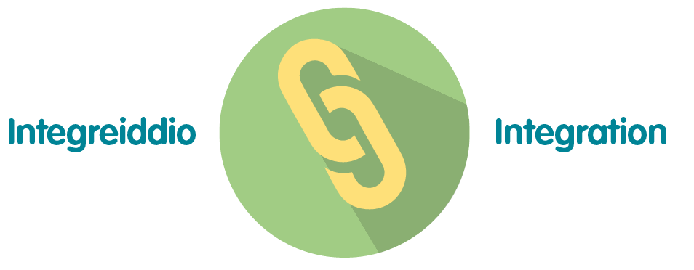 | The internal flu vaccination programme end of year report impacts a number of the wellbeing goals, including “A Resilient Wales” and “A More Equal Wales
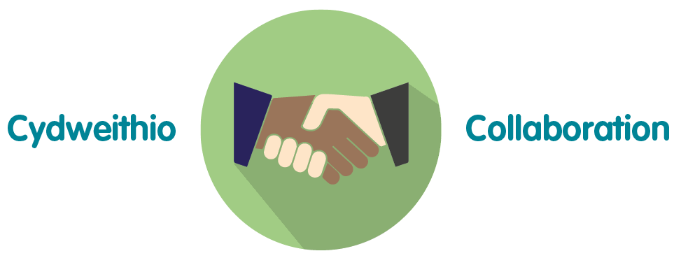 | Public Health Wales is committed to delivering the flu vaccination internally so staff have equal access to a vaccination. The vaccination team consist of a variety of staff across Public Health Wales working together to achieve the outcome.
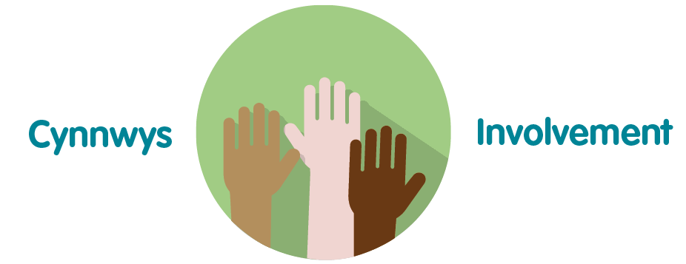 | This end of year report provides assurance that’s all divisions and teams within Public Health Wales are involved in the planning and delivery of the flu campaign.

7. Recommendation

The Committee is asked to:

- Consider and take assurance from the Internal Influenza Vaccine Campaign end of year report for 2021/22

