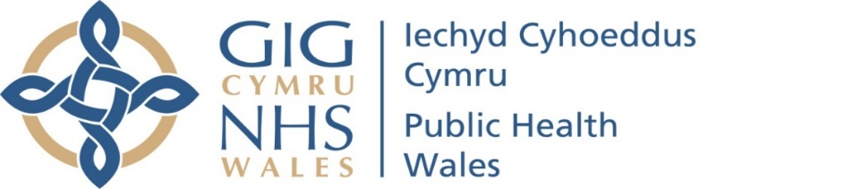

Public Health Wales Safeguarding Group
Terms of Reference
Date: 31 March 2021 | Version: 0.6
Review Date: Annually
Safeguarding is a term used to denote arrangements to support and protect the health, wellbeing and human rights of individuals who could be at risk of harm from abuse or neglect.

It is incumbent upon Public Health Wales to ensure there are arrangements in place, including supporting staff through education, training and access to expert advice, to recognise signs of potential or actual risk of harm and to know what actions to take.

Purpose

The purpose of Public Health Wales Safeguarding Group is to:

- Act as an enabler to support Public Health Wales in discharging its statutory functions under the Social Services and Well-being (Wales) Act 2014) and as identified in other relevant legislation and Safeguarding related guidance.
- Support Public Health Wales to embed the United Nations Convention on the Rights of the Child within the approach to all that we do. (Assessed using the Children’s Commissioners Toolkit)
- Support the delivery of safeguarding annual work plan objectives
- Focus the organisation on individual and organisational roles and responsibilities, with the aim of preventing, recognising and minimising the risk to individuals of all forms of abuse and neglect.
- To support the organisation in monitoring and scrutinising the effectiveness of organisational Safeguarding arrangements, including recommending and overseeing the implementation of any improvement actions. E.g. Safeguarding Maturity Matrix
- Provide support to the Quality, Safety and Improvement Committee in gaining assurance on organisational Safeguarding arrangements
- To be a source of and provide expert advice
- Identify and support research opportunities in the context of safeguarding.
- Contribute to the ongoing reinforcement of a no blame culture which supports learning, in conjunction with the POD team
- Support the organisation in a quality and improvement approach to safeguarding
- Horizon scanning, plus consider any lessons learnt from practice reviews and other recognised safeguarding reports, for application of recommendations being implemented within Public Health Wales
- Ensure effective arrangements are in place to disseminate the sharing of best practice and learning.
- Support and monitor preparedness for implementation of the Health and Social Care (Quality and Engagement) (Wales) Act
- To offer advice and support to the Executive Team, Quality Safety and Improvement Committee and Board.
2 Reporting lines

The Safeguarding Group:

- Reports by exception any risks and issues needing to be escalated to the Business Executive Team meeting, and on a minimum of an annual basis a full assurance report via the Executive Director of Quality, Nursing and Allied Health Professionals.
- Provides assurance to the Quality, Safety and Improvement Committee on a needs led basis and a minimum of annual reporting against organisational safeguarding compliance
- Contributes to NHS safeguarding network (and its sub groups) through the named Lead for Safeguarding
- Agree relevant assurance reports to be shared with Regional Safeguarding Boards. E.g. Annual Safeguarding Report.
- Decision Making

The group can make decisions which improve the effectiveness of Safeguarding arrangements within Public Health Wales.

Decisions with financial or significant corporate or service risk implications will need to be escalated to the Business Executive Team.
4 Secretariat

The Safeguarding Group meetings are supported by the QNAPS Directorate.
5 Membership
The core membership of the Safeguarding Group is as follows:

- Executive Director of Quality, Nursing and Allied Health Professionals (Chair)
- Named Lead for Safeguarding
- Head of Nursing Screening Division
- Designated Professional, National Safeguarding Team
- Risk and Incident Manager
- People OD representatives (Learning and Development)
- Health and Wellbeing representative. E.g. Service lead Help me Quit
- ACE hub representative
- Policy, Research and International Development representative
- Other people can be co-opted by the chair
- Microbiology

All members are responsible for providing relevant data and information as requested and ensuring two way dissemination of safeguarding related information across Directorates/Divisions they represent and to share good practice to enhance learning throughout Public Health Wales.
6 Frequency of meetings
The Safeguarding Group will meet on a minimum of a quarterly basis. The agendas for these meetings are agreed by the Executive Director for Quality, Nursing and Allied Health Professionals, with support from the Assistant Director for Quality and Nursing and Named Lead for Safeguarding.

The group will operate through meetings, either in person or remotely.
7 Quorum
At least one third of the total number of members of the group must be in attendance to ensure the quorum of the group, at least one of which should be the Chair or Deputy.
8 Other groups reporting to the Safeguarding group
- None

