 |  |  |  |  | Name of Meeting  Quality, Safety and Improvement Committee
Date of Meeting
14 April 2021
Agenda item:
4.5
Public Health Wales Safeguarding Group
Terms of Reference
Executive lead: |  | Rhiannon Beaumont-Wood, Executive Director, Quality, Nursing and Allied Health Professionals
Author: |  | Eleri Lloyd Burns, Interim Assistant Director of Quality, Nursing and Allied Health Professionals
Approval/Scrutiny route: |  | Rhiannon Beaumont-Wood, Executive Director, Quality, Nursing and Allied Health Professionals
Purpose
The Committee are asked to approve the proposed, revised Terms of Reference for the Public Health Wales Safeguarding Group
Recommendation:
APPROVE | CONSIDER |  |  | RECOMMEND |  | ADOPT | Assurance
The Committee is asked to:
- Approve the revised Public Health Wales Safeguarding Group Terms of Reference.

Link to Public Health Wales Strategic Plan
Public Health Wales has an agreed strategic plan, which has identified seven strategic priorities.
This report contributes to all strategic priorities.
Summary impact analysis
Equality and Health Impact Assessment |  |  | An Equality and Health Impact Assessment is not necessary as no decision is required.
Risk and Assurance |  |  | N/A
Health and Care Standards |  |  | This report supports and/or takes into account the Health and Care Standards for NHS Wales Quality Themes
 |  |  | Governance, Leadership and Accountability
 |  |  | Theme 2 - Safe Care
 |  |  | Theme 6 - Individual Care
Financial implications |  |  | N/A
People implications |  |  | N/A

Introduction

The Terms of Reference of the Public Health Wales Safeguarding Group are presented for approval which are designed to support the organisation’s corporate safeguarding governance arrangements.

Background

During 2020/21, and the continued Health Protection response to the pandemic, has led to challenges which impacted on our ability to convene quarterly safeguarding meetings during this period. The Safeguarding Group was reconvened during quarter 3. Furthermore, the continuing response to COVID19 has led to a delay in updating the Safeguarding Group Terms of Reference.

Well-being of Future Generations (Wales) Act 2015

The below information follows the five ways of working, as defined within the sustainable development principle in the Act, in the following ways:

 | The Terms of Reference for the Public Health Wales Safeguarding Group seek to provide the Business Executive Team, Board and relevant Board Committees with assurance that the organisation is meeting its statutory requirements in relation to safeguarding populations at risk of harm or abuse
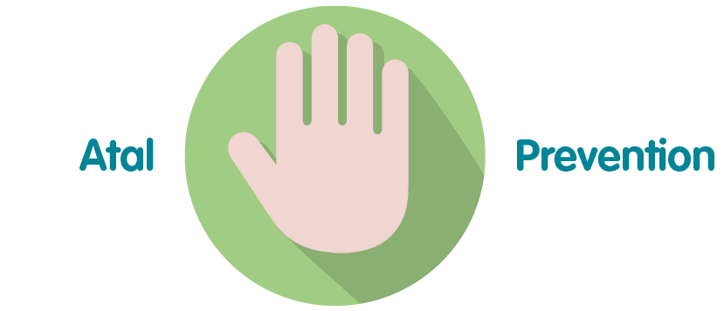 | Where possible Public Health Wales seeks to prevent the occurrence of harm or abuse by taking a proactive approach to the reporting and management of safeguarding incidents through DATIX and offering comprehensive training
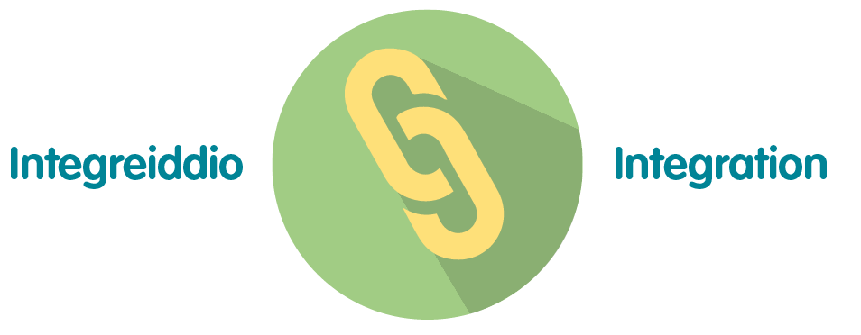 | The proposed Terms of Reference and for the Public Health Wales Safeguarding Group impacts a number of the wellbeing goals, including “A Resilient Wales” and “A More Equal Wales
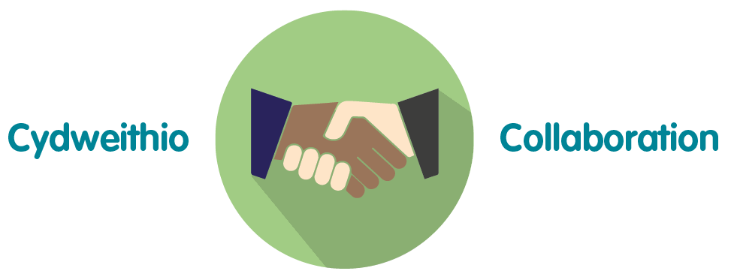 | Public Health Wales is committed to offering a timely response to any incidents where there is risk of harm or abuse to population groups.
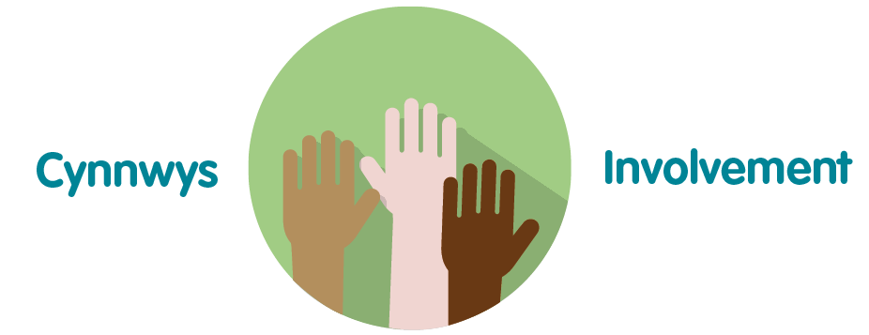 | The proposed Terms of Reference for the Public Health Wales Safeguarding Group is an important aspect of the organisation’s governance arrangements, and, as such, helps the organisation to improve the quality and safeguard the high standards of the services provided by Public Health Wales

4. Recommendation

- Approve the revised Public Health Wales Safeguarding Group Terms of Reference.

