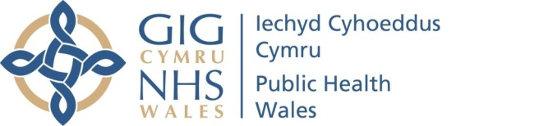 |  |  |  | Name of Meeting  Quality, Safety and Improvement Committee
Date of Meeting
14 April 2021
Agenda item:
4.4
Exposure Injury (including needle stick injury) and Safe Management of Sharps Policy and Procedure
Executive lead: |  | Rhiannon Beaumont Wood Executive Director, Quality, Nursing and Allied Health Professionals.
Author: |  | Gail Lusardi Nurse Consultant HARP  Beverley Gregory, Lead Infection Prevention and Control Nurse
Approval/Scrutiny route: |  | Business Executive Team. It has also been for wider organisational consultation and submitted to the Infection Prevention and Control Group
Purpose
The purpose of this paper is to detail Public Health Wales’s commitment to comply with current guidance, standards and practice on the management of exposure and needle stick injury and safe management of Sharps.
The policy provides an organisational statement of intent to commit to current standards and guidance with regard to exposure and needle stick injury and safe management of Sharps.
The supporting Procedure document provides detailed instructions on appropriate processes and guidance including individual responsibilities.

The documents are being submitted for approval to ensure the organisation is compliant with recommendations stipulated within the guidance
Recommendation:
APPROVE | CONSIDER |  | RECOMMEND |  | ADOPT | ASSURANCE
The Quality Safety and Improvement Committee to:
- Approve the Exposure Injury and Safe Management of Sharps Policy and supporting Procedure document for immediate implementation.

Link to Public Health Wales Strategic Plan

Public Health Wales has an agreed strategic plan, which has identified seven strategic priorities and well-being objectives.

This report contributes to the following:
Strategic Priority/Well-being Objective | 3 - Promoting healthy behaviours
Strategic Priority/Well-being Objective | 5 - Protecting the public from infection and environmental threats to health
Summary impact analysis

Equality and Health Impact Assessment | Equality and Health Improvement impact assessment has been undertaken
Risk and Assurance | This aligns to the Board Assurance Framework 3
Health and Care Standards | This report supports and/or takes into account the Health and Care Standards for NHS Wales Quality Themes
Health and Care Standards | Theme 2 - Safe Care
Health and Care Standards | Governance, Leadership and Accountability
Health and Care Standards | Choose an item.
Financial implications | There are no financial implications relating to the approval of these documents
People implications | The supporting procedure document outlines the process for management of a sharps injury. Staff will need to familiarise themselves with this guidance.

Purpose / situation

These documents are being presented for approval to Quality, Safety and Improvement Committee in accordance with the Policies, Procedures and other Written Control Documents Management Procedure.
The policy provides an organisational statement of intent to commit to current standards and guidance with regard to exposure and needle stick injury and safe management of Sharps.
The Procedure document provides information on responsibilities of managers and staff to avoid and mitigate risks from exposure injury.

Background

This policy and procedure was produced to ensure there are current documents in place for manager’s and staff, advising on sharp safety or a needle stick procedure, which reflects the nature of services delivered within the organisation and the current Occupational Health service provision. The procedure document was developed collaboratively with Public Health Wales staff, who utilise sharps regularly as part of their service delivery and those involved with running the internal influenza campaign. The guidance cited within the documents reflects best practice and current legislation.

(Public Health Wales Microbiology staff are supported, in the event of an exposure or needle stick injury, by Health Board Occupational Health staff (via Service Level Agreements) and therefore are managed in accordance with relevant Health Board procedures).

Description/Assessment

Although the majority of Public Health Wales services are non-clinical and do not involve the use of Sharps, it is essential that all Public Health Wales staff, irrespective of roles within the organisation are provided with relevant legislation and guidance to advise them in the event of an exposure or sharps injury. This Policy document and the supporting procedure document aims to provide this.

Following a review of the current documents led by the Lead IP&C Nurse, and Nurse Consultant, Healthcare Associated Infection, Antimicrobial Resistance & Prescribing Programme the policy and procedure provide clear, evidence-based framework to ensure safe practice in the use of clinical sharps devices. It also provides. A clear procedure for the management of inoculation or exposure injury where blood-to-blood contact may have occurred.

Comments having been requested and received from IP&C Group members, HealthCare Associated Infection & Antimicrobial Resistance Programme (HARP), Microbiology Screening and health protection. The paper has also been out previously for wider consultation, the final approval process was delayed due to the COVID-19 response.

Well-being of Future Generations (Wales) Act 2015

This work has been put together following the five ways of working, as defined within the sustainable development principle in the Act, in the following ways:
 | Effective, collaboratively written guidance is essential for the future management of incidents
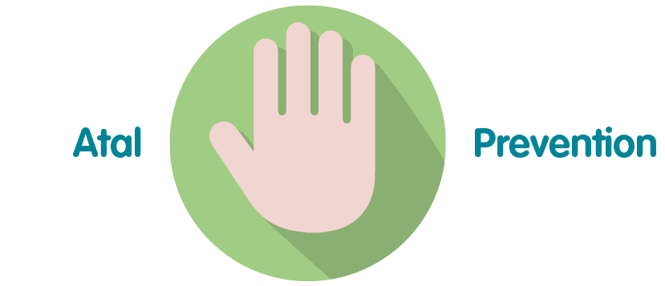 | By providing advice and best practice guidance for staff about the safe use of Sharps equipment the organisation fulfils its commitment to best practice and staff safety.
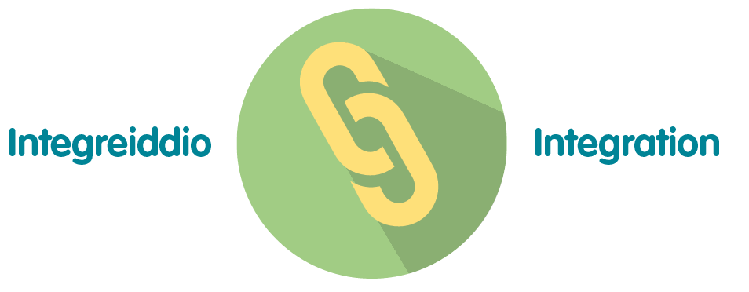 | This guidance integrates with Public Health Wales Well-being objectives by promoting preventative care and early intervention.
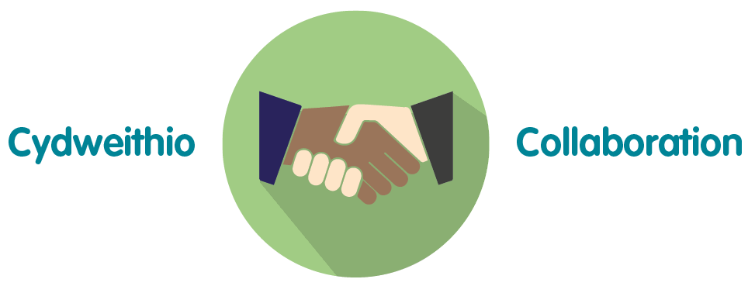 | There has been significant collaboration with others in the development of the policy and procedure to ensure effective implementation.
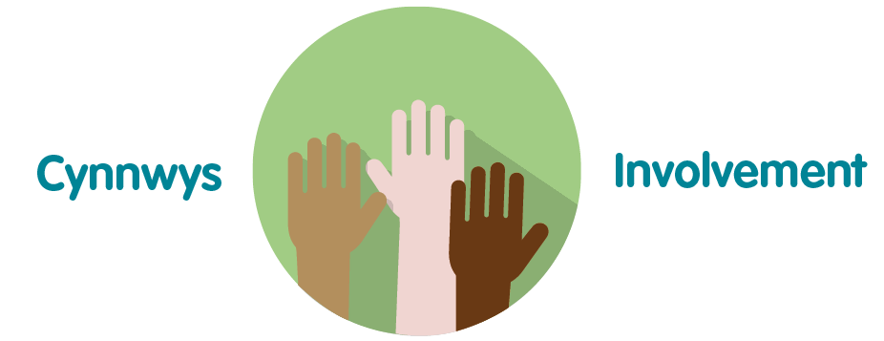 | There has been significant involvement in the development of these documents from a variety of staff within the organisation staff committed to the well-being goals.

Recommendation

The Quality, Safety and Improvement Committee is asked to

- Approve the Exposure Injury and Safe Management of Sharps Policy and supporting Procedure document for immediate implementation.

