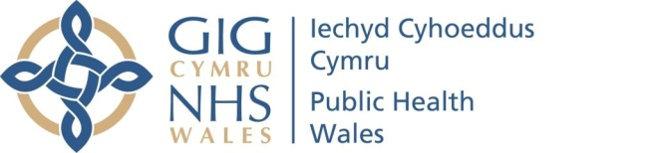 |  |  |  |  | Name of Meeting  Quality, Safety and Improvement Committee
Date of Meeting
14 April 2021
Agenda item:
4.3
Year-End Report of Annual Quality and Clinical Audit 2020/21
Executive lead: |  | Rhiannon Beaumont-Wood, Executive Director, Quality, Nursing and Allied Health Professionals
Author: |  | - Caroline Whittaker, Quality Lead, Quality, Nursing and Allied Health Professionals  - Jessica Taylor, Quality Improvement and Clinical Audit Support Officer
Approval/Scrutiny route: |  | - Rhiannon Beaumont-Wood, Executive Director, Quality, Nursing and Allied Health Professionals  - Provided to Business Executive Team via email
Purpose:
The purpose of this paper is to provide the Quality, Safety and Improvement Committee with the year-end report on the 2020/21 Annual Quality and Clinical Audit Plan. The Plan contains both National (UK and Welsh) audits (externally determined) and Local audits (internally determined) including the interim findings and recommendations listed within the full document.
Recommendation:
APPROVE | CONSIDER |  |  | RECOMMEND |  | ADOPT | ASSURANCE
The Quality, Safety and Improvement Committee is asked to:
- take assurance on progress against the Annual Quality and Clinical Audit Plan 2020/21.
Link to Public Health Wales Strategic Plan

Public Health Wales has an agreed strategic plan, which has identified seven strategic priorities and well-being objectives.

This report contributes to the following:
Strategic Priority/Well-being Objective |  |  | 6 - Supporting the development of a sustainable health and care system focused on prevention and early intervention

Summary impact analysis

Equality and Health Impact Assessment | An equality and health impact assessment is not required as there is no impact on policy or decisions relevant to Race, Disability and Gender duties
Risk and Assurance | Welsh Government expects that all NHS organisations in Wales participate in clinical audit and requires healthcare organisations to have a cycle of continuous quality improvement that includes clinical audit
Health and Care Standards | This report supports the Health and Care Standards for NHS Wales  Theme 3 Effective Care  Standard 3.3 Quality Improvement, Research and Innovation
Financial implications | None
People implications | There is no anticipated impact on the workforce of Public Health Wales NHS Trust

- Introduction

The purpose of this paper is to provide the Quality, Safety and Improvement Committee with the year-end report from the 2020/21 Annual Quality and Clinical Audit Plan (‘the Plan’).

The Plan contains both National UK and Welsh audits (externally determined) and Local audits (internally determined) with the main findings and recommendations listed within the document.

- Background

The aim of the plan is to ensure that all quality and clinical audit data, for a given financial year, is collated in one document and to make certain that actions resulting from recommendations are completed in a timely manner.

- Description

The audits detailed in the attached report include eight externally generated National (UK) and twelve Local Audits (generated by the organisation).

In 2020-21, four additional national audits have been included from Health Protection which forms the basis of the reporting to the Wales Harm Reduction Database. This then informs the UK Focal Point annual report on Drugs on the National Prevalence, Impact, Prevention and Treatment of Drug Use (Figure 1). The inclusion of these audits brings the total of National audits to eight.

Figure 1
Public Health Services–Health Protection | Needle and Syringe Programmes
Public Health Services–Health Protection | Blood Borne Virus Testing
Public Health Services–Health Protection | Take Home Naloxone
Public Health Services–Health Protection | Fatal Drug Poisoning

A breakdown of all the audits in the 2020-21 plan by Directorate/Division is below:

Directorate/ Division | National | Local
Screening Division | 4 | 7
Health Protection | 4
QNAHPs |  | 1
Ops & Finance (Estates) |  | 1
WHO CC |  | 2
Primary Care Division |  | 1
Total | 8 | 12

The following updates have been provided in relation to the National and Local Audits (incl. those removed from the plan):

General Update | Summary Numbers
Completed as planned | 4
Ongoing | 9
On hold | 7
Requested to be removed from plan | 2
Total | 22

The below contains further detail of the two audits removed from the 2021-22 plan:

Directorate/ Division | Audit | Status
Microbiology (Mid & West) | Clinical report authorisation for Hywel Dda UHB (local audit) | Removed from plan: piloted, however required re-design, not currently possible due to operational pressures
Health Protection | Re-audit of Health Protection Tarian Records (local audit) | Removed from plan due to operational pressures

The following seven audits were planned for 2020-21, but were put on hold for this audit plan and/or deferred to the 2021-22 plan due to organisational pressures:
Directorate/ Division | Audit | Status
NBHSW | All Wales Audiology Audit (in relation to newborn Hearing) (national audit) | Not taking place in 2020-21 as agreed with Welsh Government and will be reviewed in 2021-22
DESW | National diabetes audit for eye screening for antenatal patients (national audit) | Data sharing agreement not yet agreed with Local Health Boards who are the audit respondents. Participation in this annual audit will not take place until suitable information governance arrangements in place.
DESW | National diabetes paediatric audit (national audit) | Data sharing agreement not yet agreed with Local Health Boards who are the audit respondents. Participation in this annual audit will not take place until suitable information governance arrangements in place.
BTW | Re-audit: To establish the accuracy and completeness of breast care nursing record keeping (local audit) | Deferred to 2021/22 due to operational pressures
Estates, Safety and Facilities | Health and Safety Premises Inspections (local audit) | Deferred to 2021-22 due to operational pressures
Policy and International Health | Audit (improvement project) on implementation of the Well-Being of Future Generations Act (local audit) | Deferred to 2021-22 due to operational pressures
Policy and International Health | To measure impact and plan future direction following this year’s five-year Charter celebration event, as part of the 2019/20 Annual Plan. (local audit) | The work commenced in 2019 and put on hold for 2020/21 – to be reviewed in June 2021, pending release of staff currently supporting the National Health Protection Response

In summary, a range of national and local audits have been undertaken in 2020-21, reflecting the breadth of work undertaken across Public Health Wales. Four audits were successfully completed, with a further nine ongoing as planned. Seven audits had to be paused due to operational challenges.

Well-being of Future Generations (Wales) Act 2015
The report contributes to Goal 3 “Support the NHS to deliver high quality, equitable and sustainable services” This below information follows the five ways of working, as defined within the sustainable development principle in the Act, in the following ways:

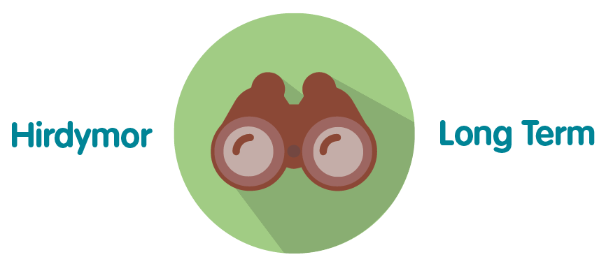 | An annual audit plan is conducted to support services to engage in activities to continuously improve by evaluating, developing and implementing innovative ways of working. The plan demonstrates the organisations commitment of continuous improvement.
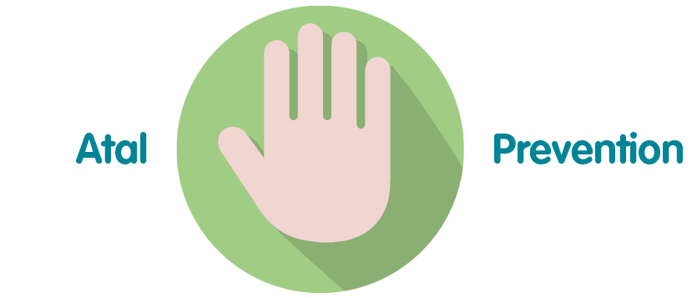 | Where possible Public Health Wales seeks to validate the efficacy of its practice and to make continuous improvements. The annual audit plan is integral to supporting this work.
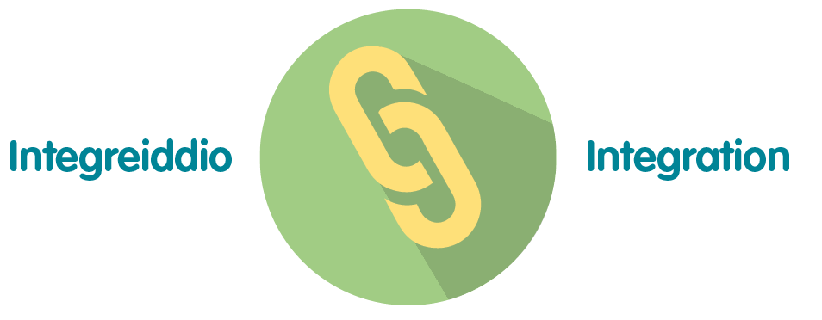 | The audit plan impacts a number of the wellbeing goals, including “A Resilient Wales” and “A More Equal Wales”.
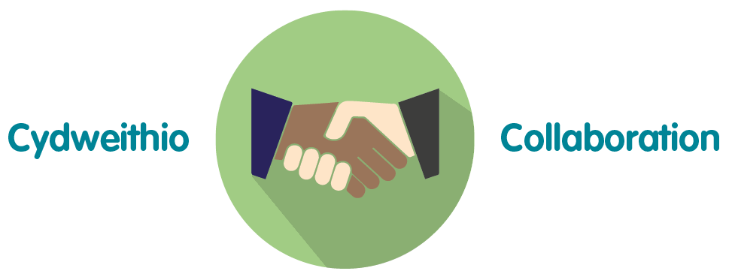 | The audit plan contains work across UK and Wales and includes other NHS bodies working together with Public Health Wales NHS Trust to provide the best outcomes.
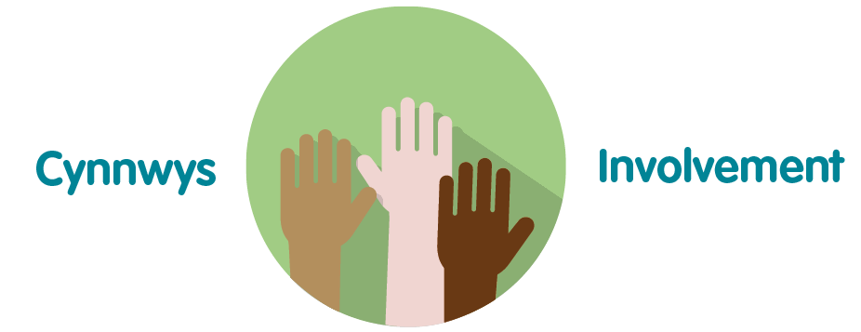 | The audit plan is an important aspect of the organisation’s governance arrangements, and, as such, helps the organisation to improve the quality and safeguard the high standards of the services provided by Public Health Wales.

- Recommendation(s)
The Quality, Safety and Improvement Committee is asked to:
- take assurance on progress against the Annual Quality and Clinical Audit Plan 2020/21.

Year-End Report: 2020/21 Annual Quality and Clinical Audit Plan

March 2021

Index

 | Page
Section 1: National Audits UK / Wales (externally generated) | 9 - 11
List of audits, year-end outcomes and recommendations
Section 2: Local Audits | 12 - 16
List of audits, year-end outcomes
and recommendations

Section 1: National Audits (UK/Wales) 2020/21 (externally generated)
Abbreviations
BSW – Bowel Screening Wales |  |  |  | BTW – Breast Test Wales |  |  | AHP – Allied Health Professionals |  |  | CSW – Cervical Screening Wales
DESW – Diabetic Eye Screening Wales |  |  |  | QNAHP – Quality Nursing and Allied Health Professionals |  |  | NBHSW – New Born Hearing Services Wales |  |  | WAAASP – Wales Abdominal Aortic Aneurysm Screening Programme Wales
No. | Direct-orate | Division | Lead |  | Audit Title  (what) | Scope/Aim  (why) |  | Start Date | End Date |  | Year-end updates
1 | Public Health Services | BTW | Head of Programme |  | Association of Breast Surgery annual audit of screening detected breast cancers | To examine NHS Breast Screening Programme surgical activity. Public Health Wales is requested to provide data to support the National Cancer Data UK programme. This is an ongoing annual audit |  | Apr  2020 | Mar  2021 |  | Ongoing - Ongoing programme reported to the Association of Breast Surgery annually. Due to be published in June.
2 | Public Health Services | NBHSW | Head of Programme |  | All Wales Audiology Audit (in relation to New born Hearing) | Newborn Hearing Screening Wales – participates in All Wales Audiology Audits and provides data on request |  | N/A | N/A |  | On hold - Not taking place in 2020 as agreed with Welsh Government and will be reviewed in 2021
3 | Public Health Services | DESW | Programme Lead Nurse |  | National diabetes audit for eye screening for antenatal patients | Public Health Wales, in conjunction and agreement with LHBs, is requested to provide data to support the National diabetes audit for eye screening for antenatal patients. |  | N/A | N/A |  | On hold - Data sharing agreement not yet agreed (required under GDPR), therefore PHW is unable to share information with LHBs who are the audit respondents. Participation in this annual audit will not take place until suitable information governance arrangements in place.
4 | Public Health Services | DESW | Programme Lead Nurse |  | National diabetes paediatric audit | Public Health Wales, in conjunction and agreement with LHBs, is requested to provide data to support the National diabetes paediatric audit. |  | N/A | N/A |  | On hold - Data sharing agreement not yet agreed (required under GDPR), therefore PHW is unable to share information with LHBs who are the audit respondents. Participation in this annual audit will not take place until suitable information governance arrangements in place.
5 | Public Health Services | Health Protection | Head of Programme |  | Needle and syringe programmes | Audit of the uptake of use of the Wales Needle and Syringe programme in operation across Wales. Data is provided to PHW from statutory and voluntary organisations via the Harm Reduction Database Wales and reports to Welsh Government and UK Focal Point. |  | 2010 | Continuous |  | Ongoing as planned - Since March 2020, an additional monthly audit report has been produced to measure the impact of COVID-19 on activity (compared with same period in the previous years) and assessment of potential health protection/public health implications. The monthly report has been disseminated directly to Health Board/Area Planning Board Chairs and Welsh Government. Monthly COVID-19 impact reports still delivered to the Welsh Government Substance Misuse Area Planning Board Leads group evidencing decreased harm reduction activity and resultant increased risk of blood borne viral, bacterial infections and premature deaths.
6 | Public Health Services | Health Protection | Head of Programme |  | Blood borne virus testing | Audit of the number of Blood Borne Virus tests undertaken in community settings across Wales. Data is provided to PHW from statutory and voluntary organisations via the Harm Reduction Database Wales and reports to Welsh Government and UK Focal Point. |  | 2017 | Continuous |  | As above
7 | Public Health Services | Health Protection | Head of Programme |  | Take home naloxone | Audit of the number of Take Home Naloxone kits issued to at risk individuals across Wales. Data is provided to PHW from statutory and voluntary organisations via the Harm Reduction Database Wales and reports to Welsh Government and UK Focal Point. |  | 2012 | Continuous |  | As above
8 | Public Health Services | Health Protection | Head of Programme |  | Fatal and non-fatal drug Poisonings | Audit of the number of suspected drug poisonings investigated across Wales. Data is provided to PHW from statutory and voluntary organisations via the Harm Reduction Database Wales and reports to Welsh Government and UK Focal Point. |  | 2015 | Continuous |  | As above

Section 2: Local Audits 2020/21 (internally generated)
Abbreviations
BSW – Bowel Screening Wales |  |  |  | BTW – Breast Test Wales |  |  | AHP – Allied Health Professionals |  |  | CSW – Cervical Screening Wales
DESW – Diabetic Eye Screening Wales |  |  |  | QNAHP – Quality Nursing and Allied Health Professionals |  |  | NBHSW – New Born Hearing Services Wales |  |  | WAAASP – Wales Abdominal Aortic Aneurysm Screening Programme Wales
No | Direct-orate | Division | Lead |  | Audit Title  (what) | Scope/Aim  (why) |  | Start Date | End Date |  | Year-end updates
 | Public Health Services | Screening | Head of Nursing, Screening Div. |  | Audit of Recording of Consent obtained in participants records | Audit of recording of consent obtained to undertaking procedures in participants records to obtain a baseline understanding across screening services. Pilot audit of 50 records to be undertaken first. |  | Sep 2020 | Oct 2020 |  | Complete - 50 records in BTW audited, identified audit form not fit for purpose and identified need to audit form 4’s. Audits of form 4’s completed and SBAR report completed
 | Public Health Services | DESW | Programme Lead Nurse DESW |  | DESW audit of patient record | To ensure the quality of patient records within the DESW clinical system. This was postponed from 2018-19 / 2019-20 due to service pressures. |  | Feb 2021 | Feb 2021 |  | Complete - Audit completed as planned.
 | Public Health Services | BTW | Head of Nursing Screening Division |  | Re-audit to establish the accuracy and completeness of breast care nursing record keeping | To provide assurance that previous areas for improvements have been addressed |  | N/A | N/A |  | On hold - Deferred to 2021/22 due to operational pressures
 | Public Health Services | BSW | Head of Programme |  | Re-audit: BSW-Central Administration Audit | Listen to 10 calls made to helpline for each team member (10x10=100) Check 10 participant records on each suspend code (18x10=180) |  | Aug 2020 | Mar 2021 |  | First half of audit complete - BSW Call Audit of telephone calls to the helpline undertaken on calls received 01/01/2020 and 01/07/2020 – 10 calls per team member were listened to. The final report will be shared with the BSW Operational Group on 19/11/2020 – actions from the report were completed October 2020, with update training sessions for the Screening Pathway team on-going throughout the year.  Second half of audit – ongoing – to be complete at the end of March/beginning of April 2021 and will include telephone calls taken between July 2020 and March 2021.
 | Public Health Services | BSW | Head of Programme |  | Audit of manual and ceased status codes | Audit of manually applied ceased and suspend status codes – check manual status code changes made by team to ensure correct code has been chosen from the drop down and that an appropriate note of explanation has been added to the participant record. |  | Aug 2020 | Oct 2020 |  | Complete - BSW Status Code Audit undertaken during September and October 2020 – 131 cease or suspend status codes were randomly checked. The final report will be shared with the BSW Operational Group on 19/11/2020 – actions from the report were completed end of October 2020, with update training sessions for the Screening Pathway team on-going throughout the year.
 | Public Health Services | WAAASP | Head of Programme |  | Audit of the accuracy of the ultrasound scan images | To ensure that screening staff are practicing within the agreed guideline |  | Sep 2020 | Mar 2021 |  | Ongoing as planned -Due to the health protection response the AAA screening was paused between March 18th and August 17th. There will be a combined report for Q2 and Q3 available in April 2021
 | Public Health Services | WAAASP | Head of Programme |  | Audit of cease pending codes | A review of all records to assess the appropriateness of status codes will be undertaken to ensure that all staff are following the standard operating procedures |  | Sep 2020 | Mar 2021 |  | Ongoing as planned - Undertaken as a monthly report and reviewed and updated by All Wales Administration Coordinator and the Regional Nurse Coordinators. This is routine part of programme work.
 | QNAHPs | Nursing and AHPs | Quality Lead |  | Re-audit: Nurse and AHPs Registration | To monitor registration of nursing and AHP personnel across PHW |  | Aug 2020 | Sep 2020 |  | Complete – findings/paper submitted to QSIC
 | Operations and Finance | Estates, Safety and Facilities Division | Health and Safety Manager |  | Health and Safety Premise inspections | To audit premises where PHW staff are tenants or hosted with a Health Board. The audit primarily covers compliance to the Workplace (Health, Safety and Welfare) Regulations 1992 but additionally covers several Estates related Statutory regulations e.g. Regulatory Reform (Fire Safety) 2005, Control of Asbestos Regulations 2012 etc. |  | Jan 2016 | Continuous |  | On hold - Health and Safety audits in their original format remain on hold due to organisational demands. However over the course of 2020/21 risk assessments and audits have been undertaken to ensure actions are identified to mitigate the risks of Covid-19 transmission in the workplace. Regular compliance monitoring has also been implemented. This will continue during 2021/22 and it is likely a revised process for Health and Safety audits will be put in place as we return to the ‘new normal.’ This is being informed following advice from our independent Health and Safety Consultant.
 | Health and Well Being | Primary Care Division | Project Manager |  | Audit of Health Boards Progress with Primary Care Model Review | Audit of the Integrated Medium-Term Plans (IMTPs) of Health Boards by the Primary Care Hub within Public Health Wales (PHW) to annually review progress towards meeting draft standards for visibility components within the Primary Care Model for Wales (PCMW) |  | 2018 | Continuous |  | Ongoing - Continuous Programme.
 | WHO CC / Policy and Int’l Health | International Health | Consultant in Public Health |  | To Evaluate the Charter for International Health Partnerships in Wales | To measure impact and plan future direction following the five-year Charter celebration event, as part of the 2019/20 Annual Plan. |  | N/A | N/A |  | On hold - The work commenced in 2019 and put on hold for 2020/21 – to be reviewed in June 2021, pending release of staff currently supporting the National Health Protection Response
 | WHO CC / Policy and Int’l Health | Policy | Consultant in Public Health |  | Audit (improvement project) on implementation of the Well-Being of Future Generations Act | Following the introduction of the Wellbeing of Future Generations Act in 2015, a Health and Sustainability Hub was set up to support the organisation to embed the sustainable development principle.  The audit (improvement project) will support the Hub and the organisation to understand the degree to which actions to date have supported staff to embed sustainable development in their day to day practice and identify opportunities for future action. The findings will also be used by the Hub to set its future work programme. |  | N/A | N/A |  | On hold - Deferred to 2021-22 due to operational pressures

