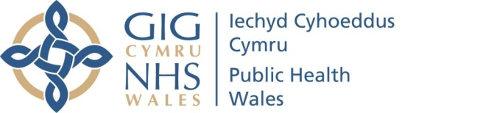 |  |  |  | Name of Meeting  Quality, Safety and Improvement Committee
Date of Meeting
14 April 2021
Agenda item:
4.2
Infection Prevention and Control Annual Report for 2019-20
Executive lead: |  | Rhiannon Beaumont-Wood, Executive Director, Quality, Nursing and Allied Health Professionals
Author: |  | - Beverley Gregory, Lead Nurse for Infection Prevention and Control  - Eleri Lloyd Burns, Interim Assistant Director of Quality, Nursing and Allied Health Professionals
Approval/Scrutiny route: |  | Rhiannon Beaumont-Wood, Executive Director, Quality, Nursing and Allied Health Professionals  Provided to Business Executive Team via email for assurance.
Purpose
The Quality, Safety and Improvement Committee is asked to approve the annual report
Recommendation:
APPROVE | CONSIDER |  | RECOMMEND |  | ADOPT | Assurance
The Quality, Safety and Improvement Committee is asked to:

- Approve the Infection Prevention and Control Annual Report for 2019/20

Link to Public Health Wales Strategic Plan

Public Health Wales has an agreed strategic plan, which has identified seven strategic priorities.

This report contributes to all strategic priorities.
Summary impact analysis

Equality and Health Impact Assessment | An Equality and Health Impact Assessment is not necessary as no decision is required.
Risk and Assurance | N/A
Health and Care Standards | This report supports and/or takes into account the Health and Care Standards for NHS Wales Quality Themes
Health and Care Standards | Governance, Leadership and Accountability
Health and Care Standards | Person Centred Care
Health and Care Standards | Theme 6 - Individual Care
Financial implications | N/A
People implications | N/A

Introduction

The paper provides the Quality, Safety and Improvement Committee with the Infection Prevention and Control Annual report for 2019/20.

This report covers the period from 1 April 2019 to 31 March 2020. Between Quarter 4 of 2019/20 and Quarter 2 of 2020/21, the lead Nurse Infection prevention and control post was vacant, with a new post holder joining the corporate team in June 2020 and has been further impacted by the need to support the COVID-19 Health Protection response. This gap resulted in challenges in capacity to provide timely reporting.

Due to operational challenges referred to above, this is first opportunity to present the Annual Report.

We aim to present the Annual 2020/21 Infection Prevention and Control report at the next Quality Safety and Improvement Committee, to bring the reporting cycle back in line with annual reporting timelines.

The report will be published in both Welsh and English.

Background

Public Health Wales is expected to comply with the Code of Practice for the Prevention and Control of Healthcare Associated Infections 2014 (the ‘Code’). A requirement of the Code is for the Board to receive an annual Infection Prevention Control Report.

The annual report seeks to provide the Board and relevant Board Committees with assurance that the organisation is meeting its statutory requirements in relation to the management of infection prevention and control.

Assessment

In striving for excellence, Public Health Wales aims to ensure the public have confidence in the services they receive. Infection prevention and control is an integral part of the services we provide. Public Health Wales is committed to ensuring that robust infection prevention and control arrangements are in place within the organisation. Our aim is to ensure that all steps are taken to minimise the spread of infection, and advice is given on appropriate intervention which needs to be made in order to reduce and mitigate any risks to service users.

This Annual report notes ongoing progress regarding compliance with the Code of Practice and offers a breakdown of improvements for 2020/21.

Well-being of Future Generations (Wales) Act 2015

The report contributes to Goal 3 “Support the NHS to deliver high quality, equitable and sustainable services”. The below information follows the five ways of working, as defined within the sustainable development principle in the Act, in the following ways:

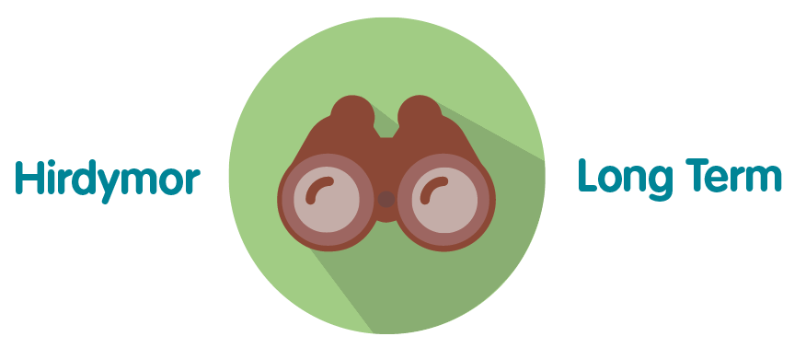 | The annual report seeks to provide the Board and relevant Board Committees with assurance that the organisation is meeting its statutory requirements in relation to the management of infection prevention and control.
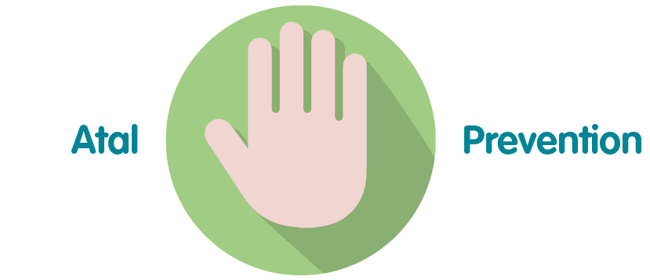 | Where possible Public Health Wales seeks to prevent the occurrence of concerns by taking a proactive approach to the reporting and management of infection risk to ensure safe services are provided to the users of our services.
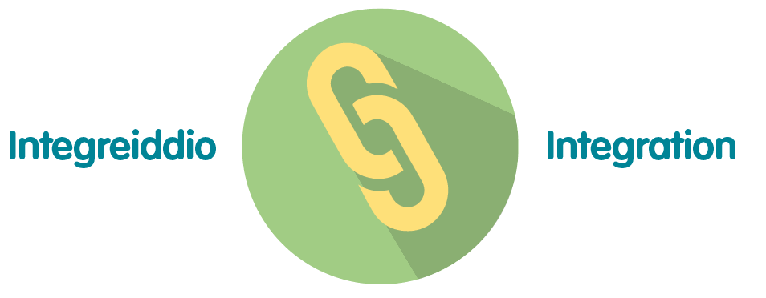 | The Infection Prevention and Control Annual report impacts a number of the wellbeing goals, including “A Resilient Wales” and “A More Equal Wales
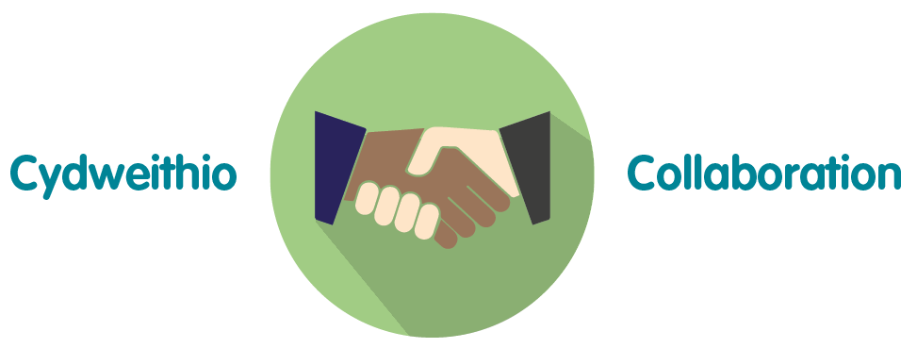 | Public Health Wales is committed to dealing with incidents where there is risk of infection in an open, accessible and fair manner. The report offers insight into how various teams are working together with Public Health Wales NHS Trust to provide the best outcomes
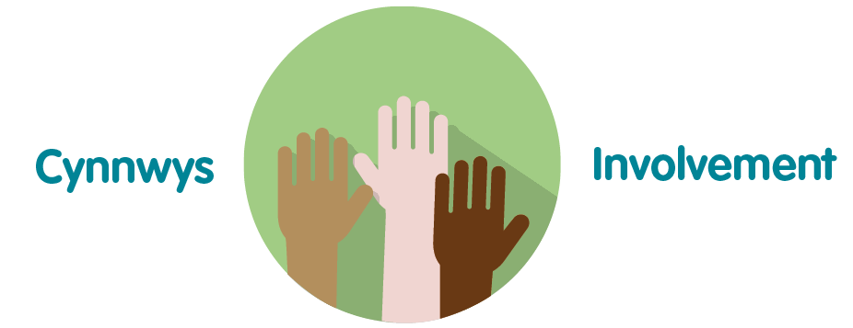 | This annual report is an important aspect of the organisation’s governance arrangements, and, as such, helps the organisation to improve the quality and safeguard the high standards of the services provided by Public Health Wales

4. Recommendation

The Quality, Safety and Improvement Committee is asked to:

- Approve the Infection Prevention and Control Annual Report for 2019/20

