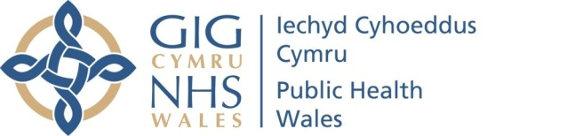 |  |  |  | Name of Meeting  Quality, Safety and Improvement Committee
Date of Meeting
14 April 2021
 |  |  |  | 3.5
Organisational Self-Assessment Report against the Health and Care
Standards 2020/21
Executive lead: |  | Rhiannon Beaumont-Wood, Executive Director, Quality Nursing and Allied Health Professionals.
Author: |  | Caroline Whittaker, Quality Lead, Quality Nursing and Allied Health Professionals.  Jessica Taylor Quality Improvement and Clinical Audit Support Officer, Quality Nursing and Allied Health Professionals.
Approval/Scrutiny route: |  | Business Executive Team – 12 April 2021.
Purpose
The purpose of this paper is to provide the Quality, Safety and Improvement Committee with an update on the organisational self-assessments against the Health and Care Standards 2020-21.
Recommendation:
APPROVE | CONSIDER |  | RECOMMEND |  | ADOPT | ASSURANCE
The Quality Safety and Improvement Committee is asked to:

- receive assurance that the Health and Care Standards process has been completed for 2020-21 and that the overall organisational position is at level 4.

Link to Public Health Wales Strategic Plan

Public Health Wales has an agreed strategic plan, which has identified seven strategic priorities and well-being objectives

This report contributes to the following:
Strategic Priority/Well-being Objective | Relate to all Strategic Objectives  Choose an item.
Summary impact analysis

Equality and Health Impact Assessment | An Equality and Health Impact Assessment is not required as there is no impact on policy or decisions relevant to the Race, Disability and Gender Duties.
Risk and Assurance | The onus is on Public Health Wales and its services, functions and programmes to demonstrate that the Standards are being used and met on a continuous basis. This will continue to be a key element of the organisation’s governance arrangements.
Health and Care Standards | This report supports and/or takes into account the Health and Care Standards for NHS Wales
Financial implications | Whilst undertaking the self-assessment against the Standards has no financial implications, some of the improvement actions identified by Directorates/ Divisions may have associated costs.
People implications | The completion of the self-assessment is reliant on staff embracing the Health and Care Standards with a focus on assurance and improvement.

Purpose / situation

  - The purpose of this paper is to provide the Committee with an overview of the process followed this year (2020/21) to evaluate and review the organisation’s compliance against the Health and Care Standards as part of Public Heath Wales own assurance process (not Welsh Government).

Background

2.1 The Health and Care Standards are core standards for the NHS in Wales and provide a consistent framework to support the NHS. Their application is mandatory for all providers of health services, in all settings, in NHS Wales. The Health and Care Standards describe “the high-level outcome required to contribute to quality and safety underpinned by governance, leadership and accountability” to support the NHS in Wales in improving the quality and safety of services and supports the principle of continuous improvement.

  - Due to the impact of the Covid-19 pandemic and the ongoing organisational Health Protection response, Directorates have not been operating as per normal arrangements during this period, instead teams and staff have been mobilised to support the response. This has resulted in significant opportunities for matrix working and the Operational Plan which was developed during 2020/21 (approved by the Board in October 2020), captures the way the organisation has organised itself during this time.

  - Therefore, given the Health and Care Standards assessment forms part of the overall assessment of organisational governance arrangements, it was important to use an approach, which reflected the way the organisation has been organised during the reporting period 2020/21.

  - In previous years, the organisation had an established peer review process to review and provide effective challenge at a directorate level for the self-assessment. This year, this process has been reviewed to reflect the current context and the nature of our response to COVID-19. This has meant that large parts of the organisation were mobilised during 2020/21 with a prominence on matrix working. Therefore, this paper offers an overview of self-assessment at an organisational level, based around the six priority areas outlined in the Operational Plan approved by the Board in October 2020 (see section 3 for further details).

3. Description / Assessment

Process for 2020/21

3.1 The completion of the Health and Care Standard were assessed and framed around the six priority areas, outlined within the Operational Plan approved in October 2020, which were:

- Organisational Learning, Knowledge
- Health Protection Response
- Population Health Outcomes
- Reactivation of Essential Services
- Organisational Recovery
- Enabling Delivery

  - This approach offers a broader view of the organisational response and approach to quality assurance; cognisant to the recommendations outlined in last year’s health and care standard self-assessment, to offer a broader view of the organisational response and approach to quality assurance.

This approach provided an opportunity to share the achievements across Public Health Wales and discuss areas for improvement at an organisational level.

3.2 There are 23 Health and Care Standards grouped around 7 themes some of which are not applicable at this time to Public Health Wales. For example: Blood Management, Nutrition and Hydration, Falls Prevention, hence 3 standards were not reviewed and applied for this assessment.

Process for 2020/21

  - A representative (business manager) from each of the six Priority Areas outlined in the Operational Plan (see paragraph 3.1) attended an initial meeting to discuss the best way to approach the self-assessment for 2020/21.

  - The representatives then completed the self-assessment of their priority areas against the Health and Care Standards, using an agreed template. As part of this process they were required to review the work undertaken within their area of responsibility, to determine areas of good practice and to identify where improvements could be made, using the maturity matrix to score (Appendix 1).

Scores range between 1 - 5; 1 being poor and 5 is optimal
(Self-assessment scoring is by nature a subjective process, based on knowledge of the application of the standards in their areas).

3.5 Evidence to support the narrative within the self-assessment and justify each of the self-assessment scores was collated onto one organisational document, which is stored in an auditable format.

3.6 It was collectively agreed that the individual self-assessment scores be collated, and an average organisation level score be agreed against each of the Health and Care Standards.

3.7 This resulted in a greater level of scrutiny of the self-assessments, through the sharing of information and analysis of each standard using a checklist (Appendix 2). This ensured a consistent approach was taken to scoring; and provided an opportunity to correct and amend any questions posed by the team.

Organisational Scoring 2020/21

3.8 Based on the maturity matrix the organisational scores detailed in the table above (Figure 1) the overall organisational score is 4 –“We have well developed plans and processes that can demonstrate sustainable improvement throughout the organisation”.

3.9 This score is based on the following:

- We can demonstrate through the evidence provided that we have structures in place providing the necessary arrangements; identifying our improvement objectives; the planning in place to achieve this; and a clear plan for the monitoring of these objectives.

- Whilst there are areas of the organisation which further work is required, the narrative indicates that this is mainly focused on COVID specific arrangements, which the underpinning structures providing a sound base to ensure these are progressed.

3.10 The table at Figure 1 below provides an overview of the agreed collective scores at an organisational level against each of the Health and Care Standards.

3.11 It is important to note that there are individual self-assessments for each of the priority areas, which are different to the overall organisational score, either because certain areas exceed the organisational score, or identify areas for improvement. The approach taken was to provide a level of consistency at an organisational level to provide a greater level of scrutiny.

3.12 The scoring at Priority level against each of standards, along with the supporting evidence are available for review if requested, and are stored in an auditable format.

Figure 1 Health and Care Standards Overall Organisational assessment
Health and Care Standard Theme and Criteria | Overall Organisational Score | Narrative and rationale for scoring
0-Governance, Leadership and Accountability  Health services demonstrate effective leadership by setting direction, igniting passion, pace, and drive, and developing people Strategy is set with a focus on outcomes, and choices based on evidence and people insight. The approach is through collaboration building on common purpose. Health services innovate and improve delivery, plan resource and prioritise, develop clear roles, responsibilities and delivery models, and manage performance and value for money. Health services foster a culture of learning and self-awareness, and personal and professional integrity. | Overall score 3  We are developing plans and processes and can demonstrate progress with some of our key areas for improvement | Operation Plan sets out the activity for the Organisation, delivered around a number of defined priority areas, and there is an Operational Milestone reporting structure in place to ensure appropriate review and monitoring of this implementation.  A robust process has been established for the continuing reactivation of functions, programmes and services, including systematic identification and management of risk through a comprehensive set of service risk profiles. The PHW Executive is kept apprised on a monthly basis of the current position.  The Corporate level governance arrangements have been robust this year, with numerous reports to Board and Committee to ensure outlining the arrangements in place during the pandemic. This is well documented and evidence is provided to support this thorough out the year. The Board and Executive governance arrangements were assessed separately to the priority areas, and the rating for this was assessed at a score of 4.  There is a strand of work that the organisation is undertaking relating to COVID governance arrangements and the ongoing development on health protection response governance model.  For this reason, the overall Organisational score has been agreed at a 3, with the reflection that once the health protection response governance model is approved and implementation, the overall rating would return to be in line with Business as usual rating
1-Safe Care  People's health, safety, and welfare are actively promoted and protected. Risks are identified, monitored and where possible, reduced or prevented | Overall score 4  We have well developed plans and processes that can demonstrate sustainable improvement throughout the organisation | Review of the individual priority level scores supported an overall organisation level of 4. Plans and processes were identified, documented and evidence to support this was provided. No substantial issues or areas for improvement were raised within the specific priority areas assessment.
2-Staying Healthy  Staff are empowered and supported to take responsibility for their own health and wellbeing. Health services work in partnership with others to protect and improve the health and wellbeing of people and reduce health inequalities | Overall score 4  We have well developed plans and processes that can demonstrate sustainable improvement throughout the organisation | Review of the individual priority level scores supported an overall organisation level of 4. Plans and processes were identified, documented and evidence to support this was provided. No substantial issues or areas for improvement were raised within the specific priority areas assessment.
3-Effective Care  Care, treatment, and decision-making should reflect best practice based on evidence to ensure that people receive the right care and support to meet their individual needs. | Overall score 4  We have well developed plans and processes that can demonstrate sustainable improvement throughout the organisation | Review of the individual priority level scores supported an overall organisation level of 4. Plans and processes were identified, documented and evidence to support this was provided. No substantial issues or areas for improvement were raised within the specific priority areas assessment.
4-Dignified Care  People's experiences of health care is one where everyone is treated with dignity, respect, compassion and kindness and which recognises and addresses individual physical, psychological, social, cultural, language and spiritual needs. | Overall score 4  We have well developed plans and processes that can demonstrate sustainable improvement throughout the organisation | Review of the individual priority level scores supported an overall organisation level of 4. Plans and processes were identified, documented and evidence to support this was provided. No substantial issues or areas for improvement were raised within the specific priority areas assessment.
5-Timely Care  All aspects of care are provided in a timely way ensuring that people are treated and cared for in the right way, at the right time, in the right place, and with the right staff. | Overall score 3  We are developing plans and processes and can demonstrate progress with some of our key areas for improvement | The COVID-19 response resulted in some services suspended between Apr-Sept 2020. This has resulted in increased waiting times and a resultant delay for further treatment if indicated.
6-Individual Care  Care provision must respect people's choices in how they care for themselves as maintaining independence improves quality of life and maximises physical and emotional well-being. | Overall score 4  We have well developed plans and processes that can demonstrate sustainable improvement throughout the organisation | Review of the individual priority level scores supported an overall organisation level of 4. Plans and processes were identified, documented and evidence to support this was provided. No substantial issues or areas for improvement were raised within the specific priority areas assessment.
7-Staff and Resources  Health services should ensure there are enough staff with the right knowledge and skills available at the right time to meet need. | Overall score 3  We are developing plans and processes and can demonstrate progress with some of our key areas for improvement | The mobilisation of staff across the organisation highlighted the need to understand the skill set involved. Further workforce planning for the future is required from a resilience and emergency planning stance. Return to medium- to long-term strategic workforce planning as part of usual integrated planning cycle

Well-being of Future Generations (Wales) Act 2015

In order to meet the “Sustainable Development Principle” in the above Act, consideration was given to aligning the five ways of working to Public Health Wales NHS Trust:

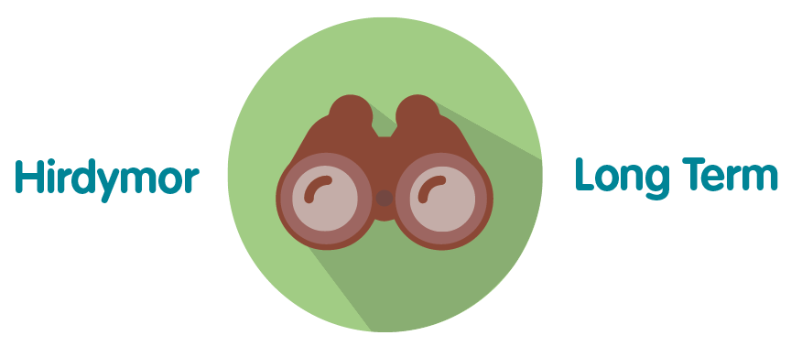 | The Health and Care Standards are reviewed and assessed annually and provide a mechanism for the organisation to improve year on year
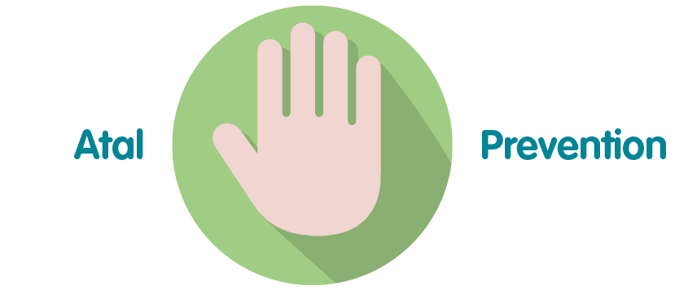 | All the Standards are self-assessed and reviewed to identify areas that require action to identify level of compliance and drive improvement
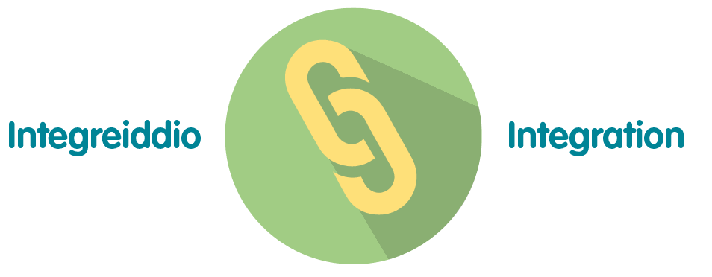 | All the Standards that relate to Public Health Wales are integral to delivering services functions and programmes, as set out in the Strategic Priorities
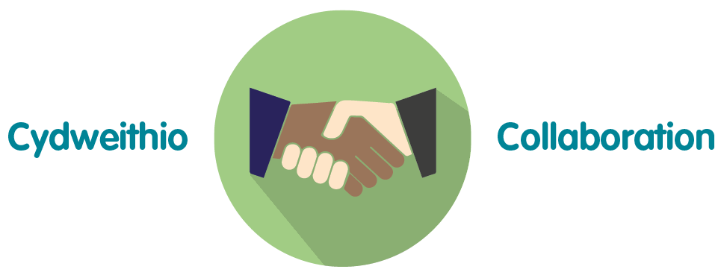 | Many of the organisations services, functions and programmes require collaboration across the organisation and with external stakeholders
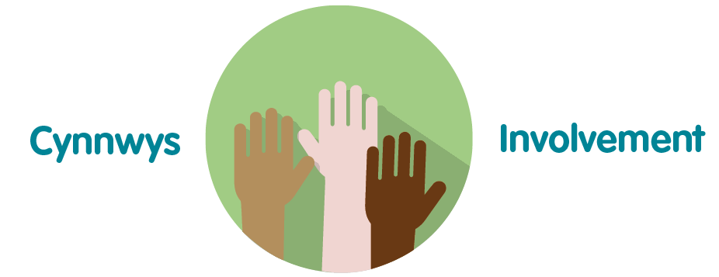 | As part of the self-assessment the Standards are peer reviewed which involves staff representation from all Directorates in addition to an Internal Audit

5. Summary

Taking an organisational approach to completing the Health and Care Standards facilitates learning and the sharing of knowledge across Public Health Wales and aligns to the Operational Plan 2020-21 and 2021-22.

Due to the challenges of completing the Health and Care Standards during the response to COVID 19, Business Leads supporting the 6 priorities reviewed and proposed an organisation position on organisational scores for the Health and Care Standards and the following organisational improvements were identified:

- Identify and scope the developing an organisational records management structure /system/process.
- The development on health protection response governance model
- Development of recovery plans to reactivate all Public Health service, programmes and functions.

Prior to the receipt of the paper SROs (Executive Leads) have not had the opportunity to input to the relevant scores, therefore it is important that they consider appendix 1 along with the narrative and rationale for the scoring.

6. Recommendations

The Quality, Safety and Improvement Committee is asked to:

- Consider appendix 1 and the narrative and rationale and agree the scoring
- Receive assurance that the Health and Care Standards process has been completed for 2020-21 and that the overall organisational position is at level 4
- Approve the report for submission to the Quality, Safety and Improvement Committee.

Appendix 1 Self-assessment Matrix

1 | 2 | 3 | 4 | 5
We do not yet have a clear, agreed understanding of where we are (or how we are doing) and what / where we need to improve | We are aware of the improvements that need to be made and have prioritised them, but are not yet able to demonstrate meaningful action. | We are developing plans and processes and can demonstrate progress with some of our key areas for improvement | We have well developed plans and processes can demonstrate sustainable improvement throughout the organisation / business | We can demonstrate sustained good practice and innovation that is shared throughout the organisations / business, and which others can learn from

Appendix 2 Peer Review Checklist
Health and Care Standards Peer Review Process: Checklist

Process
1 | Has the self-assessment been fully completed appropriate to their areas? | YES | NO | Any comment
2. | Does the narrative support the relevant Standard? | Yes | No | Any comment
3. | Is there relevant evidence attached/ linked to each Standard? (the higher score the more substantial the evidence should be) | Yes | No | Any comment
4. | Have improvement actions been identified? | YES | NO | Any comment
5. | Are there any gaps you can identify? | YES | NO | Please list:
Overall comments
6. | Please identify any strengths of the self-assessment | Please list
7. | Please identify any areas of weaknesses of the self-assessment | Please list
8. | Overall – do you think that the scores identified by the Priority Areas are evidenced by the information provided | YES | No  (Please state your rationale)

