 |  |  |  | Name of Meeting  Quality, Safety and Improvement Committee
Date of Meeting
14 April 2021
Agenda item:
3.3
Putting Things Right Report Quarter 4 2020/2021
Executive lead: |  | Rhiannon Beaumont-Wood, Executive Director, Quality, Nursing and Allied Health Professionals
Author: |  | John Lawson, Chief Risk Officer.
Approval/Scrutiny route: |  | Rhiannon Beaumont-Wood, Executive Director, Quality, Nursing and Allied Health Professionals  Provided to Business Execuitve Team 12 April 2021.
Purpose
This paper introduces the Putting Things Right report for Quarter 4, 2020-2021.
Recommendation:
APPROVE | CONSIDER |  | RECOMMEND |  | ADOPT | Assurance
The Committee is asked to:

- Consider the report and take assurance in relation to Putting Things Right.

Link to Public Health Wales Strategic Plan

Public Health Wales has an agreed strategic plan, which has identified seven strategic priorities.

This report contributes to all strategic priorities.
Summary impact analysis

Equality and Health Impact Assessment | An Equality and Health Impact Assessment is not necessary as no decision is required.
Risk and Assurance | N/A
Health and Care Standards | This report supports and/or takes into account the Health and Care Standards for NHS Wales Quality Themes
Health and Care Standards | Governance, Leadership and Accountability
Health and Care Standards | Person Centred Care
Health and Care Standards | Theme 1 - Staying Healthy
Financial implications | There are significant risks in failing to manage the ‘Putting Things Right’ process effectively, including the risk to service users and staff because of failing to learn lessons from events, and the financial and legal sanctions possible from causing avoidable harm.
People implications | N/A

Introduction

The Putting Things Right (PTR) report

Public Health Wales is currently operating in an extraordinary environment as a result of the Covid-19 emergency for which it is the lead agency. All efforts are currently focussed on supporting the response to the emergency and this report should be viewed in that context.

With a shift of emphasis on Integrated Goverance we are continuing to iteratively adapt the PTR report and align it more firmly within the broader Risk management domain in seeking to provide assurance to the Committee.

As such, the PTR report is intended to provide the narrative analysis to the data contained within the Performance and Assurance dashboard. The report is in iterative development and some of the data is not yet available as it is only now starting to emerge from Datix as the Quality Control process is implemented. Where data are presented in the report it is accurate, and where it is not yet available this has been made clear.

The PTR report is divided into sections:

Section 1 – Summary of performance against Tier 1 targets

Section 2 – Incident Management

Section 3 – Claims Management

Section 4 – Improvement Actions

Each section provides the data, and (with the exception of Section 1) a narrative to accompany it and explain identified improvement actions.

Section 1 –Performance against tier 1 targets

1.1 Serious Incidents / Never events

This section contains a brief summary of Serious Incidents / No Surprises / Never Event submissions.

There is no longer a Tier 1 target for closure of incidents but performance is reported against the previous 60 day target.

Measure | Number this qtr. | Closure performance | Number prev. qtr. | Closure performance
Serious Incidents reported to WG | 2 | 100% | 1 | 100%
No Surprises reports submitted to WG | 3 | N/A | 1 | N/A
No Surprises reports submitted and subsequently upgraded by Welsh Government to a Serious Incident | 0 | N/A | 0 | N/A
Never Events | 0 | N/A | 0 | N/A
Table 1 – Serious incident / No Surprises reporting performance

Narrative

Serious incidents reported

Serious Incident Datix ref 17245 WG ref 20210125PHW0484

As the sexual health programme were looking for results for people who emailed Public Health Wales they found positives that had not been included on the spreadsheets received Monday – Friday. It had been assumed that the results received on Mondays included tests from the weekend, however when this was raised (11th Nov) and subsequently investigated by the laboratory it became apparent that this was not the case. (26th Nov). This incident is still under investigation.

Serious Incident Datix ref 17260 WG ref 20210125PHW0485
As part of failsafe work undertaken for the programme, WAAASP identified a number of men registered on the AAA information management system who were resident in Wales for the whole of the year when they were aged 65years and not sent an invitation or moved into Wales during the year they were 65 years old and were registered for a minimum of 35 or more consecutive days. This cohort affected were men with no associated clinic, i.e. unknown GP practice and men on the Safe Haven/ Alternative Treatment Scheme (ATS) register.

A review was undertaken and twenty two men are older than 66 years + 6 months were sent an invitation letter explaining the delay in invitation with a dated and times appointment in February and March 2021. An improved system for identifying men on the Safe Haven/ Alternative Treatment Scheme (ATS) register has been agreed with the Registration Department at NHS Wales Shared Services Partnership.

No Surprises reports
No Surprises Datix ref – 17218

The laptops used in Diabetic Eye Screening are synchronised following clinics to upload data into the Optimise IT system for images to be graded. On 05/01/2021 one of the laptops failed to synchronise and investigation by software provider on 06/01/2021 identified the reason was one unsynchronised record from a clinic held on 27/09/2019. The images had not been uploaded to the server following the clinic appointment and it was not possible to retrieve the images. The person was sent a letter explaining and inviting them for re-screening but they did not wish to attend at this time. The service undertook a full synchronisation check for all screening laptops to ensure that no other issues are identified, this was completed across Wales promptly with no other significant issues identified.

No Surprises Datix ref – 17293
On 20/01/21 the Screening Pathway Coordinator was undertaking an audit of the 'Hospital Eye Service Two Year Manual Recall' failsafe process and identified 96 records (from July 2020 to December 2020) where correspondence had been received from Ophthalmology but action had not been undertaken to invite those eligible for screening. A review of the incident has been undertaken, measures taken to improve the process and participants who were eligible for diabetic eye screening identified on this failsafe have now been invited.

No Surprises Datix ref – 17299
Two members of staff who had been working in the same room at one of the static sites of Breast Test Wales, tested positive within two days of each other. A review was carried out which concluded that this could have been due to workplace transmission.

Potential staff contacts were identified and advised to self-isolate as a precaution. The room was assessed for compliance with COVID Infection Prevention and Control guidance. The conclusion of this assessment was that all necessary precautions were in place. Additional recommendations were made and maximum room capacity decreased. Changes were put into place and the importance of control measures reinforced. None of the potential staff contacts developed covid and staff returned to roles after self-isolation period ended.

Serious Incident reporting since the reporting period

There have been no further Serious Incident / No Surprises submissions since the end of the reporting period.

1.2 Complaints and Compliments

Complaints performance over time

Acknowledgement letters

There is a Welsh Government target of acknowledging by letter all complaints that are deemed as requiring formal handling. The chart below shows the performance in this area over the financial year. There were 20 formal complaints reported during the reporting period, with 51% being acknowledged within the required 2 working day target.

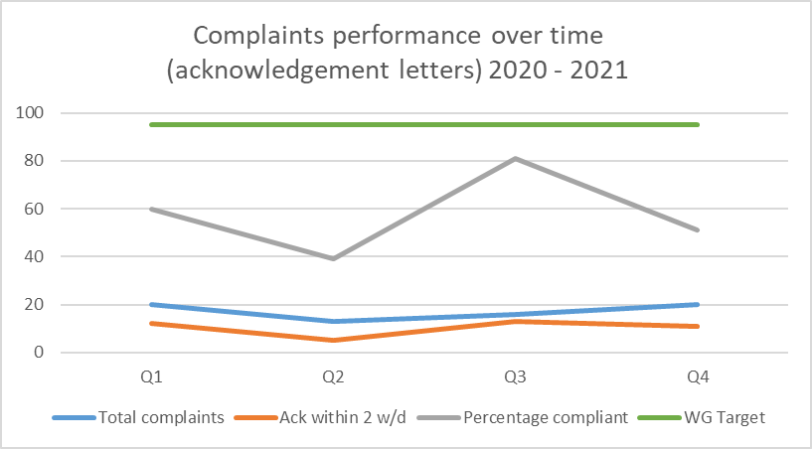
Table 2 – Complaints performance over time – acknowledgement letters

An appointment was made to the new post of Complaints Coordinator in February 2021 and it is important to note that out of the 9 formal complaints received by Handling Concerns since the post holder started, performance in this area has risen sharply to 90%.

Final response letters

There is a Welsh Government target of responding by letter to all complaints that are deemed as requiring formal handling. The chart below shows the performance in this area over the financial year. There were 20 formal complaints reported during the reporting period, with 40% being responded to within the required 30 working day target.

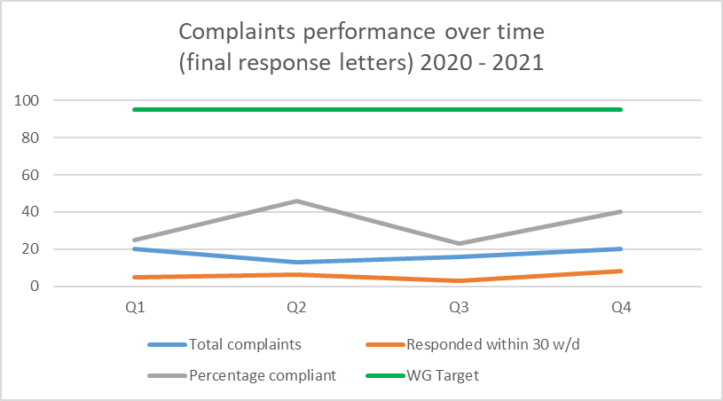
Table 3 – Complaints performance over time – final response letters

Performance in this area has also been poor. There was a significant shift in the profile of complaints with the start of the Covid19 response. Complaints had previously been almost exclusively within the Screening Division where there was considerable expertise in handling and responding to them. From April 2020, there was a shift towards complaints being around the Covid response and there was a lack of clarity around the responsibility for the investigation and response within the NCC/NHPC. Revised governance structures are in development and arrangements will clarify the respective roles and responsibilities.

Towards the end of Q4 clarity was achieved on this responsibility and it is anticipated that performance will improve accordingly.

It should also be noted that 11 of the formal complaints still open in Q4 are not yet due for closure.

Informal complaints

There are no targets for informal complaint handling and so the data in the chart below are shown for information purposes only. There were 21 informal complaints recorded during the reporting period.

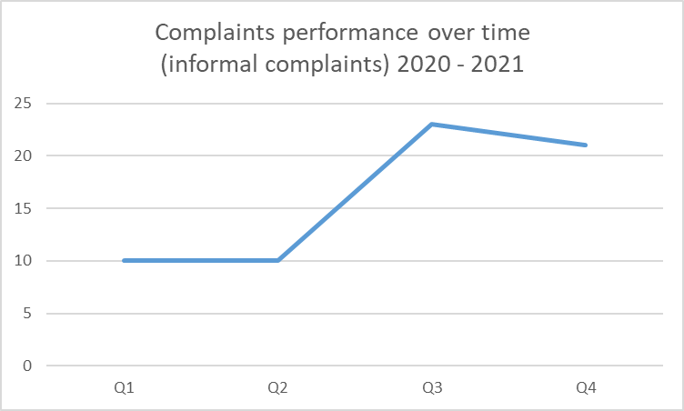
Table 4 – Complaints performance over time – informal complaints

Compliments

During the reporting period, a total of 518 compliments were received in relation to:

- Positive attitude / behaviour of staff
- Positive comments: service related
- Positive comments: waiting times
- Professionalism of staff
- Timeliness of results

The number of compliments has increased since the last reporting period, with the ratio of compliments to formal complaints now standing at 26-1 from 15-1.

For the reporting period the ratio of compliments to complaints is | Compliments | Complaints
 | 26   | 1  
Table 5 – Ratio of concerns to formal complaints

Section 2 – Incident Management

Incident Reporting activity

During the reporting period there were a total of 634 incidents reported, a slight decrease since the previous quarter which was 731. 55% of the reported incidents occurred within Screening which reflects again the increased activity. The first chart shows the incident reporting over the previous 12 months for comparison with the current reporting period highlighted, whereas the second chart shows the incidents reported by Directorate for the current reporting period.

As the organisation continues to adapt and respond to the Covid-19 emergency, the number of incidents reported continues an upward trend. The data support no conclusions that can be drawn from this, but increased training and awareness across the organisation and the use of quality reviews by the Risk and Incident Manager are likely having an effect. Public Health Services remains the largest reporter with less than 1% of incidents falling in the rest of the organisation.

Of the incidents reported, just under 20% (116) were identified as being related to Covid19 and Health Protection reported a total of 14 incidents. There was a total of 163 ‘patient and clients’ related incidents reported none of which were reported as having a potentially major impact.

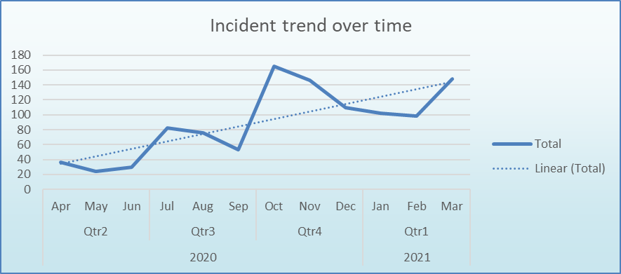
Table 6 – Incidents over time

Improvement actions identified

A significant proportion of work at this time is focussed on delivery of the Once for Wales Concerns Management System. This was due for implementation by 1st April, but due to the unavailability of a minimum viable product by the deadline, the Public Health Wales Executive approved the postponement of the go-live date to the 1st October 2021.

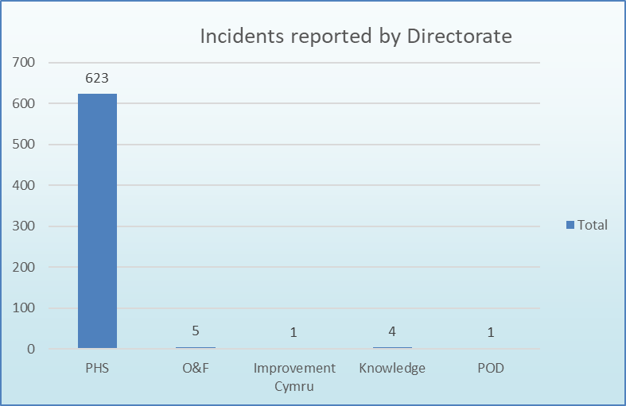
Table 7 – Incident reported by Directorate

Narrative

As shown above, it will be noted that again almost all (99%) of the incidents occur within Public Health Services, which is to be expected due to the clinical nature of their activities and the re-activation of Screening services.

Incident reports by Impact

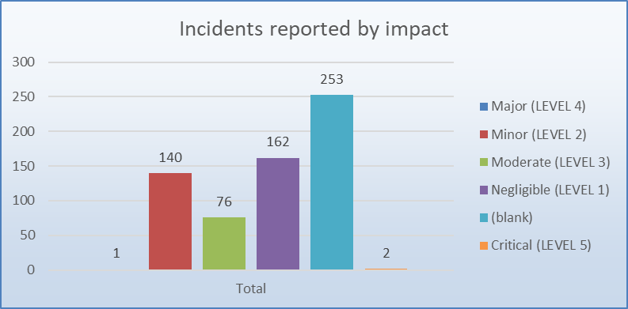
Table 8 – Incident reports by impact

Narrative

Two incidents were reported with an impact rating of Critical. These related to a safeguarding matter received in the National Contact Centre which was referred to the 101 service, and a fire safety issue at Prince Charles Hospital which has now been resolved.

One incident attracted an impact rating of Major, which was an IT issue affecting a Multi-disciplinary Team (MDT) meeting within Breast Test Wales.

With the relatively new toolkit provided to Incident Handlers there is a requirement to assess all incidents for their impact across the 9 areas from the Public Health Wales Risk Management Policy and Procedure. There has been a noticeable rise in compliance with the requirement to complete an impact assessment for all incidents report, which now stands at 60%, up from 48% last quarter. The Risk and Information Governance Team continue to provide support to Directorates to comply with this requirement and the training and support that is being provided appears to be starting to have an effect. This type of assessment is crucial to determining the level of investigation required. It must be noted however that it is almost certain as that this particular functionality will not be available in the Once for Wales Concerns Management System which is due to go live in April 2021 and other assessment processes will need to be considered.

Incidents by Type

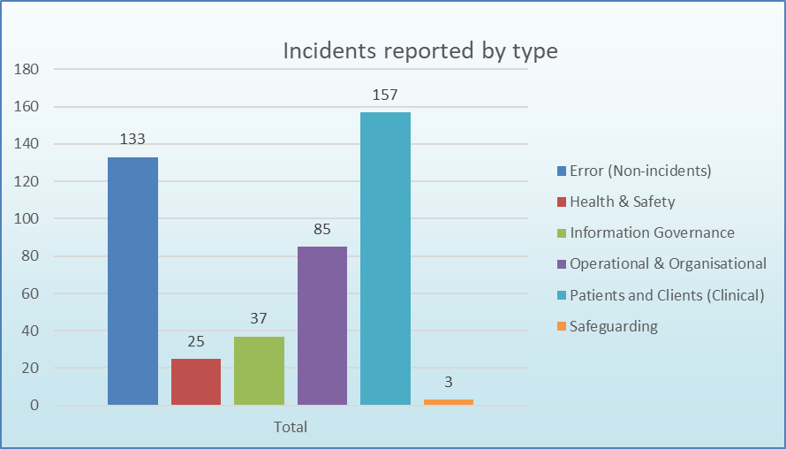
Table 9 – Incidents reported by type

Narrative

The pattern of incidents across the six types is consistent with previous reports with the highest number relating to the ‘patients and clinical’ area. There has been a slight fall in Information Governance related incidents over the previous quarter.

Section 3 – Claims Management

Claims are reported via Datix and managed with advice and support from Legal and Risk Services. All claims are managed and analysed to ensure that lessons are learnt in order to reduce risks of reoccurrence and improve services.

This is a summary of the position, with full details provided in the Quarterly Claims report

Period covered: 1st Jan – 31st Mar 2021

 | Quarter 4
Current number of confirmed claims | 14
Current number of potential claims | 9
Current number of redress cases | 1
New potential claims received in Quarter | 4
New confirmed claims received in Quarter | 2
Number of claims closed in Quarter | 2
New redress cases received in Quarter | 1
Number of redress cases closed in Quarter | 0
Number of Settled Claims in this reporting period | 1
Aggregate value of confirmed claims in progress  (Includes damages, claimant costs and defence costs) | £3,595,166.18
Aggregate value of potential claims  (Includes damages, claimant costs and defence costs) | £5,265,000.00
Aggregate value of confirmed and potential claims  (Includes damages, claimant costs and defence costs) | £8,860,166.18
Anticipated Public Health Wales Liability in respect of confirmed claims | £350,000.00
Table 10 – Financial exposure on current and projected claims

Section 4 – Areas for improvement

Quality Review – Quarter 3 2020/2021

Note – Due to the inherent lag in the process, it is only possible to report on quality one quarter in arrears and so this section of the report relates to Quarter 3.

This reporting will develop over coming months as previously advised to the Committee. Performance targets will be included once the revised Incident Management Procedure has been approved.

In Quarter 3, there were 68 quality reviews that were carried out as a sample of 737 incidents in total. This represents a quality review on a random sample of 9% of all incidents and also all incidents where the Incident Impact Score is marked as Moderate, Major or Critical.

Indicator | Narrative | Performance
Number of incidents where a handler was assigned within 3 days | There were 42 out of 68 records where the handler was assigned within 3 days. | 62%
Previous quarter |  | 57%
Number of incidents reported on Datix within 24 hours of being made known to PHW | There were 48 out of 68 records which were reported in 24 hours | 71%
Previous quarter |  | 60%
Number of incidents in which the risk of re-occurrence required a risk record to be created | 6 out of 68 records could have had a risk created, there was only 1 record in which a risk was created appropriately  There were 45 records in which it was not appropriate to create a risk record | 9%
Previous quarter |  | 43%
Number of incidents closed within 30 days | There were 41 records out of 68 which were closed within 30 days | 60%
Previous quarter |  | 42%
Number of incidents with actions created | There were 11 records which had actions created and were completed  There were no records which had actions created and valid reason provided as to why overdue  There were 49 records that did not have any actions assigned to them. | 72%
Previous quarter |  | 77%
Table 11 – Datix Quality Reviews
Narrative

These data are now produced with a comparison to the previous quarter, but the data detailed above must be treated with caution. The data shown are only a random sample of approximately 10% of the total number of incidents recorded. In addition, the targets shown are not yet approved within the Incident Policy or Procedure, but are the proposed targets once the documents are re-issued.

The data show some improvements on the previous quarter, although it is still too early to show real trends in improvement over time. It is anticipated by the next iteration of the PTR report that data for the year will be available.

It is important to note that the data only shows activity in Datix, not necessarily reflect reality. For example, only 62% of incidents had a handler assigned within 3 days. This does not mean that the incident was not being dealt with, simply that Datix was not updated to reflect it. Similarly whilst 72% of sampled incidents had no actions assigned to them, it does not automatically mean that no action was being taken, but that Datix was not being updated appropriately.

The data also illustrate two possible scenarios:

- if accurate, then incident management is poor, with staff reporting incidents but, in many cases, no action is taken to deal with them,
Or
- if the data is not accurate then staff are not using the Datix system appropriately and in line with procedures.

As part of the implementation of the Once for Wales Concerns Management System, improvements in the way the system is used will be included in the training which accompanies the system roll out.

Recommended Improvement Actions
All Divisional Directors or Heads of Department should have targets for improving the use of Datix within their areas. Until the new Once for Wales Concerns Management System is implemented the following initial improvement targets are proposed:

Indicator | Target
Incidents created within 24 hours of coming to notice | 80%
Incident handler assigned within 3 days | 80%
Incidents closed within 30 days | 80%

Table 12 – Recommended Improvement Actions

