



 |  |  |  | Name of Meeting  Knowledge, Research and Information Committee
Date of Meeting
23 September 2025
Agenda item:
3.8.2
Corporate Risk Register
Executive lead: |  | Claire Birchall, Nursing, Quality and Integrated Governance
Author: |  | Bethan Osborne, Risk Manager
Approval/Scrutiny route: |  | Corporate Risks are scrutinised and updated by the relevant Directorate Senior Leadership Teams. All Executives have had sight of the Corporate Risk Register via BET.
Purpose
The Leadership Team have delegated responsibility to scrutinise the Corporate Risk Register on behalf of the Business Executive Team and ensure the ongoing management of corporate risks. This paper provides the outcome of the most recent review of the corporate risks and any notable updates.
Recommendation:
APPROVE | CONSIDER |  | RECOMMEND |  | ADOPT | ASSURANCE
The Knowledge, Research and Information Committee is asked to:
- Take assurance that the corporate risks are being scrutinised appropriately.

Link to Public Health Wales Strategic Plan

Public Health Wales has an agreed strategic plan, which has identified seven strategic priorities and well-being objectives.

This report contributes to the following:
Strategic Priority/Well-being Objective | All Strategic Priorities/Well-being Objectives
Strategic Priority/Well-being Objective | All Strategic Priorities/Well-being Objectives
Strategic Priority/Well-being Objective | All Strategic Priorities/Well-being Objectives
Summary impact analysis
Equality and Health Impact Assessment | No decision required.
Risk and Assurance | This submission is the Corporate Risk Register.
Health and Social Care (Quality and Engagement) (Wales) Act | This report supports the implementation of the Health and Social Care (Quality and Engagement) (Wales) Act, in relation to the Duty of Quality and Candour by ensuring that the organisations most significant risks are being managed appropriately. They relate to all the Health and Care Quality Standards.
Financial implications | The financial implications of failing to manage corporate risks effectively are significant, both in terms of the potential for loss and also the failure to capitalise on opportunities.
People implications | The people implications of failing to manage corporate risks effectively are significant, both in terms of the potential implications to staff and also the failure to capitalise on the effective deployment of the workforce.

Purpose / situation

This paper presents the organisation’s corporate risks highlighting any significant updates that required further discussion and any proposals for the escalation/de-escalation of risks from or onto the Corporate Risk Register. The Corporate Risk Register details the highest-level operational risks that are being managed on a day-to-day basis by relevant Directorate Senior Leadership Teams and their associated Executives. Leadership Team consideration provides assurance to the relevant Committees and the Board that corporate risks are being effectively identified and managed.

Background

The Corporate Risk Register is submitted to the Leadership Team to ensure compliance with the organisation’s Risk policy and procedure. Where corporate risks are in part addressing any strategic risks, these linkages are referenced on the electronic risk management system and the Strategic Risk Register. If further assurance or detail is required in respect of interdependencies between strategic and corporate risk registers, this can be requested through the risk management team.

Description/Assessment

The Corporate Risk Register was submitted to the Leadership Team on the 18th September 2025. The following significant points have been summarised to indicate the outcome of the decision making at Leadership Team for those Corporate Risks that are applicable to the Knowledge, Research and Information Committee.

New risks accepted onto the Corporate Risk Register

- None.

Existing risks accepted onto the Corporate Risk Register

- 1946 - There is a risk that the organisation will fail to implement a suitable Datix Web replacement that matches the current risk maturity when the system is decommissioned in November 2027.

This is caused by no current funding allocated to procure, develop and implement a replacement system.

This would result in a failure to effectively manage risks resulting in inability to achieve strategic objectives.

Inherent Risk Rating | Residual Risk Rating | Target Risk Rating
12 | 12 | 6

Background
In 2017, PHW signed up to the national procurement for a replacement system which included the capture or risks, incidents, complaints, claims/redress and safeguarding. RL Datix was awarded the contract to migrate organisations over from their current system (Datix Web) to the new system (Datix Cloud) with the cost to organisations each year as a complete package rather than based on the number of modules adopted or retained. It was anticipated that the last module remaining active in Datix Web (risk) would be migrated over to Datix Cloud in April 2022. However, due to the core build, it was identified that many essential requirements could not be achieved. Workarounds were proposed but in early 2024, the decision was reached that the risk module would not be fit for purpose and the Datix Cymru team advised that organisations would need to individually seek an alternative solution in readiness for Datix Web being decommissioned. As such, organisations have been left to seek additional funds for a replacement risk system as no money can be clawed back from RL Datix due to the contract being based on a package rather than modular.

Rationale for escalation
An options appraisal was submitted to Leadership Team in June 2025 who agreed that this project should be progressed through the Digital and Data Design Authority. The Risk Team presented to the Digital and Data Design Authority in August 2025 who advised that without funding for technical expertise, they would be unable to advise on the most suitable solution for a replacement system. In addition, a fixed term Senior Project Manager has been recruited into the Risk Team to lead on the project, however, any further activities be required after the end of the contract in March 2026 would need to be absorbed by the existing risk team consisting two colleagues are currently support PHW and NHSWPI on strategic and operational risk management. As the risk system is utilised across all areas, the risk of not securing funding for resourcing a replacement system and the system itself will affect the whole of PHW and NHSWPI.

Outcome at Leadership Team
Leadership Team approved the escalation of the risk onto the Corporate Risk Register. The current scoping of the project will enable Leadership Team to assess the risk in its entirety to allow for decision making in relation to the appropriate management of the risk going forward.

Risks de-escalated from the Corporate Risk Register

- None.

Risks closed

- 1677 - There is a risk that the integrity of the data for recording risks to evidence robust risk management will be compromised.

This is caused by less functionality in Datix Cloud in comparison to Datix Web. In addition, Datix Cloud does not include PHW/NHSWE specific requirements.

This would result in a failure to effectively manage risks resulting in inability to achieve strategic objectives.

Inherent Risk Rating | Residual Risk Rating | Target Risk Rating
9 | 9 | 4

Progress Update
  - Successful recruitment to the senior project manager post and staff member formally commenced in post on 10th September. Risk was presented to Leadership Team and DDDA for comment and subsequent meetings with key colleagues on 11th September 2025 to agree way forward. Agreed to take the options appraisal paper through BET at the next opportunity to seek support from Executive colleagues around approach to determine what functions are necessary for a new system and support to scope the market for a new system, if required.

Outcome at Leadership Team
Given the decision of risk 1646 being accepted onto the Corporate Risk Register, it was agreed that the risk would be closed down as it represents an outdated position where Datix Cloud was anticipated to be the replacement for Datix Web.

Changes to Risk Scores

- None.

Current Risks on the Corporate Risk Register

- 1533 - There is a risk of reputational damage and failure to effectively implement the Health Impact Assessment statutory regulations that form part of the Public Health (Wales) Act which requires Public Health Wales to give assistance to other public bodies carrying out health impact assessments.

This is caused by a lack of capacity in the WHIASU team and limited knowledge, skills and capacity across PHW, outside of WHIASU, to meet the anticipated high volume of requests for assistance, guidance and training from Welsh Government, internally in PHW and externally from public bodies.

This would result in PHW not being able to fulfil its statutory duties either as a public body carrying out HIAs nor as a body which is required to provide assistance to other public bodies, as well as ineffective implementation of the regulations leading to missed opportunities to reduce inequalities and improve and protect public health in Wales.

Inherent Risk Rating | Residual Risk Rating | Target Risk Rating
16 | 9 | 4
Progress Update
  - Feedback received from Welsh Government, revisions are in hand. PHW Board meeting in October to review. E-Learning has had a soft launch. Regulatory Impact Assessment has been developed and shared with Health Minister. Regulations to come into place April 6th 2027, with a year for transition to prepare for this date. Guide to be published Jan 2026.

Outcome at Leadership Team
Leadership Team are content with the management of the risk with the identified actions and their associated timescales.

- 1541 - There is a risk of harm to service users and employees within PHW, specifically in relation to vulnerable groups such as children and adults, due to the absence of regular disclosure and barring service checks.

This is caused by the organisation not carrying out disclosure and barring service renewal checks in additional to the initial check that is undertaken at recruitment (whilst this is not a legal requirement it is best practice).

This would result in the potential misuse of position of trust, resulting in abuse of service users and potentially employees. Detrimental and adverse impact on levels of public confidence and credibility. Financial implications relating to claims made against the organisation.

Inherent Risk Rating | Residual Risk Rating | Target Risk Rating
15 | 10 | 5

Progress Update
- The remaining action was reviewed which related to the approval of the DBS policy. The planned date for implementation is 1st October 2025 which will reduce the risk.

Outcome at Leadership Team
Leadership Team are content with the management of the risk with the identified actions and their associated timescales. It was noted that an additional action is currently underway to identify any existing staff that require a repeat DBS check which would be added to the risk action plan to provide additional assurance that the risk is being appropriately managed.

- 1648 - There is a risk that Public Health Wales will lose access to Primary Care data.

This is caused by Audit+ (the current tool) used to gather primary care data is being discontinued in July 2024 and there will be no further support of Audit+ from March 2026.

This would result in the loss of Audit+ without a replacement equivalent service would lead to PHW being unable to meet its statutory responsibilities.

Inherent Risk Rating | Residual Risk Rating | Target Risk Rating
20 | 12 | 2

Progress Update
- Sam Hall, Director of Primary and Mental Health, DHCW are recommencing public briefings on the Audit+ replacement. They are working to 'step into' informatic issues and act as a data processor to provide a data extraction product that supports the current data analysis and visualisation needs for Wales. DHCW commit to continuity of support for all EXISTING/CURRENT Audit + use cases. Other cases need to apply to using the DQS form. Deep Dive scheduled for DDDA in September 2025.

Outcome at Leadership Team
Leadership Team are content with the management of the risk with the identified actions and their associated timescales.

- 1678 - There is a risk that the organisation will fail to provide sufficient assurance that it is identifying and managing risks effectively through the endorsed Risk Management Procedure and failing to identify themes and trends.

This is caused by inconsistencies of appropriate utilisation of Datix across the organisation, contrary to the approved process.

This would result in a loss in Board confidence and omission of reportable risks at all levels. In addition, a failure to instigate improvement projects resulting in potential harm to service users, reputational damage and financial implications.

Inherent Risk Rating | Residual Risk Rating | Target Risk Rating
15 | 15 | 4

Progress Update
- Policy and Procedure has been consulted on and has been received in draft by leadership team. There are a few minor changes to make following feedback, then the policy and procedure will be formally endorsed by BET and Board, hopefully September 2025. This will strengthen the policy and procedure in being a control for this risk and potentially increase compliance. Numbers of staff accessing online training has increased, specifically in microbiology. Recommend reducing the risk score if this trajectory continues.

Outcome at Leadership Team
It was noted that over the past two months, PHW has seen an increase of risks being recorded on Datix Web by 50%. This is due to all tier 1 and 2 programme risks being migrated onto Datix Web as a result of the newly launched Portfolio Management Office standards dictating that risks must be recorded and managed on Datix Web. Leadership Team were content with the management of the risk and indicated that an additional action of presenting the benefits of the use of Datix Web should be scheduled for each Directorate Leadership Team.

- 1779 - There is a risk that PHW will lose our ability to monitor its impact due to declining survey response rates across many sources of official statistics including the National Survey for Wales, the Annual Population Survey and the Labour Force Survey.

This is caused by declining survey response rates across multiple sources of official statistics.

This would result in the inability to monitor our impact and losing the oversight to be able to manage our resources effectively and be able to make evidence informed decisions about managing our services.

Inherent Risk Rating | Residual Risk Rating | Target Risk Rating
15 | 12 | 6

Progress Update
- Risk reviewed by LN and no change to scores or mitigations identified. No new actions noted.

Outcome at Leadership Team
Leadership Team are content with the management of the risk with the identified actions and their associated timescales.

- 1780 - There is a risk that PHW are unable to deliver our digital agenda due to dependencies on national programmes, DHCW and Welsh Government.

This is caused by a lack of governance, programme management, visibility, prioritisation, effective working practices and inconsistency within its partner organisations.

This will result in failure to deliver PHW programmes as our dependencies are not delivered by our partners.

Inherent Risk Rating | Residual Risk Rating | Target Risk Rating
16 | 16 | 6

Progress Update
  - Risk reviewed by DJ. Risk score remains unchanged, however some actions have been completed but the full value of attendance and outputs from those meetings hasn't been fully realised at this stage to impact the score. Review in one month.

Outcome at Leadership Team
Leadership Team are content with the management of the risk with the identified actions and their associated timescales.

Well-being of Future Generations (Wales) Act 2015

This work has been put together following the five ways of working, as defined within the sustainable development principle in the Act, in the following ways:

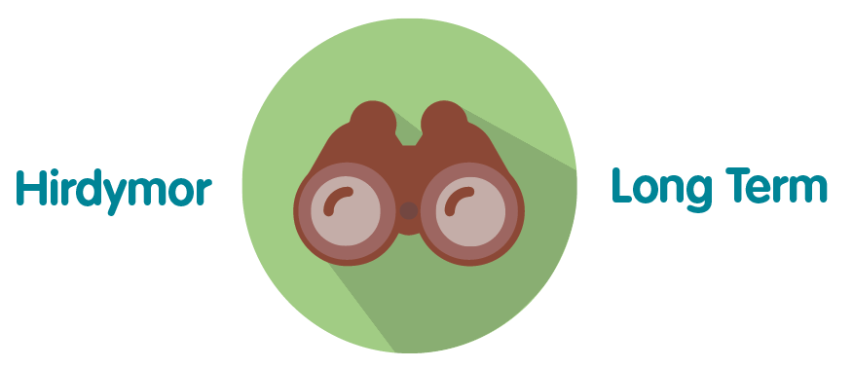 | The effective management of corporate risks supports the longevity of the organisation
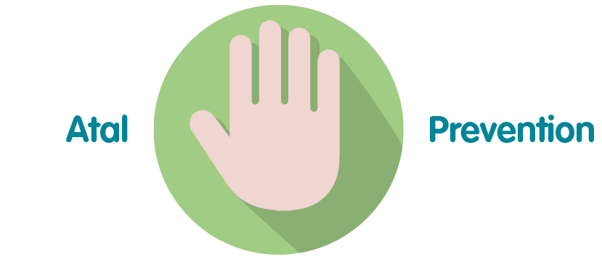 | The effective management of corporate risks reduces the likelihood or consequence of harm being realised.
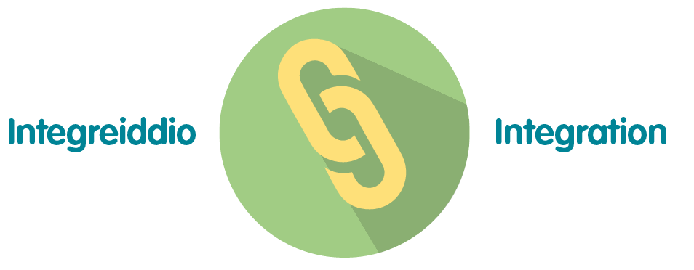 | The identification and management of risks are integrated into decision making activities.
 | Owners of corporate risks collaborate within their areas and any relevant Directorates to manage risks effectively.
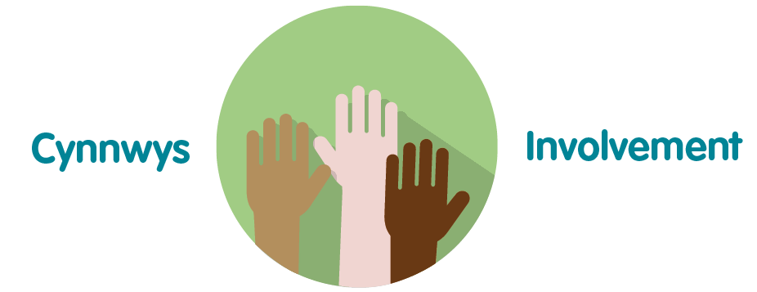 | Senior Managers engage with relevant colleagues to ensure staff are empowered to raise risks.

Recommendation

The Knowledge, Research and Information Governance Committee is asked to:
- Take assurance that the corporate risks are being scrutinised appropriately.

