Risk Owner’s Overview Assessment Status
The Directorate has gone through a period of change following the standing down from the Covid-19 response, return of staff to substantive roles and returning to a steady state.
Successful delivery against the objective appears feasible, however, there are significant dependencies/actions, including:
- recruitment and onboarding of key hires,
- acquiring of new skills and ways of working,
- building of relationships to establish robust and ongoing collaboration within the directorate, across the organisation and wider partners to ensure we maximise the benefit across all data sources including surveillance, screening, non-communicable disease and wider determinants of health

Risk 5 | There is a risk that we will fail to exploit data to inform and direct public health action and interventions. This will be caused by data being held in silos, difficulty accessing the data and inability to access to provide the impact on public health. This will result in worse public health outcomes in Wales and increased information governance risk within Public Health Wales.

Sponsor and Assurance Group
Executive Sponsor | Executive National Director of Data, Knowledge and Research
Assuring Group | Knowledge, Research and Information Committee

Inherent Risk
Date | 25/11/2021 | Likelihood: | 5 | Impact: | 4 | Score: | 20
Risk Score |  |  |  |  |  | Risk Decision | Delivery Confidence Assessment
Current Risk |  |  | Target risk |  |  | Treat | Amber
Likelihood | Impact | 20 | Likelihood | Impact | 12 | Treat | Amber
5 | 4 | 20 | 3 | 4 | 12 | Treat | Amber

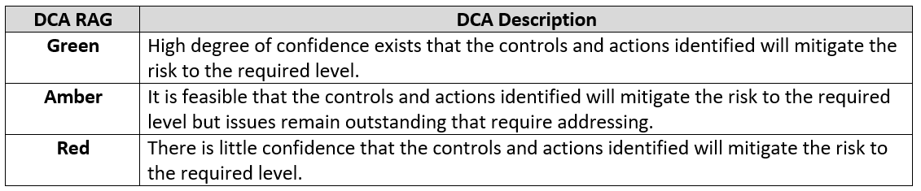

Key Controls |  |  | Sources of Assurance | Level at which the Assurance is provided to
No. | Control | Executive Owner | Sources of Assurance | Team / Division / Project /Programme | Directorate Team / Exec Lead | Business Exec Team / Sub Groups | Committee / Sub group | Board
SR 5.1 | Development of research & evaluation and digital & data strategies for Public Health Wales to take drive forward our needs on this area. | Director of Data, Knowledge and Research | KRIC on behalf of the Board |  |  | × | × | ×
SR 5.2 | Developing our data storage, access and linking as part of the Local Dara Resource and contributing/interacting with DHCW for other data needs in Health Care. | Director of Data, Knowledge and Research | Internal audit in Q3 | × | ×
SR 5.3 | Recruitment into new investment posts progressing quickly to bring in additional skills | Director of Data, Knowledge and Research | Management control | × | × | ×
SR 5.4 | Ensure we maximise exploitation of our data and information | Director of Data, Knowledge and Research | Scoping Discussions | × | ×

Action Plan No. | Gaps in controls | Action Plan | Exec Director | Due Date | Progress
AP 5.1 |  | To have all our data accessible through one place | Director of Data, Knowledge and Research | 31/10/2022 | Band 9 x 2 Head of Data Science and Head of Data roles now in post.  Consultancy and project with Amarcuni completed April 2022.  Investment supplied for the roles of:  Data Engineer, User Centred designer, User Centred Researcher, Principal Analyst, 2 Advanced Data Analysts, 2 Evaluators.  All roles out to advert with interviews scheduled for W/C 19/09/2022.  User Centred Designer and User Centred Researcher with the specific objective of developing user personas. Head of Digital Experience now in post will participate in the hiring process.  DESW discovery completed April 2022 and now developing the approach for alpha. Spending plans submitted for consideration to fund Alpha.
AP 5.2 |  | Develop a Public Health overview dashboard | Director of Data, Knowledge and Research | 31/10/2022
AP 5.3 |  | Recruitment of key personal to fill gaps in skills and knowledge | Director of Data, Knowledge and Research | 31/10/2022
AP 5.4 |  | Develop and agree a research and evaluation strategy and a digital and data strategy | Director of Data, Knowledge and Research | 31/10/2022
AP 5.5 |  | Move from discovery phase into alpha phase for diabetic eye screening and begin to implement service improvements | Director of Data, Knowledge and Research | 31/10/2022
AP 5.6 |  | Undertake a discovery phase into a single register of non-communicable and communicable diseases | Director of Data, Knowledge and Research | 31/03/2023 | Just starting to scope the work and approach. Workshops now in progress.
AP 5.7 | Assurance for maximising exploitation of our data and information | Develop research and evaluation strategy | Director of Data, Knowledge and Research | 28/02/2023 | New action
AP 5.7 |  | Five data sciences projects to be agreed | Director of Data, Knowledge and Research | 30/09/2022 | New action

