 |  |  |  | Name of Meeting  Business Executive Team Meeting
Date of Meeting
22 March 2022
 |  |  |  | Agenda item:
Risk Management Development Plan

Executive lead: |  | Rhiannon Beaumont-Wood, Executive Director Quality, Nursing and Allied Health Professionals
Author: |  | John Lawson, Chief Risk Officer and Head of Information Governance and Bethan Osborne, Risk and Incidents Manager
Approval/Scrutiny route: |  | Business Executive Team
Purpose
The purpose of this paper is to introduce the Risk Management Development Plan
Recommendation:
APPROVE | CONSIDER |  | RECOMMEND |  | ADOPT | ASSURANCE
The Business Executive Team is asked to:

- Consider this paper

- Approve the Risk Management Development Plan

Note – This is the existing Risk Development Plan, approved by BET in March 22, provided to ACGC on 19 September 2023 for reference. (Attachment 2)

Link to Public Health Wales Strategic Plan

Public Health Wales has an agreed strategic plan, which has identified seven strategic priorities and well-being objectives.

This report contributes to the following:
Strategic Priority/Well-being Objective | All Strategic Priorities/Well-being Objectives
Strategic Priority/Well-being Objective | Choose an item.
Strategic Priority/Well-being Objective | Choose an item.
Summary impact analysis

Equality and Health Impact Assessment | Not required
Risk and Assurance | A risk is currently being developed in the Information Governance Risk Register that will address this issue.
Health and Care Standards | This report supports and/or takes into account the Health and Care Standards for NHS Wales Quality Themes
Health and Care Standards | Governance, Leadership and Accountability
Health and Care Standards | Choose an item.
Health and Care Standards | Choose an item.
Financial implications | There are financial implications of not having an effective Risk Management system in terms of loss and also missed opportunity costs.
People implications | Whilst responsibility for most of the work on delivering this plan will fall to the Chief Risk Officer, there will be a need for engagement from other parts of the organisation, notably the Executive Team and Board.

Introduction

This paper introduces the proposed development plan for the Public Health Wales Risk Management System. It describes the current maturity of the system, provides the results of a stakeholder engagement exercise designed to assess the perception of the systems strengths and weaknesses and details the high-level objectives for the improvement measures set out.

This is a three year development plan, intended to build on the strengths of the existing system, consolidate the organisational position after the disruption of the last two years and take our risk management system to the next level of maturity. The plan details 13 high level objectives which are summarised at Appendix A.

Once the high level objectives have been approved, they will be supported by a detailed delivery plan.

It must be noted that this is a three year plan based on the assumption that the resources to deliver will be available to the Chief Risk Officer. Delivery of this plan is dependent not only on adequate resourcing of the risk management function but also the information governance function, for which the Chief Risk Officer is also responsible. Although this is a three year plan, it could be delivered within two years if the appropriate additional investment in the risk management function is made at the outset, which would mean that the benefits outlined below would be realised much earlier than currently projected.

The case for development

‘If we are serious about meeting objectives successfully, improving service delivery and achieving value for money, risk management must be an essential and integral part of planning and decision-making’

(The Orange Book Management of Risk - Principles and Concepts, HM Treasury 2020)

‘A weak risk management approach is effectively the biggest risk in the organisation’

The failure of risk management – Douglas W. Hubbard 2009

‘Public Health Wales is committed to the effective management of risk throughout the organisation, and will develop and maintain the appropriate systems to allow such management.’

(Public Health Wales Risk Management Policy, January 2021)

Organisations don’t manage risks; it’s the people who run the organisations that do that. Whether it be relatively low level risks of failing to meet a particular objective, or the risk of serious financial loss that could bring the organisation down, people manage those risks.

We as people are inherently disposed to managing risks without even realising that we do it. From the moment we came out of the cave and made our way to the click and collect point at Tesco, we have instinctively managed risk. We have had little if any training in how to do it, and yet the vast majority of people learn from experience and go on to live long, healthy and productive lives.

So if people are so good at managing risks, and those same people manage organisations, why do so many organisations fail because of failures in risk management? Newspaper archives are littered with high profile organisational failures, almost all of which come down to a failure to manage risk.

- London Ambulance Service (1992)
- Enron and Arthur Andersen (2001)
- Royal Bank of Scotland (2008)
- Northern Rock (2009)
- Mid Staffs NHS Trust (2009)
- Deepwater Horizon (2010)
- Monarch Airlines (2017)
- Grenfell Tower (2017)
- Carillion (2018)

Risk is a very subjective matter. No two people will view or assess the same risk in the same way; they will all bring a wealth of life’s experiences to the assessment and they will all have their own views on what is and is not an acceptable risk. This works fine when an individual is trying to work out whether a particular investment is a risk worth taking or whether that extra glass of wine is really going to cause them health problems in the long term.

But when people have to come together as a group to manage risks collectively, they need to have a common understanding of what they are trying to achieve, and of how much risk they collectively want to take to achieve it. In other words, they need a system in which to manage risk. With an effective system, risk management becomes a fundamental and integral part of all decision making that the organisation carries out, in order to develop and deliver its strategy.

It is also important to recognise that managing risk is not all about avoiding bad things happening. It is at least as important to understand how much risk we are actively prepared to engage with in pursuit of our goals. An effective risk management system is vital to enable the organisation to realise significant opportunities such as:

- Improved quality in all of our activities;
- Increased ability to exploit opportunities;
- Improved reputational image;
- Improving the well-being and motivation of staff;
- Better utilisation of resources;
- Significant costs savings;
- A reduction in clinical negligence claims and/or fines, and
- Protection from criminal prosecutions.

The current Policy and Procedure for Risk Management were adopted by the Board in 2017, and has committed to a policy of continually developing and improving the risk management system. Between 2017 and 2019, excellent progress was made, resulting in findings of ‘Reasonable Assurance’ from three annual Internal Audit reports.

Over the past eighteen months however, PHW has seen a great deal of change and adaptation in order to respond to the COVID pandemic. The organisation has seen existing services placed on hold, new services established and staff significantly adapting their ways of working both in terms of remote working and the roles that they undertake.

The past eighteen months have shown how the work done thus far has enabled people to manage risk dynamically and collectively. People speak about the ‘risk based approach’ that has been taken to so many issues, and have gained the confidence to make decisions based on sound risk assessments. But whilst there are many examples of good practice, it has been recognised that the system has not provided all of the answers and so as the organisation moves into the next phase of delivery, it has been identified that a review of the risk management system would be beneficial.

This paper proposes therefore that the risk management system undergoes a thorough review of its efficiency and effectiveness, and opportunities identified to further improve the way in which our people understand and manage risk so that we can fully exploit the opportunities that present themselves as we strive ever closer to becoming the high performing organisation to which we aspire.

Baseline Assessment

Two key preliminary activities have been undertaken to provide a baseline assessment of the current risk management system in order for high level objectives to be identified.

  - Assessment against the Risk Maturity Matrix

The Risk Maturity Matrix was developed from the requirements detailed in the International Standard for Risk Management, ISO31000 and was approved for use in PHW in 2018. The matrix works on two levels, Corporate and Directorate. At Corporate level there are seven domains as per the Standard, and then within each domain there are several criteria. For an organisation to be able to consider itself compliant with the standard the expectation would be that each of the criteria are met within the organisation’s risk management system. The current risk management system was assessed against each of the criteria to determine where gaps existed.

  - Stakeholder Engagement

Meetings were held with Non-Executive Directors and Executive Team members and senior managers within Directorates and Divisions. At Board level a workshop was carried out with a selection of Non-Executive Directors and Executive Team members, and each member of the Executive Team took part in semi-structured interviews.

At a Directorate level, semi structured interviews were carried out with leads from each Directorate to capture feedback in relation to the management of operational risks management that sit underneath the corporate level.

Identified areas of Good Practice

As part of the stakeholder engagement exercise, there were a number of notable areas of good practice of which it is important to recognise, these include:

- Although it was accepted that there was a lack of consistency and not all risks were managed according to the Policy and Procedure, all Directorates are actively engaged in managing risk at an operational level.

- The organisation’s ability to manage risk in a dynamic and fast paced environment was brought to the fore by the pandemic response.

- Risk was now a more routine and widespread element of conversation than it was some years ago, reflecting that the concept and need for risk management is becoming better embedded in everyday activities.

Risks and Benefits associated with the Risk Development Plan

  - Risks

With the organisation stretched as it is in the response to and recovery from the pandemic, there is a risk that the engagement required to deliver some of the objectives will not be achievable, resulting in target dates slipping.

The Chief Risk Officer is also responsible for Information Governance and the Records Management Programme, but resource for both of these areas is extremely limited. The only resource available to assist with this plan is the Risk and Incidents Manager. There is a risk therefore, that some of the development work may slip due to limited resources and competing priorities.

  - Benefits

The organisation has long recognised that an effective risk management system is key to delivering on its long-term strategy. Whilst there is currently a system in place, there are gaps that reduce its effectiveness.

This plan if approved and implemented will address those gaps and result in a risk management system that is robust, sustainable and will improve the organisations chances of successful delivery of its strategic priorities.

The plan will also result in the reduction of the severity of many of the risks that the organisation faces, both currently and in the future.

High Level Objectives

The high level outline of the plan makes use of ISO 31000 as a basis to outline the development and improvement programme that is proposed. The ISO uses seven groups of criteria to list the elements required for an effective Risk Management System and using these seven headings, an assessment of the organisations current position, along with high level objectives and examples of ‘what success would look like’ are shown below.

  - Risk Architecture

Current Position

The risk architecture is the structure within which the risk management system functions. It shows the levels at which risks are managed, from Team and Divisional level up to the Board, along with the escalation and de-escalation routes. It also makes clear the key distinctions between Strategic and Corporate Risk and also Corporate and Organisation wide risks. The current architecture was designed and approved in 2016.

Whilst the distinction between Strategic and Corporate risk has always been maintained, feedback suggests that it is not always understood as well as it might be and there is also concern around the way that organisational risks are managed. In order to avoid flooding the Corporate Risk Register with numerous organisation wide risks simply because they don’t have a Directorate in which to sit, the architecture allows for four separate ‘workstreams’ of organisational wide risks;

- Information Governance (IG);
- Health and Safety (H&S);
- Business Continuity (BC) and
- Programme and Project (P&P).

However whilst risk registers exist for both IG and H&S, after 5 years there is still no risk register for either BC or P&P risk. This means that not only is the organisation failing to comply with its own Policy, but it would also suggest that the model may not be as effective as required.

High Level Objectives

- Review the risk management architecture and make recommendations for any improvements that can be identified.

What would success look like?

- The distinctions between Strategic, Corporate and Organisation wide risks would be understood at all levels through a refreshed Policy and appropriate training and awareness raising activities.
- The Board would continue to take assurance that the risk management system was operating effectively at all levels of the organisation.
- The Board would continue to take assurance that risk management was an integral part of the decision making process across the organisation.

  - Risk Strategy

Current position

Public Health Wales is committed to a single holistic strategy for the organisation and the current iteration of that strategy sets the organisations direction for the next 9 years. Accordingly there is no single strategy document specifically for risk management. That said the organisation recognises the importance of understanding its current risk exposure and also understanding the direction of travel and what level of risk is acceptable.

Following a Board development event in 2018, Public Health Wales published its annual statement of risk appetite, in which it detailed the acceptable level of risk for each of its seven strategic priorities. This was very much a strategic level assessment however and the intention was that once it was embedded at this level, the work would be undertaken to operationalise it. The work commenced as a pilot in the then Public Health Services Directorate in late 2019, but was overtaken by events as the Covid19 pandemic unfolded. As a result, the concept of risk appetite is not widely understood across the organisation, nor is it overtly used in the annual planning process.

High level objectives

- To review and revise the current risk appetite against the new organisational priorities;
- To develop a system of establishing risk appetite across all levels of the organisation that aligns with the Board’s expectations;
- To significantly raise the level of awareness and understanding of the concept of risk appetite in terms of its fit with the decision making process.

What would success look like?

- Risk appetite would become an intrinsic part of the annual planning process;
- Annual statement of risk appetite would be produced by the Board every year;
- Risk appetite would be embedded in Directorates to the extent that it was an integral part of their decision making.

  - Risk Protocols

Current Position

The organisation’s approved Risk Policy and Procedure specifies that all risks should be recorded and managed on Datix. However feedback demonstrated that the majority of areas within the organisation are only using Datix to record some risks, also excluded are the Strategic and Corporate Risk Register risks which are held on SharePoint. As such a corporate view on risks is not available.

It is acknowledged that the risk module in Datix has not been reviewed for at least 5 years and as such, it would be prudent to review the module to identify any improvements. Some key areas are the flow of reporting, assessing and reviewing risks; the recording of controls and assurances and the assigning of risks to the most appropriate risk registers. This review is also timely as a national project is currently in place to develop a replacement (DatixCloud) for the current system of which PHW will wish to ensure its requirements are considered.

High Level Objectives

- Undertake review of the Datix risk module with representation from across the organisation to establish its long term suitability and deliver any short/long terms improvements that can be made to the existing system.
- Review and update the organisations Risk Policy and Procedure.
- Embed risk management as a standard agenda item in relevant meetings across the organisation levels.

What would success look like?

- All risks would be reported and managed on Datix in a timely and robust manner as the system would be agile and facilitate ease of use.
- Risks would be regularly identified and monitored by the appropriate body of people i.e. Directorate risks at SLT’s, Information Governance organisational wide risks at Information Governance Working Group and so forth.
- A clear line or “golden thread” between all levels of the organisation would be demonstrated i.e. escalation from lower level risks to a strategic level and vice versa.

  - Planning and Designing

Current Position

The feedback has indicated that at a Directorate level, efforts are made to actively identify risks to the delivery of objectives. At Board and Executive level sessions are held on an ad-hoc basis to refresh the Strategic and Corporate risks, but this is not identified formally as part of the work-plan. There is currently limited engagement in the planning stage for the organisation’s annual plan, however the challenging timescales imposed for the 2021 IMTP meant there was limited scope for development.

Currently there is little attention paid overtly to the opportunities that are presented by calculated risk taking and this links closely to the development work on risk appetite identified in 6.2 above.

High Level Objectives

- Develop the resources required to enable and empower our people to actively seek out and identify risks and opportunities.

What would success look like?

- Organisational decision making will be informed by robust and rigorous risk assessments and the organisation will be better able to explain and defend decisions taken;
- Future organisational plans and strategies will explicitly point to robust and rigorous risk assessments that enable the organisation to seek out opportunities based on carefully calculated judgements.

  - Implementing and Benchmarking

Current position

Strategic risks and Corporate risks are owned by Executive Team members and they are held to account through the Business Executive Team, the Audit and Corporate Governance Committee and the Board. Through this mechanism it can be determined if the risk remains acceptable and if the actions required if any are appropriate and on target to achieve the desired outcomes.

Reporting of risks and the presentation of risk registers to these groups however is not always as timely and up to date as would be expected of a high performing organisation and there is a need to better define the timetables for presentation of risk registers to ensure that risk owners can be better supported to present their risks for scrutiny and challenge.

At Directorate level however, whilst Directorate Senior Management Teams hold risk owners to account, since the start of the pandemic and the suspension of the Senior Leadership Team (SLT) there has been no formal scrutiny of risks beyond the Directorate itself. The SLT previously took the role of ‘critical friend’ scrutinising the risk registers on behalf of the Business Executive Team and providing advice and guidance on where risks needed to be escalated. In order for the Board to take assurance that Directorate risks are being managed with the same degree of rigour as those at Corporate level, there is a need to return to a more formalised organisational scrutiny of Directorate risks. It is likely that a formal procedure would assist in this area.

High level objectives

- Review and revise the roles and responsibilities of Committees in the risk management system;
- Clarify the role of the Senior Leadership Team in both Corporate and Directorate risk management;

What would success look like?

- The system would enable the organisation to mature to the point where the Board and Executive Team would be assured by higher level data rather than relying on the minutiae of day to day risk management.
- Risk Registers would be presented at all levels in a timely fashion, updated as required with sufficient detail to enable the scrutinising group to take the assurance it requires.
- The Senior Leadership Team would have a clear role to play in risk management that added value to the process and gave the Business Executive Team confidence that Directorate risk management was effective.

  - Measuring and Monitoring

Current position

There is currently no effective performance measuring for risk management. Performance measures need to be developed in line with the maturity of the system, but it is important to note that such measures will need to evidence actual performance and go far beyond numbers of risks or timeliness of updates. Performance measures will therefore be developed and presented to the Business Executive Team for ratification, which will demonstrate that the organisation is managing risk to an acceptable level.

High level objectives

- Develop effective performance metrics for the risk management system.

What would success look like?

- Performance measures would be reported upon regularly which demonstrate not only effective risk management, but continuous improvement.

  - Learning and Reporting

Current Position

Over the past year, PHW have been developing a Performance Assurance Dashboard (PAD) and a Directorate Assurance Dashboard (DAD) to view risk data. This is enabling the organisation to monitor, review and report risk data, however there are currently no agreed performance indicators in which to assess against.

A number of Directorates/Divisions produce reports and narrative from data in Datix or risks held elsewhere which are shared within Divisions/Directorates but there is no standard approach across the organisation.

Initially scoping activities have commenced to consider the linkages between risks and concerns (incidents/complaints) in order to work with Directorates to develop standard activities to identify trends and quality improvement projects to learn from data captured. An activity currently excluded is in relation to the identification and management of Issues which the organisation would benefit from reviewing as part of this plan.

High Level Objectives

- Data pulled into the PAD and DAD demonstrates a true reflection of the risks recorded in Datix (and SharePoint) and managed within agreed performance indicators, and standard reports/narrative templates developed.
- Ensuring learning is identified and drawn from risk/concerns data in order to implement improvements/support business cases.

What would success look like?

- PHW would be able to demonstrate the learning gained from risk, issues and concerns identification and management, with delivered improvement projects as an outcome.
- The organisation to achieve compliance with the approved performance metrics (see 6.6. above).
- The sharing of learning and “Good News Stories” actively shared across the organisation.

- Well-being of Future Generations (Wales) Act 2015

This work has been put together following the five ways of working, as defined within the sustainable development principle in the Act, in the following ways:

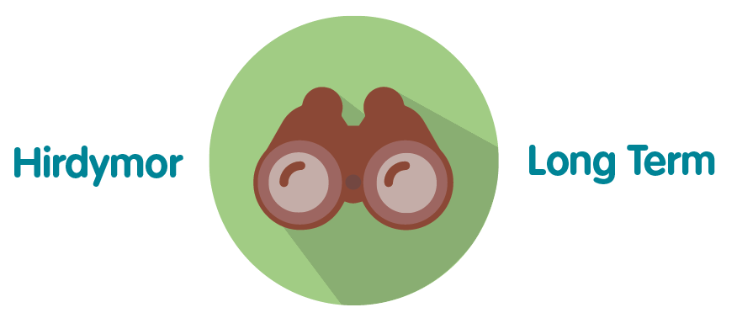 | A sound Risk Management System is essential to ensure the long term viability and effectiveness of the organisation
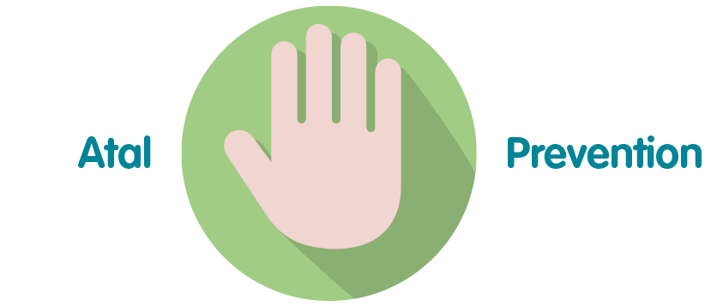 | Effective Risk Management will support the organisation to reduce its exposure to risk, thereby reducing the likelihood of loss or failure to meet objectives
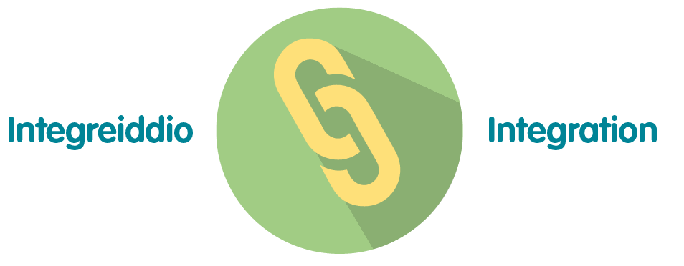 | An effective Risk Management system will ensure that the process is integrated across the whole organisation, improving on the current position of silo working.
 | This work will be done in collaboration with all staff members and groups.
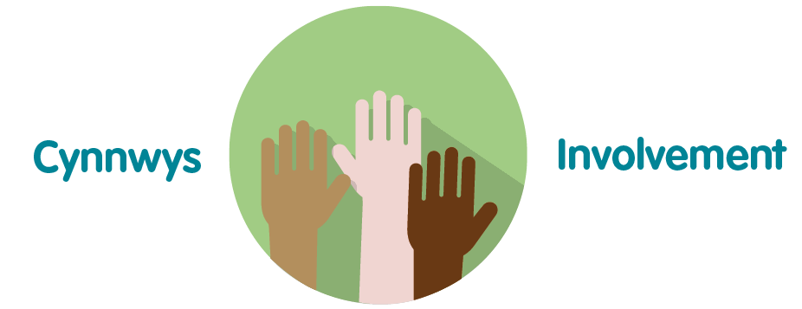 | All parts of the business will be involved in developing the Risk Management system to ensure its proper integration across all business areas

- Conclusions

Feedback from the stakeholder engagement exercise and the analysis against the International Standard both show that whilst the organisation has had to shift priorities over the past 18 months, the fundamentals of risk management have stood firm and have assisted the organisation in the way it managed the constantly changing environment that the Covid19 pandemic brought.

It is also encouraging to note that many of the comments were acknowledging that despite the successes there are still weaknesses in the system, and it became clear from interviews with Executive and Board members that the appetite exists to develop the system to the next level.

This plan if approved will further develop the organisation’s risk management system in line with its vision of becoming a high performing organisation and will allow PHW to move closer to full compliance with the International Standard with which it has aligned itself.

- Recommendation

The Business Executive Team is asked to:

- Consider this paper

- Approve the Risk Management Development Plan

Appendix A – Summary of high level objectives

No | Objective | Timescale for delivery
1 | Review the risk management architecture and make recommendations for any improvements that can be identified | Year 2
2 | To review and revise the current risk appetite against the new organisational priorities | Year 1
3 | To develop a system of establishing risk appetite across all levels of the organisation that aligns with the Board’s expectations | Year 1
4 | To significantly raise the level of awareness and understanding of the concept of risk appetite in terms of its fit with the decision making process | Year 2
5 | Undertake review of the Datix risk module with representation from across the organisation to establish its long term suitability and deliver any short/long terms improvements that can be made to the existing system | Year 2
 | Review and update the organisations Risk Policy and Procedure | Year 3
7 | Embed risk management as a standard agenda item in relevant meetings across the organisation levels | Year 1
8 | Develop the resources required to enable and empower our people to actively seek out and identify risks and opportunities | Year 2
9 | Review and revise the schedule for the presentation of both Corporate and Strategic Risk Registers at Executive, Committee and Board levels | Year 1
10 | Clarify the role of the Senior Leadership Team in both Corporate and Directorate risk management | Year 1
11 | Develop effective performance metrics for the risk management system | Year 3
12 | Data pulled into the PAD and DAD demonstrates a true reflection of the risks recorded in Datix (and SharePoint) and managed within agreed performance indicators, and standard reports/narrative templates developed | Year 2
13 | Quality Improvement process in place and embedded to learning from risk/concerns data in order to implement improvements/support business cases | Year 3

Appendix B – ISO31000 Gap Analysis

It is also worthy of note that in at least half of the cases cited, the organisation had received favourable reports on its risk management systems from auditors and regulators.
It should be noted that ISO31000 is not prescriptive, but is written as guidance, recognising the fact that there can never be a ‘one size fits all’ approach to organisational risk management. Whilst it is possible therefore to be compliant with the standard, because of its status it is not possible to obtain certification against it.
Long Term Strategy_English.indd (nhs.wales)

