 |  |  |  | Name of Meeting  Audit and Corporate Governance Committee
Date of Meeting
19 September 2023
Agenda item:
5.1a
Risk Management Development Plan
Executive lead: |  | Angela Cook, Acting Executive Director Quality, Nursing and Allied Health Professionals
Author: |  | Beth Osborne, Risk Manager
Approval/Scrutiny route: |  | Angela Cook, Acting Executive Director Quality, Nursing and Allied Health Professionals  Business Executive Team (16 August)
Purpose
To provide the Business Executive Team with an updated Risk Management Development Plan (RMDP). The Plan has been refreshed to reflect the progress made to date and the recommendations made in the external Review of Operational Risk Management commissioned by Public Health Wales and undertaken by Grant Thornton UK LLP.
Recommendation:
APPROVE | CONSIDER |  | RECOMMEND |  | ADOPT | ASSURANCE
The Committee is asked to:

- Note that Executive oversight for the delivery of the RMDP incorporating the external recommendations has been delegated to the Leadership Team.
- Take assurance on the development of the Risk Development Plan, noting the revised plan.

Link to Public Health Wales Strategic Plan

Public Health Wales has an agreed strategic plan, which has identified seven strategic priorities and well-being objectives.

This report contributes to the following:
Strategic Priority/Well-being Objective | All Strategic Priorities/Well-being Objectives
Summary impact analysis

Equality and Health Impact Assessment | N/A no decision required
Risk and Assurance | The review of operational risk management was undertaken to support and drive the Risk Management Development Plan.
Health and Care Standards | This report supports and/or takes into account the Health and Care Standards for NHS Wales Quality Themes
Health and Care Standards | Governance, Leadership and Accountability
Health and Care Standards | Choose an item.
Health and Care Standards | Choose an item.
Financial implications | There are financial implications of not having an effective Risk Management system in terms of loss and also missed opportunity costs.
People implications | People resources will be required to take forward the recommendations

Purpose/Situation

The purpose of this paper is to provide the Committee with an updated Risk Management Development Plan (RMDP). The Plan has been refreshed to reflect progress made to date and to incorporate the recommendations made in the external Review of Operational Risk Management commissioned by Public Health Wales and undertaken by Grant Thornton UK LLP.

Background

In February 2022 BET approved the RMDP. This is a three year plan intended to build on the existing risk system, to consolidate the organisational position after the disruption caused by the response to the Covid-19 pandemic, and to take our risk management system to the next level of maturity. The original plan is attached in Appendix 1.

While some progress in implementing the plan has been made, to further strengthen its approach to assessing and addressing risk, Public Health Wales commissioned an external organisation to undertake a review of our operational risk management arrangements. The key aims were to learn and take specialist advice on how improvements to the plan could be implemented. Grant Thornton UK LLP were appointed in March 2023. The work sought to understand how well-embedded existing processes are and where further improvements could be made to improve understanding, ownership and management of operational risk.

BET received the Review of Operational Risk Management Review on 19 June 2023 and agreed with the findings and recommendations in the report. It was agreed that the RMDP would be updated to reflect the recommendations within the report.

Description/Assessment

The RMDP has been reviewed and updated and now reflects the recommendations from the external Review of Operational Risk Management. As summarised in the following sections, the recommendations have been mapped to the objectives within the original plan with additional recommendations now included. This was approved by BET on 6 September.

Resource Consideration

Following BET investment approval on 6 September, the post of Head of Risk has been created within the Integrated Governance Division. Over the past three months, 3 successive recruitment attempts to fill this position have been made without success. In lieu of further attempts to recruit, a contract specification for temporary risk management resource to support the Risk Manager and implementation of the RMDP is being prepared. The implementation timetable for the RMDP objectives have been adjusted as a result of the inability to recruit but may well be brought forward following the successful appointment of the temporary resource. There is, of course, a risk to the implementation time table should we fail to procure a temporary resource.

- Leadership Team Role

The Leadership Team now has responsibility to review, update and report on the Corporate Risk Register and to provide oversight of operational risk management across the organisation. At the Business Executive Team meeting on 6 September, it was agreed that the Leadership Team provide oversight to the implementation of the RMDP.

- Well-being of Future Generations (Wales) Act 2015

This work has been put together following the five ways of working, as defined within the sustainable development principle in the Act, in the following ways:

 | A sound Risk Management System is essential to ensure the long term viability and effectiveness of the organisation
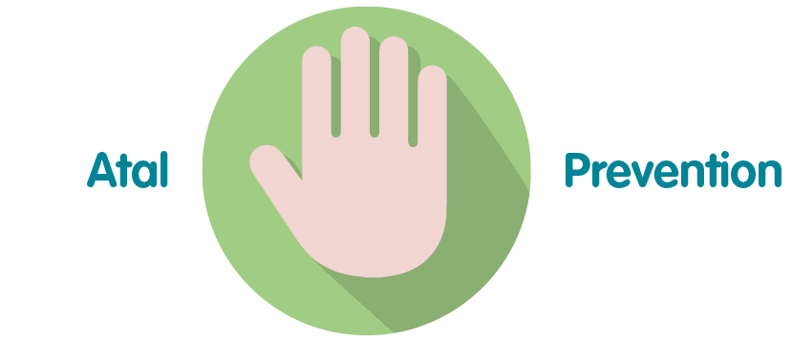 | Effective Risk Management will support the organisation to reduce its exposure to risk, thereby reducing the likelihood of loss or failure to meet objectives
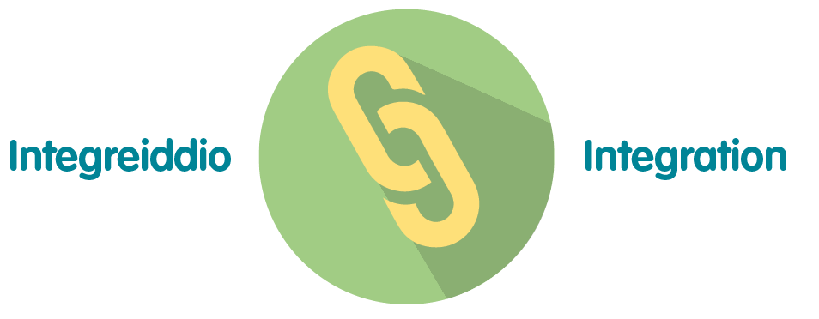 | An effective Risk Management system will ensure that the process is integrated across the whole organisation, improving on the current position of silo working.
 | This work will be done in collaboration with all staff members and groups.
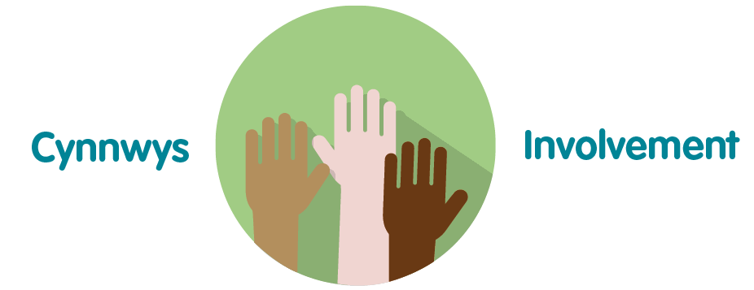 | All parts of the business will be involved in developing the Risk Management system to ensure its proper integration across all business areas

- Recommendations

- Note that Executive oversight for the delivery of the RMDP incorporating the external recommendations has been delegated to the Leadership Team.
- Take assurance on the development of the Risk Development Plan, noting the revised plan.

Risk Architecture

RMDP Objective | Status | Timescale
5.1 Review the risk management architecture and make recommendations for any improvements that can be identified | Action completed | N/A

Grant Thornton Recommendations | New or existing in RMDP | Status | Timescale
5.2 Clarify risk escalation routes | Existing | Action completed | N/A
5.3 Risks on the CRR have evidence of escalation from appropriate level | Existing | In progress | 31/08/2023
5.4 Introduce escalation thresholds i.e. escalation driven by risk scores | New | To be considered within Enterprise Risk Management principles and guidance | 31/08/2023

Risk Strategy

RDMP Objectives | Status | Timescale
6.1 To review and revise the current risk appetite against the new organisational priorities | Completed but now need to be refreshed at Corporate Risk Register level and throughout the organisation | 31/12/2023
6.2 To develop a system of establishing risk appetite across all levels of the organisation that aligns with the Board’s expectations | Not started | To be agreed subject to outcome at 6.1
6.3 To significantly raise the level of awareness and understanding of the concept of risk appetite in terms of its fit with the decision making process | Not started | To be confirmed  (TBC)

Grant Thornton Recommendations | New or existing in RMDP | Status | Timescale
6.4 Agree a process for how risk appetite translates into day to day risk management activities | Existing | As above in 6.3 | N/A

- Risk Protocols

RDMP Objectives | Status | Timescale
7.1 Undertake review of the Datix risk module (Web and Cloud versions) with representation from across the organisation to establish its long term suitability and deliver any short/long terms improvements that can be made to the existing system | In progress | 31/03/2024
7.2 Review and update the organisations Risk Policy and Procedure | In progress | 31/03/2024
7.3 Embed risk management as a standard agenda item in relevant meetings across the organisation levels | Completed | N/A

Grant Thornton Recommendations | New or existing in RMDP | Status | Timescale
7.4 Integrate project/programme risk management into its wider risk management processes | Existing | In progress | TBC
7.5 Developing tailored and proportionate risk reporting | Existing | In progress | 31/03/2024

- Planning and Designing

RDMP Objectives | Status | Timescale
8.1 Develop the resources required to enable and empower our people to actively seek out and identify risks and opportunities. | In progress | 31/12/2023
8.2 Organisational plans and strategies explicitly point to robust and rigorous risk assessments | In progress | 30/09/2023

Grant Thornton Recommendations | New or existing in RMDP | Status | Timescale
8.3 Training need analysis and ongoing training plan | Existing | In progress | 31/12/2023
8.4 Update its annual business planning and ongoing management processes in order to more effectively integrate horizon scanning, risk identification and monitoring activities | Existing | In progress | 30/09/2023
8.5 Defining a risk aggregation approach – aggregating similar risks across Directorates | Existing | In progress | 31/12/2023

- Implementing and Benchmarking

RDMP Objectives | Status | Timescale
9.1 Review and revise the roles and responsibilities of Committees in the risk management system | In progress | 31/12/2023
9.2 Clarify the role of the Leadership Team in both Corporate and Directorate risk management | In progress | 30/09/2023

Grant Thornton Recommendations | New or existing in RMDP | Status | Timescale
9.3 Consistent ‘tone from the top’ | New | Not started | TBC in association with the development of the corporate governance framework and culture work
9.4 Review of governance below Board level – role of Leadership Team | Existing | As per 9.2 above | N/A

- Measuring and Monitoring

RDMP Objectives | Status | Timescale
- Develop effective performance metrics for the risk management system | In progress | TBC

Grant Thornton Recommendations | New or existing in RMDP | Status | Timescale
10.2 Develop a risk management compliance monitoring framework with key performance indicators | Existing | As per 10.1 above | TBC

- Learning and Reporting

RMDP Objectives | Status | Timescale
Data pulled into the PAD and DAD demonstrates a true reflection of the risks recorded in Datix (and SharePoint) and managed within agreed performance indicators, and standard reports/narrative templates developed | In progress | 31/08/2023
Ensuring learning is identified and drawn from risk/concerns data in order to implement improvements/support business cases | In progress | TBC

Grant Thornton Recommendations | New or existing in RMDP | Status | Timescale
Adopting a single source of truth | Existing | In progress | TBC

Appendix A – Summary of high level objectives

No | Objective | Timescale for delivery
1 | Review the risk management architecture and make recommendations for any improvements that can be identified | Year 2
2 | To review and revise the current risk appetite against the new organisational priorities | Year 1
3 | To develop a system of establishing risk appetite across all levels of the organisation that aligns with the Board’s expectations | Year 1
4 | To significantly raise the level of awareness and understanding of the concept of risk appetite in terms of its fit with the decision making process | Year 2
5 | Undertake review of the Datix risk module with representation from across the organisation to establish its long term suitability and deliver any short/long terms improvements that can be made to the existing system | Year 2
 | Review and update the organisations Risk Policy and Procedure | Year 3
7 | Embed risk management as a standard agenda item in relevant meetings across the organisation levels | Year 1
8 | Develop the resources required to enable and empower our people to actively seek out and identify risks and opportunities | Year 2
9 | Review and revise the schedule for the presentation of both Corporate and Strategic Risk Registers at Executive, Committee and Board levels | Year 1
10 | Clarify the role of the Senior Leadership Team in both Corporate and Directorate risk management | Year 1
11 | Develop effective performance metrics for the risk management system | Year 3
12 | Data pulled into the PAD and DAD demonstrates a true reflection of the risks recorded in Datix (and SharePoint) and managed within agreed performance indicators, and standard reports/narrative templates developed | Year 2
13 | Quality Improvement process in place and embedded to learning from risk/concerns data in order to implement improvements/support business cases | Year 3
Appendix 1 – ISO31000 Gap Analysis
(See separate document)

Appendix 2 – Existing Risk Development Plan is attached for reference.

(See separate document)

